FACECRYPT – THE SELFIE
FACE OF SECURITY

SMILE - make a Selfie with FaceCrypt...the new face of smartphone and tablet security.

This revolutionary face recognition app is a leap ahead of Apple's iPhone 5S dedicated fingerprint access technology and simply works with the front face camera so is available to all iPhone/iPad owners.

FaceCrypt is the ultimate defense for millions of existing mobile device users whose passwords, documents, personal, credit cards and bank accounts details, passport copies, privates images and videos remain vulnerable.

Don't stand still - consider the future that promises a boom in payments via mobile devices and an unfathomable increase in data storage.

For those who do not want this sensitive information to ever be seen by others, FaceCypt offers multiple levels of security access.

FaceCrypt works and protects with the blink of an eye (to avoid any fooling with a picture) and the basic app is just $4.99, while the plus version is $7.99. This amazing app is set to make waves in the industry because it contains enhanced biometric face recognition technology along with foolproof encryption.

So regardless of whether you lose your device or use it on public Wi-Fi networks through which data can be breached, this application continues to protect all vital data.

It uses an unbreakable 256 bit industry standard encrypted vault system that allows users to store all their sensitive data or information in one centralized and safe location that only they can access.

Additionally remote FaceCrypt offers a back-up service retaining the same level of secure encryption.

Official launch date 27th November 2013 so available now, this application can be downloaded from the Apple App Store.

FaceCrypt will change the way data protection is done by providing military-grade security so you can rest assured that any information you store in the FaceCrypt vault will be for your eyes only.

editors - full copy available to review - please email press@facecrypt.com for code and instructions to install free from AppStore

Press photo’s available from - http://facecrypt.com/press-images/

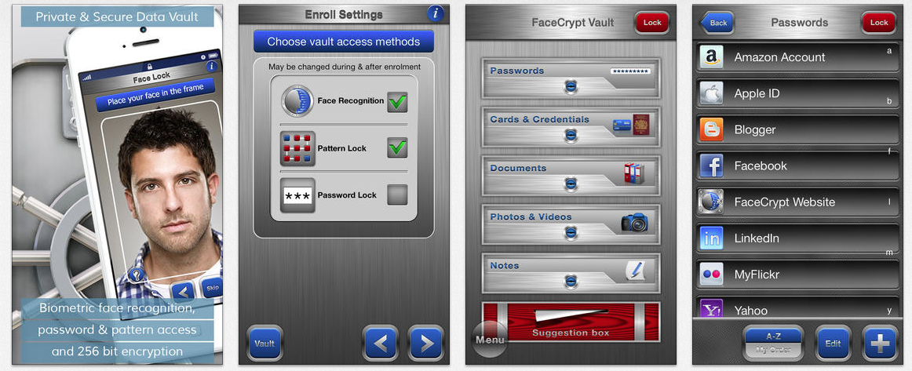

ABOUT THE COMPANY

FaceCrypt, led by Jeremy Rose, has years of experience building the most versatile and efficient biometric security applications for prisons, governments, police departments, and corporations around the world.

These applications are built to identify individuals quickly and securely. With this success behind them, FaceCrypt developers have the pedigree and reputation to now apply this experience to the mobile security industry.

Please contact Jeremy Rose on press@facecrypt.com for further information.

