Media Contact:
Kurman Communications, Inc.
Cindy Kurman or Alyssa Komish
(312) 651-9000
kurmanstaff@kurman.com

FOR IMMEDIATE RELEASE

Say ‘Hello’ to Summer with New Menu Items from Luella’s Southern Kitchen

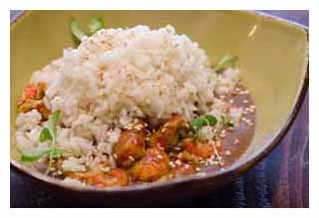
CHICAGO (June 2015) – Summer has officially started, and with the update in season comes menu updates from Luella’s Southern Kitchen (4609 N. Lincoln Ave.; 773-961-8196). Owner/Chef Darnell Reed is bringing three exciting new items to the menu, adding a brunch favorite to the lunch and dinner menu and changing the Seasonal Iced Tea flavor monthly.

The newcomer to the lunch and dinner menu is a Crawfish Etouffee ($14), made with Carolina Gold rice, Creole seasoning and Benne seeds. In addition to the Etouffee, the Oyster Po’ Boy has transformed into the Soft Shell Crab Po’ Boy ($15), served on French bread with cayenne remoulade and seasoned fries.
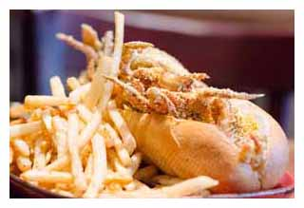
By popular demand, Chef Reed is moving the brunch Pimento Cheeseburger ($11) to the lunch and dinner menu. The Slagel Farms dry aged burger is topped with pimento cheese and a sunny side up egg, served on a brioche bun and complimented by seasoned fries.

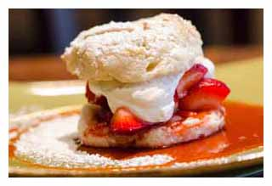
“Summer gives us the chance to lighten up our menu and incorporate seasonal produce into our food,” said Chef Reed. “Luella’s is bringing summer in the South to Lincoln Square this season. We are excited about the menu changes and updates, and we know customers will be too.”

Over on the dessert menu, Chef Reed is swapping out the Blackberry Hand Pie for Strawberry Shortcake ($5), taking advantage of the seasonal strawberry. The Strawberry Shortcake is made with a buttermilk biscuit, fresh strawberry compote and Chantilly cream.

And to beat the heat this summer, make sure to pick up a cool glass of Seasonal Fruit Iced Tea ($2, complimentary refills). While the Apricot Iced Tea ends at the end of the month, guests can look forward to Rainier Cherry Iced Tea in July and Black Mission Fig Iced Tea in August. Nothing tastes better on a hot summer day than one of Luella’s Southern Kitchen’s refreshing Seasonal Fruit Iced Teas.

About Chef Reed
Darnell Reed is a graduate of Washburne Culinary Institute in Chicago. He began his professional career in 1997 at the Palmer House Hilton where he served as Restaurant Chef at the French Quarter and the Big Downtown. In 2005, he was promoted to Executive Sous Chef at the Embassy Suites Chicago Lakefront where he handled banquet functions for up to 700 people. In April 2007, Reed was promoted to the dual Executive Chef position at the Hilton of Oakbrook and Hilton Garden Inn of Oakbrook. In May of 2010, he accepted the Executive Sous Chef position at the Conrad Chicago Hotel and was promoted to Executive Chef in 2011.
About Luella’s Southern Kitchen
Luella’s Southern Kitchen, located at 4609 N. Lincoln Ave. in Chicago’s Lincoln Square, is a casual independent restaurant owned by Chef Darnell Reed. The restaurant opened February 3, 2015. Luella’s serves lunch and dinner Tuesday through Friday from 11:30 a.m. to 10 p.m. Weekend brunch is served from 10 a.m. to 3 p.m. on Saturday and Sunday; dinner is served until 10 p.m. on Saturday and 8 p.m. on Sunday. All major cards are accepted. Luella’s is a BYOB establishment; no corkage fee is charged. Takeout and delivery service are available. For more information, call the restaurant at (773) 961-8196 or visit the website at www.luellassouthernkitchen.com.

###

