Latest Android App 'Share Your Venue' Celebrating Juneteenth With Black Wikipedia's
Latest Android app “Share Your Venue” celebrates upcoming Juneteenth holiday with a unique Black Wikipedia section on the great Black heroes. It also contains footages of old music concerts as well as categories on education, entertainment, technology etc.
Place, Date: With Juneteenth commemorating the great emancipation of African-Americans from slavery, how about having a Wikipedia especially dedicated to the legendary Black heroes? Well, a Juneteenth celebration can never be more apt and with that spirit alive, latest android app “Share Your Venue” has come up with Black Wikipedia's for the first time ever.
Developed by Antuan Simmons, the app is released recently in honor of the upcoming Juneteenth Celebration this year on June 19th.
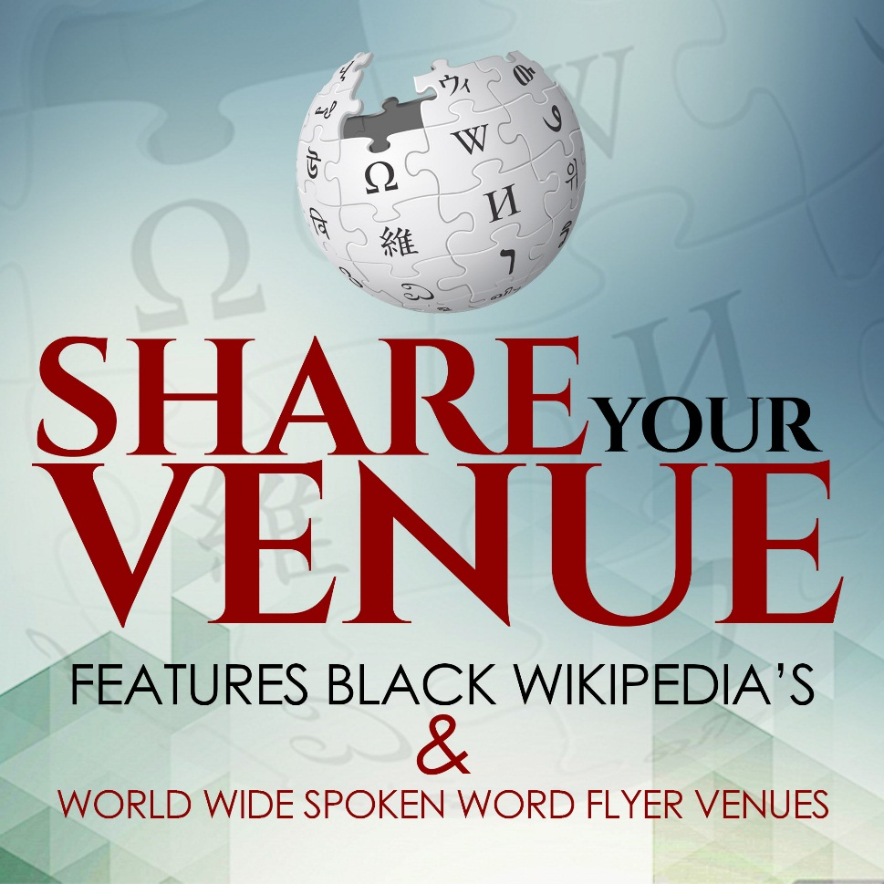
“My new app celebrates the upcoming legendary African-American holiday Juneteenth that champions the historic fight put forward by our valiant forefathers to break-free themselves from the oppressive shackles of slavery. The holiday is all about honoring our heroes and thus I thought of the unique inclusion of a black Wikipedia section in my app to complement the great day ahead. No one has ever thought of such inclusion and my new app assures the thrill of something never-seen-before”, smiled Simmons while announcing the launch of her app.
The Black Wikipedia’s in the app hosts videos & Wiki contents of legendary African-American figures who have created a stir in different aspects of life- be it sports or entertainment or politics or art or education & much more.
“I really love Wikipedia and I wanted to have a Black version of it that will enlighten especially about the grand achievements and contributions of our Black icons – my app helped me to fulfill my wish which I am sure would be duly appreciated by everybody upholding the Juneteenth holiday.”
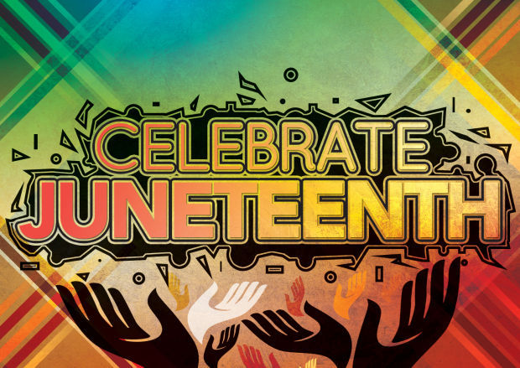
The app is not just about the unique Black Wikipedia but beyond. Share Your Venue hosts multiple categories on education, entertainment, technology and so on. The users will also find footage of old concerts performed by famous musicians from the by-gone days, spanning across 1940’s to 70’s.
“Black music has always won hearts since yesteryears and if you want a glimpse of such glorious musical days of esteemed musicians, this app is the thing for you with its rare footages of the old concerts- what a beautiful way to time-travel to such great old musical journeys just through a few touches on your smartphone!”
Share Your Venue further shows updated & latest social networking tools that would be useful for regular technological use. The users can join the Facebook Group of “Share Your Venue” to stay updated on bi-weekly & weekly additions of the app.
The app has received rave reviews from its users and they are especially delighted about the unique Black Wikipedia section.
“If you are looking forward to know more about Black history and heroes, this is the app for you. It features all categories on Black History heroes and can provide you with the needed knowledge in just an instant”, stated a happy user Janice.
“I just love the way Antuan has integrated multiple features in one user-friendly mobile app”, Jamil is another happy user of Share Your Venue.
To download Share Your Venue, please visit https://play.google.com/store/apps/details?id=share.yourvenue.app&amp;hl=en.

