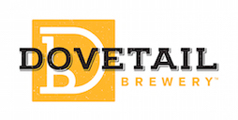
Media contact:
Kurman Communications, Inc.
Cindy Kurman or Lee Barrie
(312) 651-9000
team@kurman.com

FOR IMMEDIATE RELEASE

DOVETAIL BREWERY JANUARY NEWS ROUNDUP
New Beer Alert! Dovetail Vienna Lager
Mozart was played full-volume in the brewhouse as the Dovetail Vienna Lager was born! Brewed with 100% Vienna malt and Styrian Golding hops, the lager is a warm copper color with an equally a warm and malty character. May it make you grow a feather in your Alpine hat.

The Return of the Rauchbier
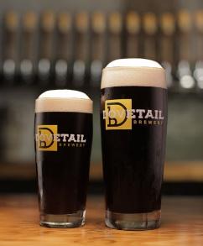
You asked, we answered! The Rauchbier is back! With a 5.3% ABV, the Rauchbier is dark with reddish tones and an off-white head with a rocky foam standing above the rim of the glass. Produced using 95% beechwood-smoked malt, it gives the impression of eating a bar of chocolate in a smokehouse, full and rich with generous hopping to balance the flavor of beechwood smoked bacon. Full bodied and comforting, the Rauchbier will help keep you warm this Chicago winter.

Meet Dovetail’s Growler
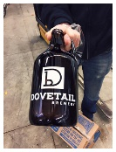
Last month Dovetail released its first growler just in time for the holidays as the ultimate gift that keeps on giving. Buy a growler, fill it with your favorite Dovetail brew, drink it, bring it back to the taproom and get your growler refilled. Repeat indefinitely.

Dovetail Upcoming events
Winter Brew Fest: Friday and Saturday, January 27-28, 2017
Beer, Bread, Sausage and Cheese Event: noon-6PM Saturday, February 11, 2017
Springfest: Saturday, May 27, 2017*
Oktoberfestiversary: Saturday, September 9, 2017*
Holiday Market: Saturday, December 16, 2017* (third weekend in December just like 2016)

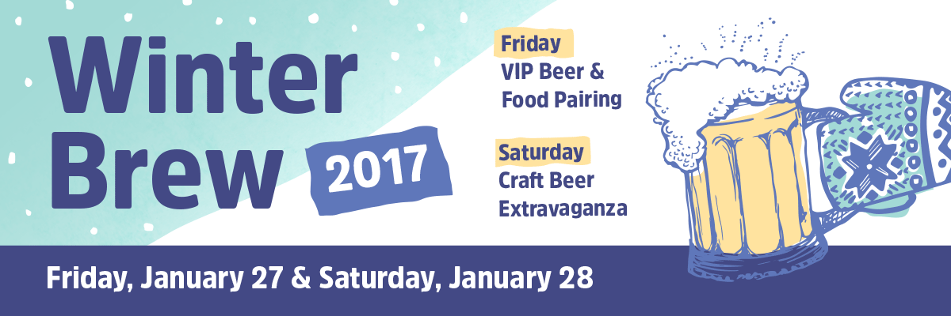
Each winter the Lincoln Square Ravenswood Chamber of Commerce takes the Chicago Street Festival scene indoors for the annual Winter Brew! The weekend starts off with a smaller, more intimate VIP experience at Architectural Artifacts where local Ravenswood restaurants pair up with local Ravenswood Breweries. Then the big event takes place on Saturday with local breweries from around Chicago who set up shop on the 5th floor ballroom and 6th floor skyline lounge of the Dank Haus German American Cultural Center. Each brewery will showcase at least two different craft beers, with some limited releases being offered. It’s sure to be an event you won’t want to miss!

Purchase tickets here: https://chirrpy.com/events/winter-brew-2017/

Tune-in to Fox32 (WFLD-TV) at 9:45 a.m., Thursday, January 26, and see Hagen & Bill talk about the Fest and all of its wonderful activities. Check the Dovetail Facebook Page for updates.

Friday - VIP Beer & Food Pairing
Date: Friday, January 27th 2017 (Ravenswood)
Time: 7pm – 10pm
Location: Artifact Events, 4325 N Ravenswood Avenue
Admission: $50.00
(includes 8 oz. tasting glass)
Beverage/Food Tickets: All Inclusive (Two beers & two food tastings at each participating brewery & restaurant)

Participating Breweries
Band of Bohemia
Begyle Brewing
Dovetail Brewery
Empirical Brewery
Metropolitan Brewing

Participating Restaurants
Band of Bohemia
Bang Bang Pie & Biscuits
Fountainhead
Wisconsin Milk Marketing Board
AND MORE TO BE ANNOUNCED SOON!

Participating Distillery
Koval Distillery

Saturday - Craft Beer Extravaganza
Date: Saturday, January 28th 2017 (Lincoln Square)
Time: 2pm – 5pm (Saturday 1st session)
7pm – 10pm (Saturday 2nd session) – Dovetail Brewery serving Rauchbier & Dunkelweizen
Location: DANK Haus, 4740 N Western Avenue
Admission: $15.00
(includes 8 oz. tasting glass & first beer)
Beverage/Food Tickets: 4-5 tickets per beer/food item ($4.00 - $5.00)

Participating Breweries
5 Rabbit Brewery
Alarmist Brewing
Aleman Brewing Company
Around the Bend Beer Co (1st session only)
Band of Bohemia
Begyle Brewing
Dovetail Brewery (2nd session only)
Empirical Brewery (2nd session only)
Half Acre Beer Company
Metropolitan Brewing
Peckish Pig
Pipeworks (1st session only)
Sketchbook Brewing Co.
Temperance Beer Co.
Ten Ninety Brewing Co.

Dovetail isn’t just dog friendly, it’s food friendly too
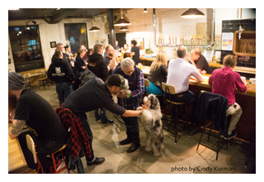
Dovetail beer is great on its own but enjoying it with traditional German food never hurt anybody! Wash down the beer with thick warm pretzels, a pair of Landjäger or Kabanos sausages, pickled egg or Lucila’s Homemade Alfajores. Made down the street from the Dovetail Taproom, these Argentinian pastries consist of a thick layer of Dulce de Leche sandwiched between two crumbly cookies and come in three flavors: Traditional, try with the Hefeweizen, White Chocolate, we think this goes best with a Lager but you can decide for yourself, and Dark Chocolate, pair with the Rauchweizen. Pro tip: order the pretzel, sausage and egg and eat them together for a delicious, traditional German breakfast!

Dovetail Brewery is helping spread the love this Valentine’s Day
Dovetail’s Valentine’s Day gift baskets are the perfect gift for longtime partners, new significant others and every type of relationship in between. Choose from thoughtfully put together baskets or create your own to add your own personal touch ($20-$30). Don’t forget your BFFs! Let your friends know how much they mean to you with A Mug Full of Kisses ($12), Dovetail’s beautiful glass stein stuffed with chocolate kisses.

About Dovetail Brewery
Dovetail Brewery, located at 1800 W. Belle Plaine in Chicago, Illinois, is a craft brewery owned by brewers Hagen Dost and Bill Wesselink, specializing in delicious, balanced beers brewed using traditional German and Belgian brewing methods. Signature beers include unfiltered German-style lagers, traditional Hefeweizen, Rauchbier and Lambic-style sour beers. Dovetail Brewery also produces a variety of special seasonal beers.

Taproom hours are: Tuesday- 2 pm - 10 pm;
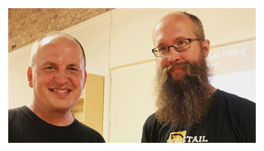
Wednesday- 2 pm - 10 pm; Thursday- 2 pm - 10 pm; Friday- 12 pm - 11 pm; Saturday- 11 am - 11 pm; Sunday- 10 am - 8 pm.

The 22,000-square foot brewing facility includes an attractive tap room that is open to the public for drinking and retail sales. The tap room is also available as a rental space for private events.

Dovetail Brewery delivers beer by the keg to venues near the brewery and also to some select venues closer to the Loop. All bars, taverns and restaurants in the greater Chicagoland area that wish to serve Dovetail beer on tap are welcome to pick up kegs, in two sizes, at the brewery during normal business hours.

For more information about Dovetail Brewery, please visit the brewery’s website at http://dovetailbrewery.com, their newsroom at http://www.newsline360.com/dovetailbrewery or contact Bill Wesselink or Hagen Dost by email. For information about special promotions and private events, contact Adrianne Dost by email. For additional information, call 773-683-1414.

Follow Dovetail Brewery on Twitter (https://twitter.com/dovetailbrewchi; @DovetailBrewChi)
Follow Dovetail Brewery on Facebook (https://www.facebook.com/DovetailBrewery/)
Follow Dovetail Brewery on Instagram (https://www.instagram.com/dovetailbrewery/)

# # #

