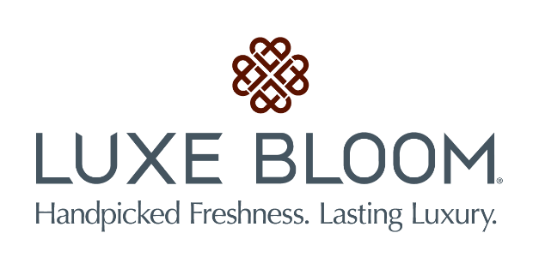

Media contact:
Kurman Communications, Inc.
Cindy Kurman or Lee Barrie
(312) 651-9000 office
(312) 543-3928 mobile
team@kurman.com

FOR IMMEDIATE RELEASE

Luxe Bloom’s® long lasting preserved rose arrangements are chosen as the
official Rose for Disney’s upcoming live-action adaptation of
“Beauty and the Beast”

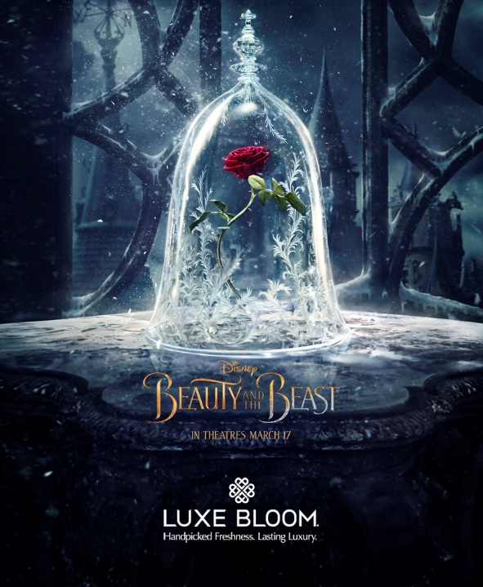
Hollywood movie musicals are once again front and center, and Chicago-based Luxe Bloom® is about to make the forthcoming live-action adaptation from Walt Disney Studios Motion Pictures®, “Beauty and the Beast,” a luxuriously magical one. Luxe Bloom is the “official flower” for “Beauty and the Beast” and will supply the film’s official Roses. These specially produced roses, which keep their vibrant beauty for at least two months without the need for water or refrigeration, will make an auspicious appearance at the film’s Hollywood premiere and play a role in Disney’s social media promotion of the film.

Premiering in March, “Beauty and the Beast” is a live-action adaptation starring Emma Watson, Dan Stevens, Luke Evans, Kevin Kline, Josh Gad, Ewan McGregor, Stanley Tucci, Audra McDonald, Gugu Mbatha-Raw with Ian McKellen and Emma Thompson.
“We contacted Luxe Bloom® to provide the roses because they offer a unique product that was a perfect fit for the film—highest quality preserved roses that are unparalleled for their beauty and luxury—and like magic, they last for months without water or maintenance. The Roses will be adored by fans young and old,” said Jan Coleman, Director Global Marketing Partnerships, “and be a very stunning enhancement to the film’s marketing campaign.”
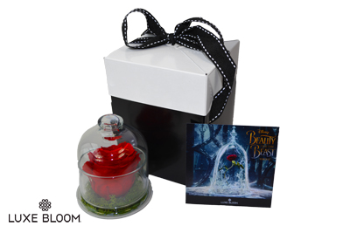
Luxe Bloom will be selling beautiful rose arrangements online in celebration of “Beauty and the Beast” at www.luxebloom.com and at amazon.com. They will offer three products; a 4.5” Glass Cloche containing one crimson rose is priced at $55; a 6”x 6” crimson Rose Box of 9 roses is priced at $149 and an 8”x8” crimson Rose Box of 16 roses is priced at $399.

At the film’s premiere, the stars of the film and other celebrities will be photographed in front of a breathtaking Rose Wall produced by Luxe Bloom® as the stunning backdrop to the premiere’s red carpet promenade of stars.

“We are changing the way people buy flowers,” said Shelley Rosen, Luxe Bloom’s founder and CEO. “We are excited beyond words that Walt Disney Studios sought us out to be part of a great love story retold.”

Luxe Bloom’s roses are real roses from Ecuador, the producer of the world’s finest roses. They are preserved using an ancient all-natural method and are available in a wide range of colors.

A growing number of luxury operators and hotels have become loyal ongoing customers of Luxe Bloom, including the St. Regis Washington, DC; St. Regis New York; Langham Hotel Chicago; Langham Place New York; Red Door Salons and Spas Nationwide and Saks Fifth Avenue.

“We work closely with our clients to deliver the experience of their brand guests deserve,” said Rosen. “Our creativity comes to play in how to execute long lasting rose displays without compromise and ship direct. Our clients save significant money because they no longer have to buy fresh flowers every few days and we’ve totally eliminated the need to water and maintain them.”

Luxe Bloom’s visibility and reputation have been growing steadily. They were named a Finalist for the Best Innovative Products Editor’s Choice Awards at the 2012 International Hotel, Motel and Restaurant Show. They have been featured on NBC’s The Today Show and on QVC. In December 2016, the Langham Place New York’s Christmas tree, created with 3,500 red, cream and dusty pink roses from Luxe Bloom, was named one of the top 12 hotel Christmas trees by Conde Nast Traveler magazine. The Better Business Bureau magazine featured Luxe Bloom in its January 2017 issue on how to build a trusted brand. Luxe Bloom also has been featured in several hospitality industry publications.

The public can purchase beautiful arrangements of Luxe Bloom roses, in a variety of sizes, styles and colors, online at luxebloom.com.

About “Beauty and the Beast” from Walt Disney Studios Motion Pictures
The story and characters audiences know and love come to spectacular life in the live-action adaptation of Disney’s animated classic “Beauty and the Beast,” a stunning, cinematic event celebrating one of the most beloved tales ever told. “Beauty and the Beast” is the fantastic journey of Belle, a bright, beautiful and independent young woman who is taken prisoner by a Beast in his castle. Despite her fears, she befriends the castle’s enchanted staff and learns to look beyond the Beast’s hideous exterior and realize the kind heart of the true Prince within. The film stars: Emma Watson as Belle; Dan Stevens as the Beast; Luke Evans as Gaston, the handsome, but shallow villager who woos Belle; Kevin Kline as Maurice, Belle’s father; Josh Gad as LeFou, Gaston’s long-suffering aide-de-camp; Ewan McGregor as Lumière, the candelabra; Stanley Tucci as Maestro Cadenza, the harpsichord; Audra McDonald as Madame de Garderobe, the wardrobe; Gugu Mbatha-Raw as Plumette, the feather duster; Hattie Morahan as the enchantress; and Nathan Mack as Chip, the teacup; with Ian McKellen as Cogsworth, the mantel clock; and Emma Thompson as the teapot, Mrs. Potts.
Directed by Bill Condon based on the 1991 animated film, “Beauty and the Beast,” the screenplay is written by Stephen Chbosky and Evan Spiliotopoulos and produced by Mandeville Films’ David Hoberman, p.g.a. and Todd Lieberman, p.g.a. with Jeffrey Silver, Thomas Schumacher and Don Hahn serving as executive producers. Alan Menken, who won two Academy Awards® (Best Original Score and Best Song) for the animated film, provides the score, which includes new recordings of the original songs written by Menken and Howard Ashman, as well as three new songs written by Menken and Tim Rice. “Beauty and the Beast” will be released in U.S. theaters on March 17, 2017.
About Luxe Bloom
Based in Chicago, Illinois, Luxe Bloom, LLC was founded in early 2013 by former Fortune 50 executive Shelley Rosen. Luxe Bloom offers real, long-lasting rose arrangements to luxury business operators and consumers on a monthly recurring basis. Luxe Bloom roses are 100% ethically sourced from Ecuador, producer of the world’s finest roses.

View the whole collection at http://www.luxebloom.com. Follow Luxe Bloom news at http://www.newsline360.com/luxebloom, Like Luxe Bloom on Facebook, Follow us on Twitter at @Luxebloomroses and on Instagram at luxebloomroses. @PROECUADORCHICAGO

# # #

