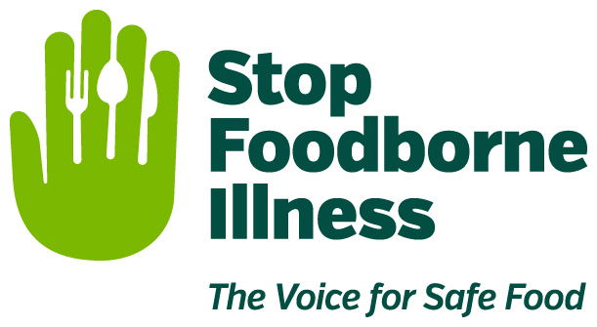

Media Contact:
Kurman Communications, Inc.
Cindy Kurman, Lee Barrie or Elisa Rascia
(312) 651-9000
team@kurman.com

FOR IMMEDIATE RELEASE

Eating Safely While Eating Healthy

Every couple of months we hear about another popular health trend online. As scientists and doctors announce more and more benefits of healthy, clean eating, more and more people strive to make better choices when it comes to their diet.

While eating healthy is a good thing, some assumptions about healthy eating can lead to danger. STOP Foodborne Illness, a national nonprofit, public health organization dedicated to preventing illness and death from foodborne pathogens, supports healthy eating but wants to ensure healthy eating habits do not compromise safe eating habits. To help keep people safe from foodborne pathogens, STOP has provided a list of some things to keep in mind when shopping for and consuming healthy branded food and beverages.

Raw and Unpasteurized Milk
Milk that has not been pasteurized is considered “raw” and some will tell you it contains beneficial bacteria, enzymes and natural vitamins otherwise killed off by the high heat of the pasteurization process. However, raw milk may also contain bad bacteria that can transmit serious infectious diseases, such as E. Coli O157:H7. Everyone, especially children, mature adults, pregnant mothers and people with compromised immune systems, should always drink pasteurized milk. Read more raw milk myths.

Organic Food
Organic food is becoming increasingly popular due to many factors such as being healthier and better for the environment. Organic produce does not contain harmful, synthetic pesticides or other chemicals and organically raised animals are not given antibiotics, growth hormones, or fed animal byproducts.

As a result of these benefits, organic food is also often assumed to be safe as is. This assumption is false; like conventionally-grown food, organic food is grown outside, in dirt, and fertilized by manure and water—all of which may contain harmful bacteria. Contamination may also occur after it’s harvested, during delivery, preparation or storage. Before you eat, cut or cook your veggies and fruits, wash them thoroughly under running water.

Home Gardening
Knowing and controlling what goes into your mouth is just one of the many benefits of growing your own vegetables, herbs and fruits. Yet, it is still important for those with a green thumb to practice food safety, as home grown produce is susceptible to pathogens carrying foodborne illnesses. Wash produce after harvesting and wash your hands before and after handling your garden’s fresh bounty. More on food safety in your home garden.

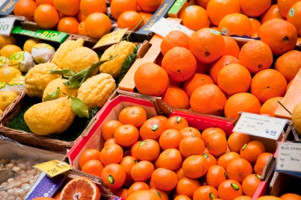
Juicing
Cold-pressed juice is another popular health practice climbing the ranks of popularity. “Cold-pressed juice doesn’t use heat and has significantly more vitamins and enzymes,” says Aly Shoom, Chief Nutritionist of Smash Juice Bar. As a result of the lack of pasteurization, there are claims that the cold-pressed process preserves valuable enzymes and vitamins for up to three days.

While there is little to no evidence that shows whether or not cold-pressing juice has a significant impact on nutrients overall, or whether it's healthier than regular cold juice, one thing is certain: since cold-pressed juice is unpasteurized, consumers can potentially develop a foodborne illness. Just like raw milk or unwashed produce, unpasteurized and cold-pressed juice can carry harmful pathogens and dangerous bacteria. Two simple steps to juice safety.

About STOP Foodborne Illness
STOP Foodborne Illness is a national nonprofit, public health organization dedicated to preventing illness and death from foodborne pathogens by advocating for sound public policies, building public awareness and assisting those impacted by foodborne illness. For more food safety tips please visit http://www.stopfoodborneillness.org/awareness/. If you think you have been sickened from food, contact your local health professional. You may subscribe to receive STOP Foodborne Illness e-Alerts and eNews here: http://www.stopfoodborneillness.org/take-action/sign-up-for-e-alerts/.

For questions and personal assistance, please contact Stanley Rutledge, Community Coordinator, at srutledge@stopfoodborneillness.org or 773-269-6555 x7.
# # #

