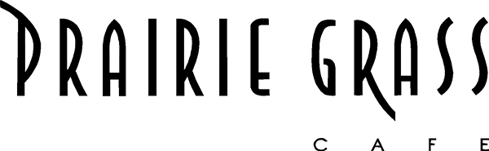

Media Contact:
Kurman Communications, Inc.
Cindy Kurman or Elisa Rascia
team@kurman.com
312-651-9000

Enjoy a Delicious Easter Brunch Buffet at Prairie Grass Cafe

Celebrate a delicious Easter Sunday with family and friends at Prairie Grass Cafe (601 Skokie Blvd, Northbrook, IL 60062; 847-205-4433). Easter Brunch will be served buffet style from 10 a.m. to 2 p.m., April 16. The price is $49.50 for adults and $18 for children 10 and under. View the full Easter Brunch menu here. Reservations are strongly recommended.

Each guest starts with the restaurant’s signature “PGC Benedict” featuring a perfectly poached egg on top of spinach and served with a roasted tomato Hollandaise sauce.

The buffet has many different stations to satisfy all cravings from savory to sweet. Additionally, meat is making a couple grand appearances on the menu. Carnivores, dig into slices of carved-to-order Bone-In Glazed Ham, Ancho Marinated Skirt Steak, Applewood, Braised Pulled Chicken Chiliquilles, Applewood Smoked Maple Creek Farm Bacon, Ancho Breakfast Sausage or Prairie Grass Cafe’s Signature Moussaka—alternating layers of eggplant, potato and braised lamb topped with Béchamel sauce.

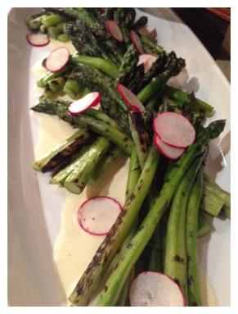
Fish options include Crab Cakes with Ancho-Sriracha-Honey mayo and Sliced Seared Ahi Tuna with spicy lime vinaigrette, avocado, jicama, cucumber and orange.

Vegetable lovers and vegetarians, you’re in luck! The buffet will have a variety of delicious and meatless dishes like salads, grilled vegetables, Roasted Carrots with pistachios in a honey yogurt sauce and more.

Easter Buffet at Prairie Grass Cafe wouldn’t be complete without the “made to order” stations: a Hot Fresh Waffle Station with Maple Syrup for young kids and grown up kids and an Omelet Station with a variety of fixings including homemade crumbled Maple Creek Farm chorizo, poblano peppers, spring onions, tomato, jack cheese, cheddar cheese, mushrooms and spinach.

For those with a sweet tooth, there will be more than enough mouth-watering sweets at the Dessert Buffet to satisfy your craving. Enjoy fresh fruit and berries, Double Chocolate Cup Cakes, Carrot Cakes Muffins with Cream Cheese, Mom’s Lemon Chiffon Pie and Warm Cherry Crumble with Toasted Oat Topping. Or, order a crepe at the Crepe Station where toppings include chocolate and regular whipped cream, raspberry jam and powdered sugar.

About Prairie Grass Cafe
Prairie Grass Cafe (601 Skokie Blvd.; Northbrook, IL; 847-205-4433) supports Chicago’s Green City Market and local sustainable farms, selecting the freshest ingredients to reflect the season. Prairie Grass Cafe currently serves lunch Monday - Friday 11 a.m. to 2 p.m. and dinner Monday through Sunday. Dinner is served Tuesday - Thursday from 5 p.m. to 9:30 p.m., Friday and Saturday from 5 p.m. to 10:30 p.m., and Monday and Sunday 5 p.m. to 9 p.m. Prairie Grass Cafe also serves breakfast Saturdays 10 a.m. to 2 p.m. and Sundays 9:30 a.m. to 2 p.m. Light fare is available in the bar Monday through Friday
2 p.m. to 5 p.m. For more information or to make a reservation, please call (847) 205-4433 or visit prairiegrasscafe.com. Follow Prairie Grass Cafe news at newsline360.com/prairiegrasscafe and on Facebook at Facebook.com/PrairieGrassCafe.

# # #

