Media Contact:
Kurman Communications, Inc.
Cindy Kurman or Lee Barrie
(312) 651-9000
kurmanstaff@kurman.com

FOR IMMEDIATE RELEASE

Dovetail Brewery and Artisanal Imports Announce Sales Partnership

Dovetail Brewery (1800 W. Belle Plaine, Chicago; www.dovetailbrewery.com) has established a sales partnership with Artisanal Imports (www.artisanalimports.com), a highly-respected importer of the most highly acclaimed, internationally award-winning beverages from around the world. Artisanal Imports is based in Austin, Texas.

Currently, Dovetail beer is sold in the brewery’s tap room and sold wholesale by the keg to bars and restaurants near the brewery, located in what has become known as Chicago’s Ravenswood Brewery Corridor. Dovetail will continue to self-distribute in Chicago. The new sales initiative, which begins in April 2017, enables the brewery to expand its presence in the greater Chicagoland area and later, into other regional and national markets.

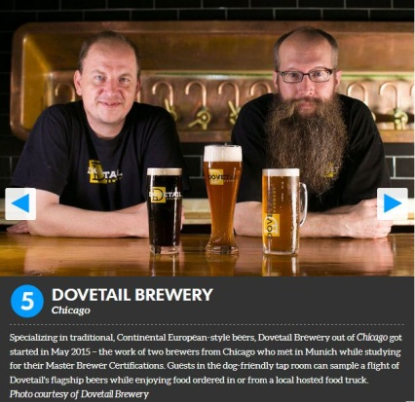
Dovetail has already built an impressive national reputation for its expert brews. Beer Advocate named the brewery one of the 34 Best New Breweries—out of 861—that opened in the United States in 2016. In March, Dovetail was voted one of the Top Five Best New Breweries in the United States in USA TODAY 10Best’s “Best New Brewery” contest.

“We got into this business to make great beer and we’ve had some very nice initial success. At this point, we feel it’s time to bring on a dedicated sales force to let us focus on what we do best,” said Hagen Dost, owner/brewer.

Once Dost and owner/brewer Bill Wesselink decided it was time to bring on a sales team, choosing to partner with Artisanal Imports was a no brainer—a friendship between the two companies had already been brewing. “Adam and Seth (local sales representatives for Artisanal Imports) have been regulars in the taproom since we opened,” said Dost, “and because they’re well-respected in the industry, we like them as people, and they like what we do, we decided to explore a relationship with them.”

Similarly, Artisanal Imports felt Dovetail Brewery was a natural addition to their beer family. In the past couple of years, the company expanded their portfolio to include several established German and Bavarian breweries, so incorporating a domestic producer that represented those traditional styles very well was a no brainer. “We love to bring new beverage experiences to the market and just like some of our import brands we feel the Dovetail beers have a place in the market and deserve to be enjoyed,” said Sean Knoll, Vice President of Sales at Artisanal Imports. “What is impressive about the Dovetail beers is that they exhibit a depth of flavor and nuance that generally take years and years, or even generations to refine, yet they have been able to accomplish that level of complexity in a relatively short period.” In addition to sharing a similar taste in beers, “we share [Dovetail’s] vision of pragmatic and responsible growth,” said Knoll.

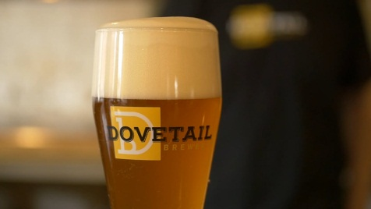
While the company is already receiving inquiries about Dovetail beer from all corners of the country, Artisanal Imports is focusing on responsible expansion into regional markets to ensure they are doing what is best for the quality and consistency of the beer. The immediate goal is to build the brand locally and expand out as production allows. In the near-term they will focus heavily on sales in Chicago to maintain a realistic distribution area. The Chicago suburbs will follow and then a select few metropolitan areas in the nearby region.

About Dovetail Brewery
Dovetail Brewery, located at 1800 W. Belle Plaine in Chicago, Illinois, is a craft brewery owned by master brewers Hagen Dost and Bill Wesselink, specializing in delicious, balanced beers brewed using traditional German and Belgian brewing methods. Signature beers include unfiltered German-style lagers, traditional Hefeweizen, Rauchbier and Lambic-style sour beers. Dovetail Brewery also produces a variety of special seasonal beers.

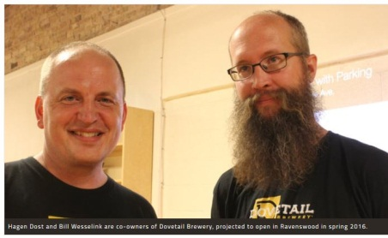
Taproom hours are: Tuesday- 2 pm - 10 pm; Wednesday- 2 pm - 10 pm; Thursday- 2 pm - 10 pm; Friday- 12 pm - 11 pm; Saturday- 11 am - 11 pm; Sunday- 10 am - 8 pm.

The 22,000-square foot brewing facility includes an attractive tap room that is open to the public for drinking and retail sales. The tap room is also available as a rental space for private events.

Dovetail Brewery delivers beer by the keg to venues near the brewery and also to some select venues closer to the Loop. All bars, taverns and restaurants in the greater Chicagoland area that wish to serve Dovetail beer on tap are welcome to pick up kegs, in two sizes, at the brewery during normal business hours.

See what passionate beer lovers and industry professionals are saying about Dovetail: https://www.newsline360.com/dovetailbrewery/itn/.

For more information about Dovetail Brewery, please visit the brewery’s website at http://dovetailbrewery.com, their newsroom at http://www.newsline360.com/dovetailbrewery or contact Bill Wesselink or Hagen Dost by email. For information about promotions and private events, please contact Adrianne Dost. For additional information, call 773-683-1414.

Follow Dovetail Brewery on Twitter (https://twitter.com/dovetailbrewchi; @DovetailBrewChi)
Follow Dovetail Brewery on Facebook (https://www.facebook.com/DovetailBrewery/)
Follow Dovetail Brewery on Instagram (https://www.instagram.com/dovetailbrewery/)

About Artisanal Imports
Artisanal Imports was founded in 2001 as an importer of specialty crafted beverages from around the world. The Artisanal Imports’ focus is on brand development and specialty beverage marketing. Artisanal sells its world-class portfolio of products in 47 States. The goal of Artisanal Imports is to diligently work in partnership with their suppliers and distributors to develop its brands in the best possible way to maximize growth and establish long-term brand equity. The Artisanal Imports sales team provides direct distributor management as well as critical direct market contact and sales support. The Artisanal Imports sales staff consists of a diverse group of knowledgeable and respected sales representatives that are key assets in building brands locally and regionally through direct market activities in the distribution and retail channels. Artisanal Imports portfolio of products represents some of the most highly acclaimed, internationally award-winning beverages from around the world. It is our company mission to seek out the best and most interesting products from around the world and to provide unique beverage experiences to the US market. The Artisanal ownership group has been pioneers in the specialty import business for 40+ years and is committed to continuing that quest.

# # #

