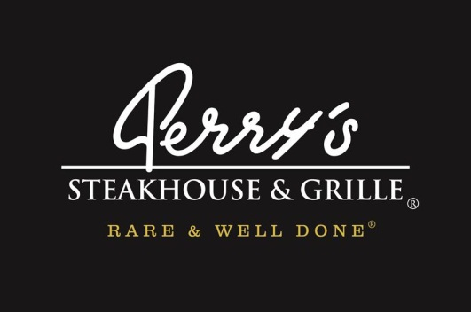

Media Contact:
Kurman Communications, Inc.
Cindy Kurman or Elisa Rascia
(312) 651-9000
team@kurman.com

FOR IMMEDIATE RELEASE

TGIF. Savor a Delicious Friday Lunch at Perry’s Steakhouse & Grille in Oak Brook

Start the weekend right with an indulgent lunch at Perry’s Steakhouse & Grille (5 Oakbrook Court, Oak Brook, IL 60523; 630-571-1808). Perry’s serves lunch only on Fridays, and it has become a highlight of the week for many food lovers and business leaders in Chicago’s western suburbs. Lunch at Perry’s is perfect for client lunch meetings, celebratory end of work week dining, pick me up meals and everything in between.

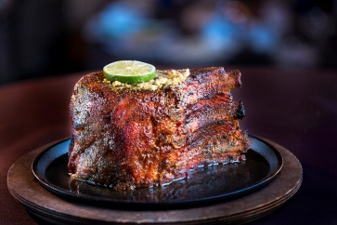
Perry’s two lunch specialty items are exceptional and have customers returning often for these lunchtime treats. The first show stopper is a Lunch-Cut portion of Perry’s Famous Pork Chop ($14.95). A mouth-watering prime chop sourced from choice Midwestern farms and butchered in house from the pork loin. Once cut, it’s rubbed with proprietary seasoning, cured and roasted on a rotisserie with pecan wood for up to six hours until it is sweet, smoky and sizzling. Upon order, the chop is glazed, caramelized, topped with Perry’s signature herb-garlic butter and served with whipped potatoes and homemade applesauce. It’s a 5-star dinner entrée that’s a real deal at lunch.

The second crowd pleaser is the Butcher’s Blend Burger ($13.95), a succulent patty of mixed brisket, chuck and short rib and served with lettuce, tomato, onion and pickles on a toasted bun. For a side, choose between French Fries or sweet potato fries; the side is included in the price.
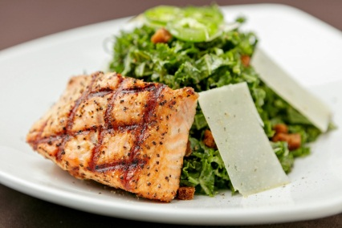
Lighter meals include the Wedge Salad ($8.95), Spinach & Warm Bacon Vinaigrette Salad ($9.95), Caesar Salad ($8.95), Butcher’s Chop Salad with Perry’s famous homemade Italian dressing ($9.95), Kale Salad with Jalapeño Mint Vinaigrette ($9.95) and the Field Green, Pear & Candied Pecan Salad ($9.95). Additionally, Chicken, Shrimp, Grilled Salmon or Beef Tenderloin can be added to any salad ($4.95-$7.95).

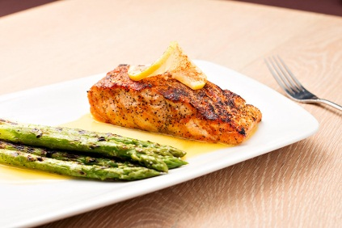
Other delicious dinner favorites making a lunch sized appearance include: Grilled Salmon served with grilled asparagus and beurre fondue ($19.95), a 6 oz. Filet Mignon ($29.95), a 10 oz. Prime Hawaiian Ribeye ($32.95), Chef’s Chicken & Roasted Carrots served with Moroccan spiced yogurt sauce ($14.95), and Steakhouse Pasta, a savory tomato basil pasta with grilled beef tenderloin ($16.95).

The full Perry’s dinner menu also is available at Friday lunch.
Perry’s Friday lunch special is served from 11am to 4pm every Friday. Even though Perry’s is closed Mon-Thurs at lunch, the restaurant is available to host private event luncheons during the week.
To make reservations call (630) 571-1808.

About Perry’s Steakhouse & Grille
Perry¹s Steakhouse & Grille has earned a faithful following by perfecting prime since 1979. Beginning as a small butcher shop, Perry¹s has grown into a renowned group of award-winning restaurants featuring USDA Prime beef, tableside carvings, signature selections, flaming desserts and handcrafted cocktails at its Bar 79. Specializing in a Rare and Well Done experience, Perry¹s currently operates 13 steakhouse locations in Birmingham, Chicago, Denver, and across Texas, as well as the two original butcher shops now known as Perry & Sons Market & Grille. A new Perry¹s Steakhouse will be opening in Grapevine, Texas late 2017. For more information and updates on Perry¹s Steakhouse, please visit www.PerrysSteakhouse.com.

# # #

