Kidneys Quest Foundation’s Founders
Honorably Presenting

“Fight 4 Life” On Father’s Day, Sunday, June 18, 2017.
About our Pioneers of Kickboxing & Boxing
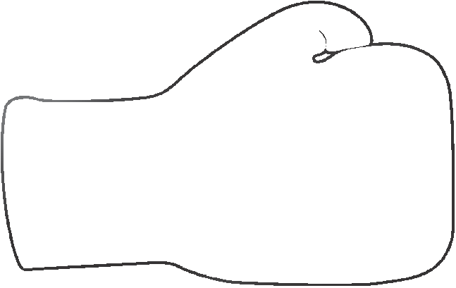
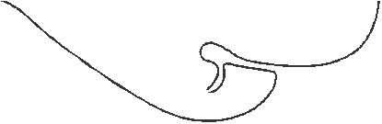
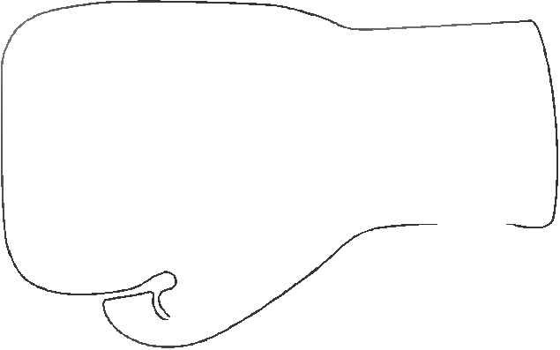
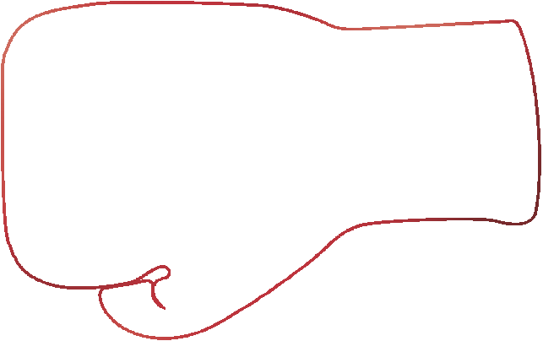
Arnold Urquidez Mr. Urquidez is recognized throughout the world as one of the founders of American martial arts. He has been inducted into the Martial Arts Museum, the Martial Arts Hall of Fame, and is known for managing and training many world champions in kick boxing and boxing. Mr. Urquidez remains known in the boxing and martial arts world for a lifetime of achievements, including writing the first set of kick boxing rules in the United States (adopted by the State of California), training the first kick boxing coaches in the United States, founding the Kenpo-Shotokan style of karate (the first American martial arts style), and for being among the first promoters of foreign boxing and kick boxing fighters in Japan. Mr. Urquidez is a recognized seventh-degree black belt and martial arts Grand Master in Japan and the United States.
Benny Urquidez
Benny “The Jet” Urquidez has made immense contributions to martial arts. As a young man, Urquidez was a pioneer and 12 time world champion in full-contact kickboxing. His fights carried the sport across the globe and into the spotlight. Today the Ukidokan karate system he founded is taught in schools throughout the country.

Lily Urquidez Rodriguez
Lilly Urquidez Rodriguez, a pioneering female, world kickboxing champion, boxing champion, and martial arts champion. Also, who helped establish kickboxing as a sport for women. She is one of the 1st female boxers in the California Boxing Hall of Fame and earned her a place in the Martial Arts History Museum's Hall of Fame in 2003. She was the 1st women to fight at the Madison Square Garden in New York, Los Angeles Forum, Tokyo Arena, and Vancouver Arena to mention a few. She rose to prominence in the late 1970’s era, made it acceptable for women to try their hands at fighting. She set the standard and became a top fighter and world champion when it was mainly for men. "Lilly was just a tremendous person, a great fighter and an amazing trainer."

Proceeds from the “FIGHT 4 LIFE” event with go towards the Emergency
Backpack Program. Kidneys Quest Foundation is an outreach organization
dedicated to the families and individuals with Kidney Disorders, and those in need of kidney transplants. Kidneys Quest Foundation (KQF) has been helping, supporting, and educating patients and donors since 2007. The KQF outreach started in the San Fernando Valley, and spread throughout the US.

Kidneys Quest Foundation Inc. (KQF) is a 501 (c)(3) nonprofit organization. All donations to KQF are tax deductible.

Location: Marriott Burbank
2500 N. Hollywood Way
Burbank, Ca 91505
Doors open at 1pm
Fights commence at 3pm
General Admission - $20.00
Preferred Seating - $25.00

Tickets available for purchase online at:
www.kidneysquestfoundation.org
or you can call (818) 521-6348

For Media Inquiries & Sponsorship opportunities email kqfoundation@gmail.com

