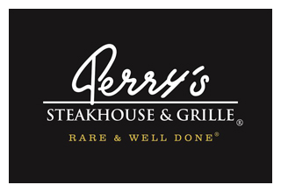

Media Contact:
Kurman Communications, Inc.
Cindy Kurman or Elisa Rascia
(312) 651-9000
kurmanstaff@kurman.com

FOR IMMEDIATE RELEASE

Dine Deliciously, Dine Alfresco at Perry’s Steakhouse & Grille in Oak Brook
New Outdoor Patio Now Open

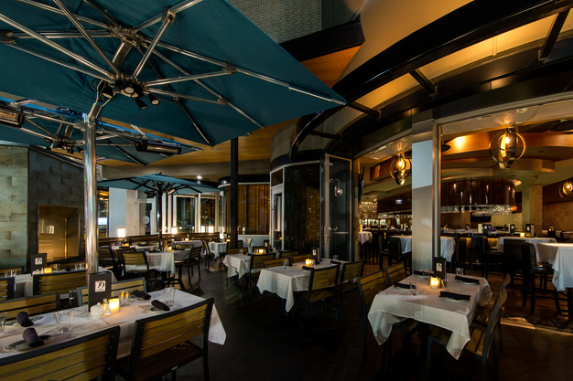
After a long winter there is nothing Chicagoans love more than outdoor dining and Perry’s Steakhouse & Grille’s Bar 79 (5 Oakbrook Court, Oak Brook, IL 60523; 630-571-1808) is giving the people what they want—a new fantastic outdoor patio to enjoy this summer.

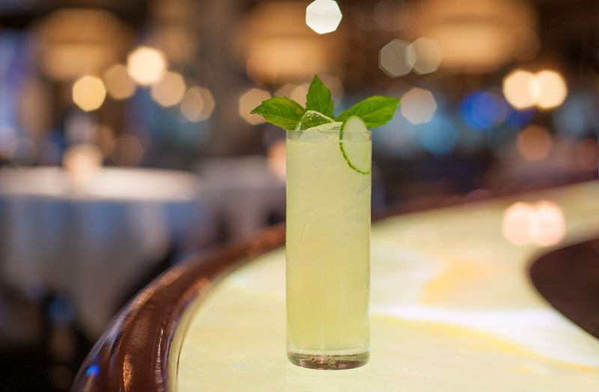
The patio is the perfect place to enjoy a mouthwatering meal, refreshing drinks and the warm summer breeze. To celebrate the patio’s expansion, Perry’s is launching a new drink—the Key Gin Gimlet. Expertly crafted with Chicago’s own CH Key Gin, lime juice and freshly muddled basil and cucumber, this cocktail is cool, crisp and invigorating. Enjoy the Key Gin Gimlet for only $9 from May 15 to June 15.

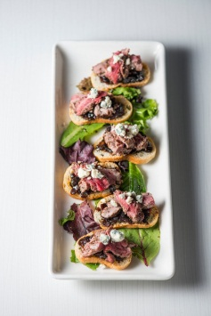
The patio’s extensive Bar Bites menu is an elegant extension of Perry’s Bar 79 and features a sampling of indulgent appetizers and bar specialties. The menu features an array of delicious food including Asian Ahi Tuna Tartare, Prime Beef Carpaccio, Iced Seafood Tower with Lobster Cocktail, Shrimp Cocktail, Blue Crab Cocktail, and Blue Point Oysters on the Half Shell; Crab Cakes, Cherry Pepper Calamari, Escargot, Tempura Fried Lobster, Beef and Blue; Bacon Wrapped Scallops, Butcher’s Blend Burger - Brisket, Chuck & Short rib, served with your choice of French fries or sweet potato fries, and of course, Perry’s Famous Pork Chop “Bites”, among other items.

Perry’s sweetens the deal by offering an additional menu during Social Hour, 4-7 p.m. Monday – Friday. Treat yourself to one—or a few—of the $9 Bar Bites specials including Perry’s Famous Pork Chop ‘Bites’; Beef & Bleu, sliced beef filet with bleu cheese and bacon marmalade on a toasted French baguette; Escargot; Cherry Pepper Calamari; Sliders 79, beef tenderloin sliders served with onion strings or the Steakhouse Pizza topped with chopped beef tenderloin.

Those who want a full Perry’s dinner will be pleased to know that Perry’s regular dining menu also is available on the patio. View the menu here. With a famously delicious menu and exciting new drink special, Perry’s is the perfect place for winding down from the work day or winding up for a night out all summer long.

Reservations may be made online or by calling 630-571-1808.

About Perry’s Steakhouse & Grille
Perry’s Steakhouse & Grille has earned a faithful following by perfecting prime since 1979. Beginning as a small butcher shop, Perry’s has grown into a renowned group of award-winning restaurants featuring USDA Prime beef, tableside carvings, signature selections, flaming desserts and handcrafted cocktails at its Bar 79. Specializing in a Rare and Well Done experience, Perry’s currently operates 13 steakhouse locations in Chicago, Birmingham, Denver, and across Texas, as well as the two original butcher shops now known as Perry & Sons Market & Grille. A new Perry’s Steakhouse will be opening in Grapevine, Texas late 2017. For more information and updates on Perry’s Steakhouse, please visit www.PerrysSteakhouse.com.

Facebook (Facebook.com/PerrysDining), Twitter (@PerrysDining) and Instagram (@PerrysSteakhouse)
###

