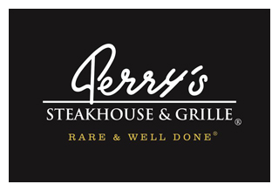

Media Contact:
Kurman Communications, Inc.
Cindy Kurman or Elisa Rascia
(312) 651-9000
kurmanstaff@kurman.com

FOR IMMEDIATE RELEASE

Toast to National Chardonnay Day at Perry’s Steakhouse & Grille in Oak Brook

Friday, May 26 is National Chardonnay Day and Perry’s Steakhouse & Grille (5 Oakbrook Court, Oak Brook, IL 60523; 630-571-1808) is celebrating in style. On this day only, Perry’s is offering half-price bottles of their Private Label Chardonnay for $28 (regularly $56) with the purchase of two lunch or dinner entrées.
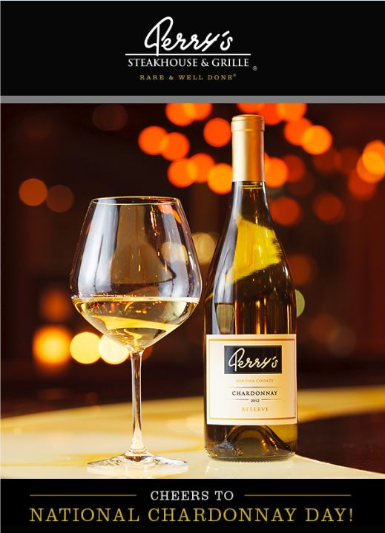
Aged in French oak barrels, the restaurant’s Private Label Chardonnay features luscious notes of pear, green apple, and vanilla with a long elegant finish, making it a patron favorite and versatile accompaniment to Perry’s dining menu.

For appetizers and sides, pair it with Perry’s Signature Fried Asparagus topped with jumbo lump crabmeat ($16.95).

As far as entrées go, Perry’s Private Label Chardonnay pairs well with nearly the entire menu. Complement a bottle with the Chef's Chicken & Roasted Carrots served with Moroccan spiced yogurt sauce ($25.95); Perry’s Famous Pork Chop ($37.95); or any of the many seafood dishes: Steamed Lobster Tail ($47.95); Grilled Salmon with grilled asparagus and beurre fondue ($34.95); Sushi-Grade Sesame Crusted Ahi-Tuna with red chili lime miso butter and sushi rice ($39.95); Hong Kong Style Sea Bass with teriyaki glazed julienne vegetables and sushi rice ($39.95); or the Fried Shrimp served with French fries or sweet potato fries ($26.95).

Be sure to leave room for Perry’s mouthwatering desserts, including the Signature Flaming Desserts, each $10: Bananas Foster, sliced bananas flambéed with brown sugar, rum, cinnamon and nutmeg, and served over vanilla ice cream; Mont Blanc a la Frisc, vanilla ice cream served on a homemade sponge cake with freshly cut strawberries, topped with a flambéed Belgian white chocolate sauce and Bailey’s Irish Cream; or the Nutty D’angelo, crushed pecans flambéed with brown sugar and brandy, served over vanilla ice cream, dipped in white chocolate and toasted almonds.

Kick off the weekend on a high note. Bring a friend, or the whole crew, and raise a glass to National Chardonnay Day.

About Perry’s Steakhouse & Grille
Perry’s Steakhouse & Grille has earned a faithful following by perfecting prime since 1979. Beginning as a small butcher shop, Perry’s has grown into a renowned group of award-winning restaurants featuring USDA Prime beef, tableside carvings, signature selections, flaming desserts and handcrafted cocktails at its Bar 79. Specializing in a Rare and Well Done experience, Perry’s currently operates 13 steakhouse locations in Chicago, Birmingham, Denver, and across Texas, as well as the two original butcher shops now known as Perry & Sons Market & Grille. A new Perry’s Steakhouse will be opening in Grapevine, Texas late 2017. For more information and updates on Perry’s Steakhouse, please visit www.PerrysSteakhouse.com.

Follow Perry’s news on Facebook (Facebook.com/PerrysDining), Twitter (@PerrysDining) and Instagram (@PerrysSteakhouse).
# # #

