Africa’s First Ethiopian B-787-9 Made Its Debut Flight to the Roof of Africa
October 31, 2017
Ethiopian Airlines Group is pleased to announce that its new B-787-9 aircraft has made its maiden commercial flight to Kilimanjaro, Tanzania.
Ethiopian operation with B-787-9 is part of its commitment to deliver exceptional level of service to the African market by operating the latest technologically advanced aircraft in the market.
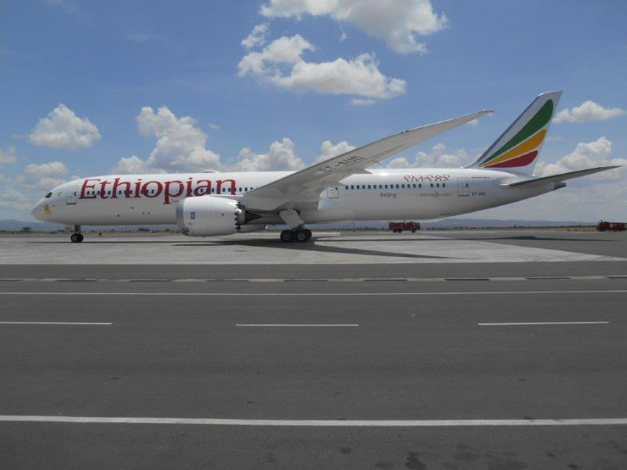
Africa’s first B-787 at Kilimanjaro International Airport
Passengers have enjoyed the unique onboard features of this latest technology aircraft such as on-board comfort thanks to their unique features such as the biggest windows in the sky, high ceiling, less noise, distinctive lighting, and higher air humidity.
The flight is part of its tour of stations in the Ethiopian global network. Kilimanjaro is a major tourist destination with huge economic significance for Tanzania and part of Ethiopian’s extensive network in Africa. Ethiopian currently operates 28 weekly flights to Tanzania; daily to Kilimanjaro and Zanzibar and twice daily to Dar es Salaam, further connecting the cities to stations in Asia, the Middle East, Europe, and the US via its main hub in Addis Ababa.
About Ethiopian
Ethiopian Airlines (Ethiopian) is the fastest growing Airline in Africa. In its seventy plus years of operation, Ethiopian has become one of the continent’s leading carriers, unrivalled in efficiency and operational success.
Ethiopian commands the lion’s share of the pan-African passenger and cargo network operating the youngest and most modern fleet to more than 100 international passenger and cargo destinations across five continents. Ethiopian fleet includes ultra-modern and environmentally friendly aircraft such as Airbus A350, Boeing 787, Boeing 777-300ER, Boeing 777-200LR, Boeing 777-200 Freighter, Bombardier Q-400 double cabin with an average fleet age of five years. In fact, Ethiopian is the first airline in Africa to own and operate these aircraft.
Ethiopian is currently implementing a 15-year strategic plan called Vision 2025 that will see it become the leading aviation group in Africa with seven business centers: Ethiopian Express & Ancillary Services; Ethiopian International Services; Ethiopian Cargo & Logistics Services; Ethiopian MRO Services; Ethiopian Aviation Academy; ET In-flight Catering; and Ethiopian Ground Services. Ethiopian is a multi-award winning airline registering an average growth of 25% in the past seven years.
For more information about this press release, please contact etuspr@gmail.com or:
Mrs. Hanna Atnafu
Manager Corporate Communications, Ethiopian Airlines
Tel :( 251-1)517-89-07/656/165/913/529
CorporateCommunication@ethiopianairlines.com
www.ethiopianairlines.com
www.facebook.com/ethiopianairlines
www.twitter.com/flyethiopian

