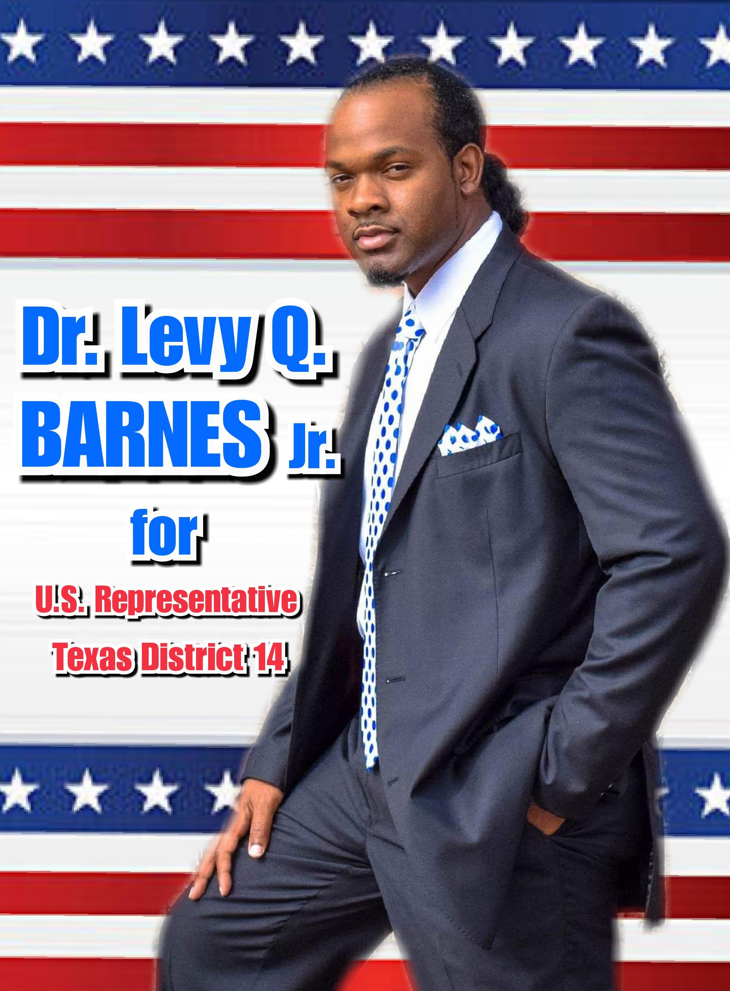

For Immediate Release
Dr. Levy Q. Barnes, Jr. Is running for US Congress
On Wednesday, November 15, 2017 at 12:00p.m., in front of the Jefferson County Beaumont Courthouse steps, Dr. Levy Q. Barnes Jr. will be announcing his candidacy for US Congress in District 14 covering Jefferson, Brazoria, &Galveston. He is a resident of Port Arthur, TX in Jefferson county, and he believes that as a US Representative he can be a major factor to allow this country to rise above the array of obstacles that it faces. His intentions are to take the spot of the incumbent Randy Weber so that our country can focus on the efforts of new business development, better wages for labor workers, intervention for struggling educational institutions, equal rights and civil liberties for minorities and women, the right medical coverage for Americans, our military and veterans, reuniting our divided country, aiding in mental illness & drug prevention, unemployment and underemployment, economic development, and our ecosystem. Dr. Barnes will be the 1st African American and minority to be the US Representative of the Congressional 14th District of Texas. He believes that “ We Shall Rise Together.”
As a businessman, he has worked with hundreds of small and large business owners and understands the issues they face. He is the inventor of Q. Hair Regrowth Spray which is used for people who suffer with hair loss and works with an array of companies on a daily basis. He started his own company without any help and grew it himself. Yet, he understands the needs of labor workers because while he was in college, he was a worker and had the same frustration of low wages like other Americans have. As a preacher, his life has been dedicated to working with seniors and low-income families. He is a humanitarian. As an educator and author, he understands the issues our youth face. He taught Biology and Chemistry to high school students and mentored them. He has worked with the fatherless and started programs to equip them for professional lives. He has worked as a Peace & Civil Rights Activist and has worked with other leaders to host gun buy back events. As a recording artist, he has also held peace concerts with other award-winning artists. His father and both grandfathers are veterans and he honors the military and its veterans. He understands the need for a strong military. Yet, his biggest accomplishment is his family. He is a devoted husband and father of two sons. He knows that the strongest American organization is the family.
Dr. Levy Q Barnes Jr. is a representative that will not just go with the agenda of a political party, but he will also properly represent those whom he serves. He has the experience of being a businessman, educator, inventor, humanitarian, peace &equal rights activist, preacher, husband, and father to properly vote on and propose legislation that will benefit Americans and allow this country to rise. He has worked with people of many walks and with this experience he will guide this country with the help of other legislators to a higher greatness. He will fight for education, equal rights, health, healthcare, our military, veterans, seniors, laborers, and businesses together so that they shall rise.
To schedule an interview call
504-810-7141 or email barnesforcongress2018@gmail.com

