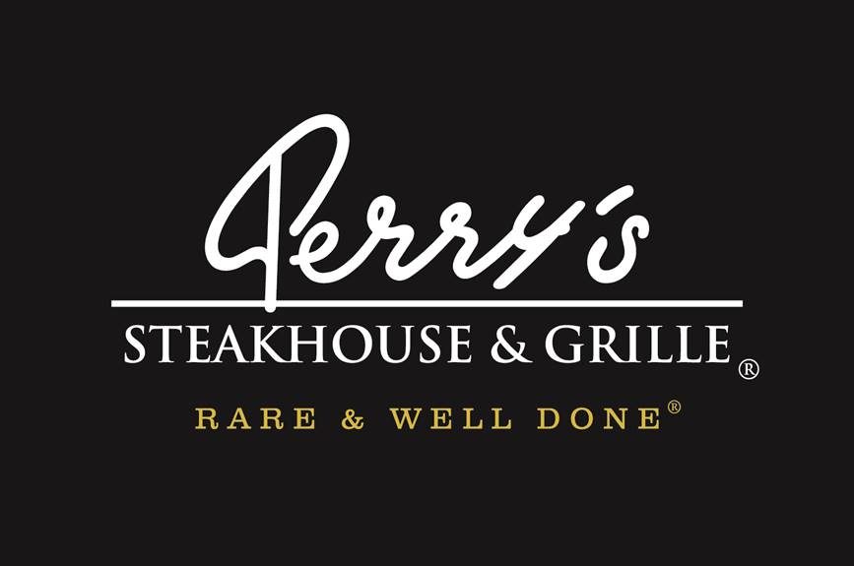
Media Contact:
Kurman Communications, Inc.
Cindy Kurman or Lee Barrie
(312) 651-9000
kurmanstaff@kurman.com

FOR IMMEDIATE RELEASE

Treat Mom to a Delicious Mother’s Day Meal All Day
at Perry’s Steakhouse & Grille in Oak Brook
Opening at 11 a.m. on Mother’s Day, May 13, 2018
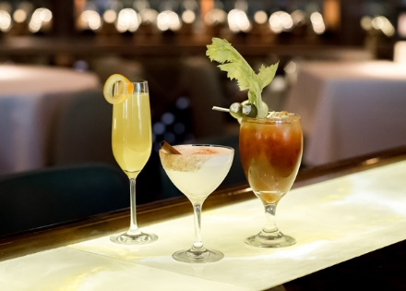

Give mom the day off from cooking and enjoy an indulgent dinner, served all day at Perry’s Steakhouse & Grille (5 Oakbrook Center, Oak Brook, IL 60523; 630-571-1808) on Mother’s Day, Sunday, May 13.

In honor of the holiday, Perry’s Steakhouse & Grille will open at 11 a.m., serving its dinner menu throughout the day and evening.

Perry’s also is offering special Mother’s Day cocktails including Bloody Marys, Mimosas, and Brandy Milk Punch for only $4.95 each from 11 a.m. to 4 p.m.

In addition, Perry’s will be offering its popular on-going three-course Sunday Supper Special from 4 p.m. to 9 p.m. for $34.95 a person. The Sunday Supper Special menu consists of three-courses: a salad, Perry’s Famous Pork Chop and the dessert trio, making it the perfect meal for family celebrations.

To start, choose between the Wedge Salad, Spinach & Warm Bacon Vinaigrette Salad, Caesar Salad, Butcher’s Chop Salad with Perry’s famous homemade Italian dressing, Kale Salad with Jalapeño Mint Vinaigrette or the Field Green, Pear & Candied Pecan Salad.

Move onto the main course, Perry’s Famous Pork Chop. A mouth-watering chop measuring seven fingers high as an ode to the measuring system used by butchers back in the day. Once cut, it’s rubbed with proprietary seasoning, cured and roasted on a rotisserie with pecan wood for up to six hours until it’s sweet, smoky and sizzling. Upon order, the chop is glazed, caramelized, topped with Perry’s signature herb-garlic butter and carved tableside. The pork chop is plated as three portions: the “eyelash” (the most marbled, tender, melt-in-your-mouth section above the eye of the chop), three baby-back ribs and the center-cut loin for the ultimate comforting indulgence.

Finish on a sweet note with Perry’s Dessert Trio featuring three of Perry’s finest sweets: Vanilla Bean Crème Brûlée, Praline Cheesecake and Perry’s Chocolate Crunch, crunchy milk chocolate covered with a dark chocolate ganache, served with homemade whipped cream, toffee and peanut brittle.

Make Mother’s Day reservations for Sunday, May 13 by calling (630) 571-1808 or by visiting http://www.perryssteakhouse.com.
About Perry’s Steakhouse & Grille
Perry’s Steakhouse & Grille has earned a faithful following by perfecting prime since 1979. Beginning as a small butcher shop, Perry’s has grown into a renowned group of award-winning restaurants featuring USDA Prime beef, tableside carvings, signature selections, flaming desserts and handcrafted cocktails at its Bar 79. Specializing in a Rare and Well Done experience, Perry’s currently operates 14 steakhouse locations in Chicago, Birmingham, Denver, and across Texas, as well as the two original butcher shops now known as Perry & Sons Market & Grille. For more information and updates on Perry’s Steakhouse, please visit www.PerrysSteakhouse.com.

Facebook (Facebook.com/PerrysDining), Twitter (@PerrysDining) and Instagram (@PerrysSteakhouse)

# # #

