ETHIOPIA TO HOST FIRST-EVER INTERNATIONAL COFFEE EVENT

Alexandria, VA – October 30, 2018

Ethiopia invites the coffee industry to attend the inaugural event on Dec. 4-5, 2018 in Addis Ababa at the United Nations Conference Center. The two-day meeting is projected to bring together multiple stakeholders from all over the world including coffee exporters, coffee researchers, coffee roasters and exhibitors and will serve as an ideal platform for experiences sharing and networking.

Coffee lovers will feel right at home in Ethiopia as the Land of Origins is widely considered to be the birthplace of coffee. Life in Ethiopia is celebrated with coffee, it is an integral part of daily life so guests should take the opportunity to enjoy this exquisite natural resource by partaking in a traditional coffee ceremony.

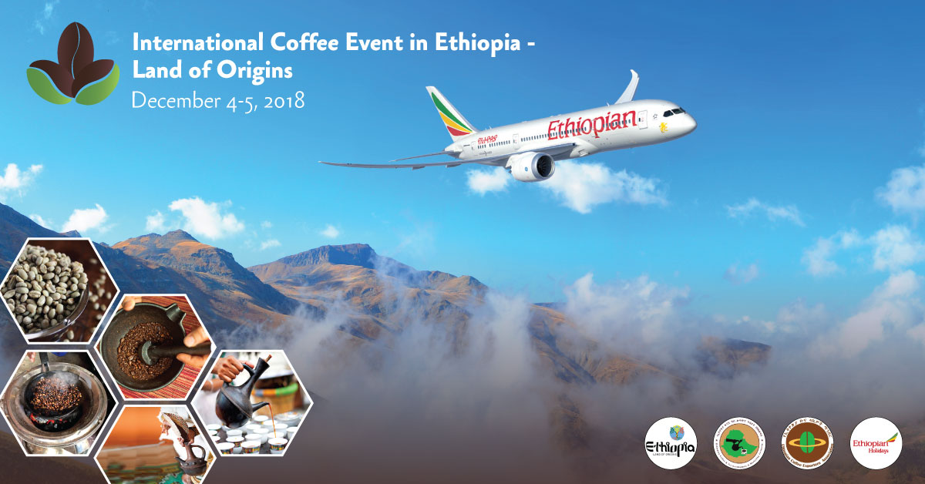

After the exhibition and conference there is an option for a coffee safari to Kaffa, a forested
region in the southwest where Coffea Arabica grows wild. The word in Ethiopia for coffee is
"bun" so the term coffee bean likely dates its origins to "Kaffa bun".

The event is being spearheaded by Ethiopian Airlines, The New Spirit of Africa, along with the
Ethiopian Coffee & Tea Authority, Ethiopian Coffee Exporters Association, Ethiopian Tourism
Organization, Ministry of Foreign Affairs, and Ministry of Trade.

For more information, including program details and registration, please visit
https://www.ethiopianairlines.com/International-coffee-Event/

About Ethiopian
Ethiopian Airlines (Ethiopian) is the fastest growing Airline in Africa. In its seventy plus years of operation, Ethiopian has become one of the continent’s leading carriers, unrivalled in efficiency and operational success.
Ethiopian commands the lion’s share of the pan-African passenger and cargo network operating the youngest and most modern fleet to more than 100 international passenger and cargo destinations across five continents. Ethiopian fleet includes ultra-modern and environmentally friendly aircraft such as Airbus A350, Boeing 787-8, Boeing 787-9, Boeing 777-300ER, Boeing 777-200LR, Boeing 777- 200 Freighter, Bombardier Q-400 double cabin with an average fleet age of five years. In fact, Ethiopian is the first airline in Africa to own and operate these aircraft.
Ethiopian is currently implementing a 15-year strategic plan called Vision 2025 that will see it become the leading aviation group in Africa with seven business centers: Ethiopian Regional Services; Ethiopian International Services; Ethiopian Cargo Services; Ethiopian MRO Services; Ethiopian Aviation Academy; ET In-flight Catering; and Ethiopian Ground Services. Ethiopian is a multi-award winning airline registering an average growth of 25% in the past seven years.
For more information about this press release, please contact etuspr@gmail.com.

