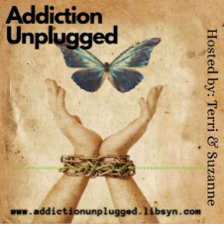
We are 2 Sober chicks who met in an Online Recovery Program during Covid-19. We were both skeptical about being Online but nearly all rehab facilities and in-person meetings had been closed. We got sober and got to know each other and as we both graduated from a challenging but life changing program we agreed to be each other's support system. We would be available if either had a trigger or an urge to drink. We'd also call to talk about how we were doing, what we were feeling and after several times we agreed to co-hosting a weekly Podcast and inviting other people to join in as well. Our topics are very versatile, our experts often offer science and our friends also in recovery provide common sense and sometimes a few tears and so many great laughs! We deal with Addiction and we do it Unplugged. Join us!

