FOR IMMEDIATE RELEASE
February 28, 2022

CONTACT:
Holly Jo Anderson
+1 952.738.8177
holly@veritasmarketing.com

Diversified Plastics, Inc. announces the 2021 Acceleration Station™ service grant winners

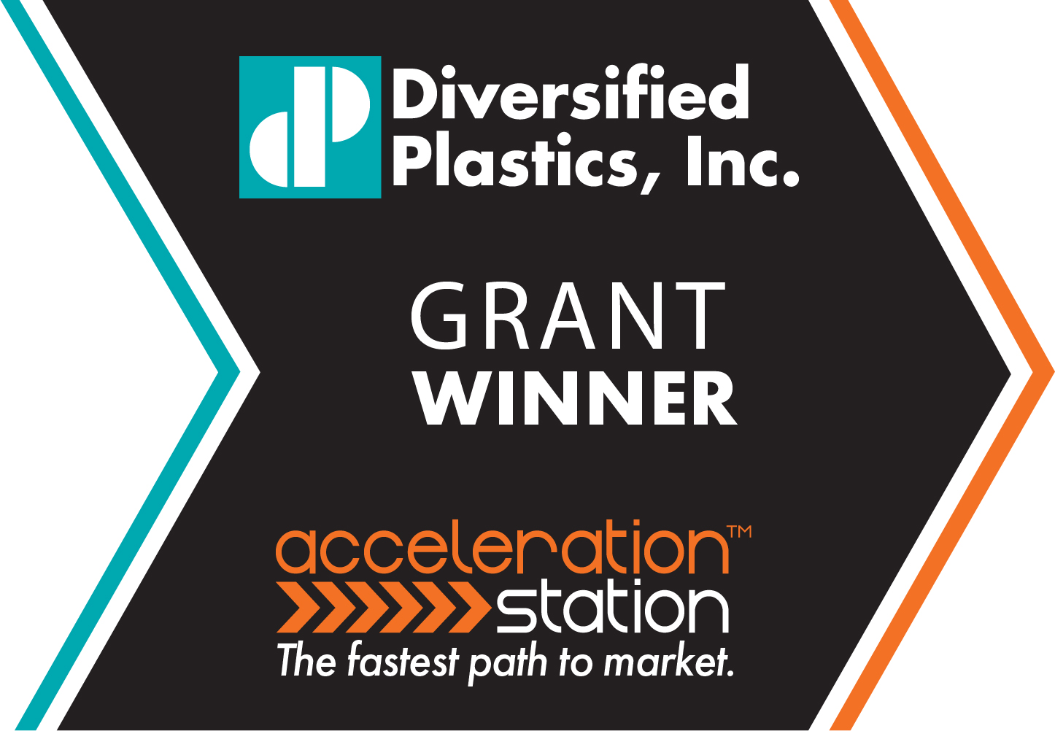
Diversified Plastics, Inc. (DPI) is pleased to announce the winners of the 2021 Acceleration Station™ service grants. Offered in partnership with Medical Alley Association’s Starts program, the grants provide design for additive manufacturing and 3D printing services to medical device start-up companies in Minnesota. Acceleration Station, powered by the Carbon® Digital Light Synthesis™ (DLS™) additive manufacturing process, meets the needs of medical device start-ups by delivering end-use and prototype components in days. The $7,500 grant recipient is Oncodea. Additional $2,500 service grants have been awarded to Agitated Solutions, Ambient Intelligence and U Deliver Medical.
“We are excited about the award and working with the DPI team,” says Dan Que Pham, cofounder/CEO of Oncodea. “We’re looking forward to collaborating with their team on design for manufacturing to produce prototypes and being ready to move into end-use additive manufacturing or injection molding production.”
Oncodea is developing a testing technology for early cancer detection. To learn more about Oncodea, visit oncodea.com.
“We are delighted to be part of the grant award companies’ go-to-market journeys,” says Kevin Hogan, chief executive officer (CEO) at Diversified Plastics, Inc. “As a contract manufacturer, one of the most exciting parts of our job is seeing the evolution of a part and the successes of the product it goes into.”

Secondary grant winners:
- Agitated Solutions (agitatedsolutions.com): an innovative, faster, safer and more effective ultrasound contrast system that provides simpler and more sensitive diagnostic testing.
- Ambient Intelligence (www.linkedin.com/company/ambientintelligence/): a radio frequency-based fall detection system for long-term care facilities.
- U Deliver Medical (udelivermedical.com): the bFed® System, which gives tube fed people the freedom to eat what, when and where they want.
Getting to market faster provides a significant competitive advantage for medical device manufacturers. It often results in increased revenue and market share. The Acceleration Station, from DPI, produces high-quality plastic parts faster. Capable of producing parts that were once unmanufacturable, this cutting-edge manufacturing technology provides innovators and engineers with design freedom to further advance their products to improve and save lives. These services, including the Carbon DLS additive manufacturing process, produce affordable, high-quality plastic prototype and end-use parts 100 times faster than traditional 3D printing methods. Acceleration Station protocols adhere precisely to customers’ specifications, performance and safety standards. In addition to additive manufacturing, DPI provides in-house tooling, plastic injection molding, assembly and other services to support future needs. To learn more about the Acceleration Station, visit divplast.com/acceleration-station.

The Medical Alley Starts program is an initiative to lower the cost of starting, scaling and pivoting new ventures in health innovation and care market segments. The Starts program aligns with DPI’s core value of giving back to the community and the industries they serve. Applicants, selected by Medical Alley Starts and DPI, were required to meet various criteria:
- Minnesota-based company.
- A medical device startup developing a class 1 or class 2 product with plastic as a primary material.
- Have developed a business plan and initial management team.
- Initial product concept is developed sufficiently where prototype production, engineering and design for additive manufacturing will advance the business.
Applications are open for the 2022 Acceleration Station service grant. Interested Minnesota-based companies may visit divplast.com/starts to learn more.

About The Medical Alley Association

Founded in 1984, MAA supports and advances the global leadership of Medical Alley’s healthcare industry, and its connectivity around the world. MAA delivers the collective influence, intelligence, and interactions that support Medical Alley. medicalalley.org/medical-alley-starts

About Diversified Plastics, Inc.

Employee-owned Diversified Plastics, Inc. (DPI) is a custom plastic-injection molder and digital manufacturer of high-precision, close-tolerance parts and components for medical device, filtration, aerospace and a variety of other industrial markets. Founded in 1977, the company is a full-service contract manufacturer providing design for manufacturing assistance, additive manufacturing, mold construction and intricate molding, as well as cleanroom assembly. In 2018, DPI purchased Pacific Plastics Injection Molding in Vista, Calif. DPI is ISO 9001:2015 and 13485:2016 certified, FDA registered, ITAR certified and UL registered. www.divplast.com

