FOR IMMEDIATE RELEASE
Tuesday, March 21, 2023

CONTACT: Holly Jo Anderson
+1 952.738.8177, ext. 700
holly@veritasmarketing.com

Pacific Plastics Injection Molding achieves ISO 13485:2016 certification

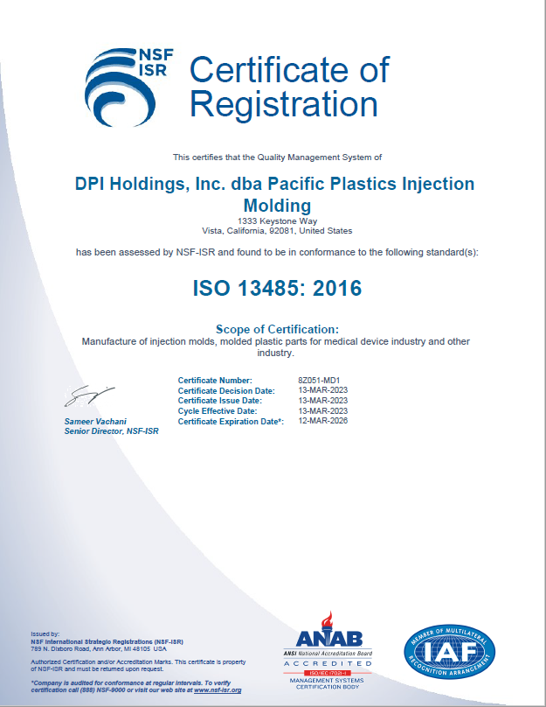
VISTA, Calif.—Pacific Plastics Injection Molding (PPIM),
a division of Diversified Plastics, Inc. (DPI), is proud to announce that it has achieved ISO 13485:2016 certification for the medical device industry. ISO 13485 certification is part of the company’s growth initiative to meet the increased demand for medical device contract manufacturing.

ISO 13485:2016 is an international standard that details the requirements for a quality management system (QMS) specific to the medical device industry. To become ISO 13485 QMS certified, best practices in each step of a product’s life cycle must be demonstrated through quality management processes, including manufacturing, service and delivery.

“It is a testament to PPIM’s commitment to the highest safety and quality standards for medical device contract manufacturing,” says Pablo Soto, quality manager at PPIM. “Earning ISO 13485:2016 certification is a valuable achievement,.”

Planned during the company’s 2021 expansion, PPIM is in preparation for the installation of a 1,500-square foot cleanroom for plastic injection molding as well as a white room for assembly and packaging. Combined, the DPI facility in Minnesota and the PPIM facility in California total 99,000 square feet. The Minnesota location also has two ISO Class 8 cleanroom (Class 100,000)—one for micro injection molding.

PPIM and DPI have experience working with various medical-grade resins, including, but not limited, to PEEK, Ultem, polypropylene, polycarbonate and ABS. They include low- to large-volume production of endoscopes, pulse oximeters, surgical suture delivery devices, tabletop vital monitors, X-ray housings, wearable devices and more. The quality departments in both locations are well-informed in FDA 21 and CFR 820 specifications, which include IQ, OQ, PQs and other validation requirements.

For more information or to request a quote, call +1 760-598-5333 or visit www.pacificplastic.com. You can also download PPIM’s tool transfer white paper by visiting www.pacificplastic.com/resources.

###
About Pacific Plastics Injection Molding
Pacific Plastics Injection Molding (PPIM) produces custom injection molds and molded plastic parts to meet or exceed customer requirements, on schedule, at a competitive price. ISO 9001 and 13485 certified, the company has a fully integrated operation that offers design, in-house and offshore tooling and production. www.pacificplastic.com

About Diversified Plastics, Inc.
Employee-owned Diversified Plastics, Inc. (DPI) is a custom plastic-injection molder and digital manufacturer of high-precision, close-tolerance parts and components for medical device, industrial OEM, telecommunications, electronics, filtration, energy/power and a variety of other markets. Founded in 1977, the company is a full-service contract manufacturer providing design for manufacturing assistance, additive manufacturing, mold construction and intricate molding as well as cleanroom assembly. In 2018, DPI purchased Pacific Plastics Injection Molding in Vista, Calif. DPI is ISO 9001 and 13485 certified, FDA registered, ITAR certified and UL registered. www.divplast.com

