For Immediate Release
Tuesday, January 9, 2024
Contact:
Holly Jo Anderson
(952) 738-8177, ext. 700
holly@veritasmarketing.com

Dynamic sculpture made with custom SONEX® baffles and LED lights provides a vibrant look and acoustic control in the lobby at CORSAIR’s headquarters

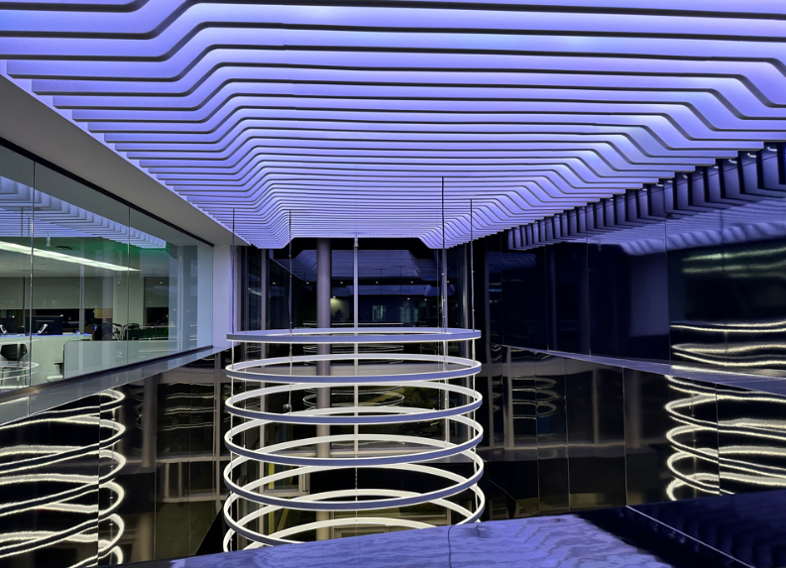
MINNEAPOLIS—Located in Milpitas, California, CORSAIR’s new 118,000-square-foot corporate headquarters was transformed from an ordinary office building into a vibrant, modern technology hub. Offering top-tier components and products, CORSAIR is an industry-leading innovator and manufacturer of high-performance gear and technology for gamers, content creators and PC enthusiasts. Familiar with CORSAIR’s products, David Fenster, AIA LEED AP at Modulus, worked with engineers from pinta acoustic and West General, pinta acoustic’s California distributor, to create a unique experience in the lobby. A ceiling-mounted sculpture, made from LED lights and custom SONEX® Linear Baffles from pinta, creates a dynamic experience for people entering the building.
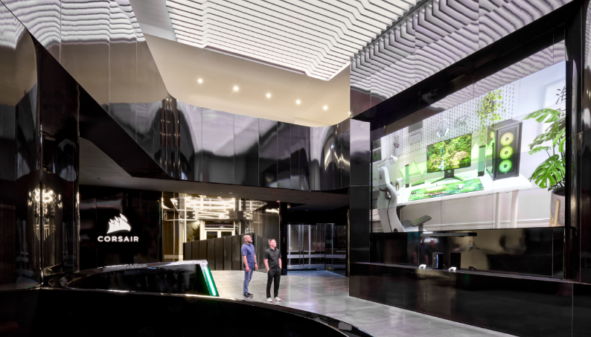
The narrow, two-story lobby is clad in glossy black laminate and has a tinted, polished concrete floor with large glass doors and windows. The architect knew that the sound from people talking and moving through the various wings on the ground and second floors could reverberate off the hard surfaces, causing unwanted noise and echo in the lobby. In addition to mitigating these potential sound issues, the acoustic treatment provides a signature CORSAIR aesthetic.
“More than a decade ago, I built my own PC,” says Fenster. “I wanted to use the best memory in the industry, which was CORSAIR’s DIMM [dual in-line memory modules].”
The design of the baffles was inspired by the shape of a DIMM, which was achieved using 117 two-inch-wide, custom-profile SONEX Linear Baffles in various lengths. The sound absorbers were installed on the tall ceiling using pinta’s acouSTIC adhesive and c-channels with LED lights, which change color, mounted between the rows of baffles.
“West General has been partnering with pinta acoustic for over 30 years,” says
Jean Sebastien Marineau, business unit manager for pinta acoustic. “They are very knowledgeable about pinta’s products and capabilities. Architects benefit from virtually unlimited design freedom to create spectacular and affordable acoustic treatments.”
SONEX Linear Absorbers are straight-line baffles with excellent sound control and a modern appearance. Highly customizable product design and profile options offer optimum form and function possibilities in a variety of interior ceiling applications. Class 1 fire rated, SONEX Linear is constructed of pinta’s WILLTEC™ foam and is offered in natural white, light grey and HPC color coatings. SONEX Linear Absorbers are available in standard and custom sizes, with lengths up to 96 inches (2438 mm) and depths of 6 to 24 inches (152 to 610 mm). These baffles are easily slip-fit into 2-inch-wide (52 mm) channel trim, typically fastened in place to wall or ceiling substrates.
pinta’s highly customizable products aligned well with CORSAIR’s branding, budget and time constraints. Fenster worked closely with the engineering and production teams at pinta acoustic to refine the acoustic product designs quickly and efficiently.
“The timing was quick,” says Fenster. “The longer it takes to get materials and products, the longer the general contractor is there. pinta was able to optimize, manufacture and deliver the acoustic products to fit the contractor’s schedule.”
After meeting with pinta’s engineering team, the order was placed in May. The products were shipped and delivered at the end of July—in time for installation in August.
“Installation required comprehensive pre-planning and coordination with the electrician installing the LED lighting,” says Rudy Vargas, project manager at Ad-In. “We also needed to make sure the sprinkler heads were not obstructed. pinta provides detailed, project-specific installation information.”
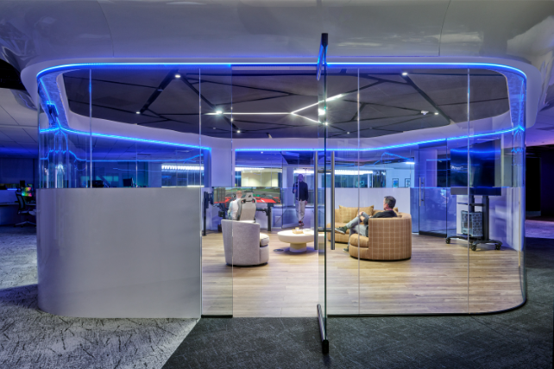
In addition to the acoustic treatment in the lobby, black triangular WILLTEC ceiling clouds were installed in multipurpose meeting areas, or nodes, to absorb unwanted sound reverberation. Surrounded by workstations, the eight nodes are hexagonal and enclosed in glass with half walls. These spaces are used for conferences, gaming and collaboration.
“The ceiling design complements the hexagonal shape of the nodes,” says Fenster. “We included gaps between the clouds for pendent lights, fire sprinklers and airflow from the HVAC system. Of varying sizes, the triangle clouds efficiently used the maximum dimensions of the
flat sheet.”
The ceiling clouds were installed by CAM, located in Santa Clara, California. The company engineered an innovative hanging system to suspend the lightweight WILLTEC clouds from
the ceiling.
“To provide flexibility, we engineered a mechanical and magnetic hanging system,” says Todd Lyon, co-owner and design/developer for CAM. “While secure when hanging, the ceiling clouds can easily be removed to service the lights and the fire sprinkler system.”
Corkscrew hangers were attached to the back of each triangle cloud. A template of the positioning of the corkscrew hangers was created to establish the corresponding anchor points on the ceiling. Placed on the floor, a laser beam was projected from the template to pinpoint the anchor sites. The anchors consisted of washers secured to the drop ceiling using butterfly bolts. Key rings were then attached to rare-earth magnet hooks to secure them to the corkscrew hangers. Each cloud was then raised and magnetically attached to the anchors.
Custom WILLTEC suspended-ceiling clouds provide excellent design flexibility and sound absorption across all frequencies. These clouds are offered in standard and custom sizes up to 48 by 48 inches (1220 by 1220 mm) and 3 inches (76 mm) thick. Natural white or light grey and water-based acoustic coating is available in standard, premium and custom colors. Resistant to mold, fungus and bacteria growth, these clouds are easy to install with corkscrew and other hanging systems.
“When I am doing something custom that requires acoustics, pinta acoustic’s products are my default,” says Fenster. “pinta has great products that are cost-effective for the impact you get when you use them creatively.”
For more information or to find a representative, visit www.pinta-acoustic.com or call
1-800-662-0032 or +1 (612) 355-4200. To download pinta’s “The Science of Better Acoustics” white paper, go to https://bit.ly/acousticscience.
CORSAIR
CORSAIR (NASDAQ:CRSR) is a leading global developer and manufacturer of high-performance gear and technology for gamers, content creators and PC enthusiasts. From award-winning PC components and peripherals to premium streaming equipment, smart ambient lighting and esports coaching services, CORSAIR delivers a full ecosystem of products that work together to enable everyone to perform at their very best. www.corsair.com

Modulus
Founded in 2010, Modulus encompasses a belief that architecture is about more than the built environment. It is about capturing the vision of where we want to be and embodying the soul of why we want to be there. Modulus is a unique team intricately focused on creating special and creative spaces. Through mindful exploration and thoughtful integration, we craft solutions and intriguing environments that lend to pleasurable atmospheres for working, dreaming, thinking, communicating and living.
www.modulus.com

West General
Located in San Jose, California, West General is a passionate representative and distributor of architectural finishes and acoustic materials. The company’s dedicated team prides itself in being a resource for spaces that are stunning, practical, distinct and affordable. Focusing on commercial, public and industrial applications, West General works with designers, installers, facility managers and end users. www.westgeneral.com

Ad-In Inc.
A highly specialized acoustical subcontractor, Ad-In provides unique and custom installations throughout Northern California. The company offers a wide range of skills to suit a variety of budgets and acoustical requirements. Ad-In delivers superior craftsmanship, excellent customer service and meticulous attention to detail. www.adininc.com

CAM
CAM brings creativity to life. In addition to engineered commercial interior installations, the company provides solutions for visual merchandising, retail spaces and trade show exhibits. CAM starts with the client’s aesthetic and creative needs to design the project around installation requirements, manufacturability and cost targets. www.cammakes.it

pinta acoustic, inc.
pinta acoustic, inc. manufactures a broad range of attractive direct-apply, glue-up ceiling and wall panels, suspended lay-in grid panels, suspended baffles and clouds for commercial and industrial applications. pinta acoustic’s product lines include WHISPERWAVE™, PHONSTOP™, CONTOUR®, HARMONI, WHITELINE®, SQUARELINE®, WILLTEC™ Flat Sheets, SONEX® Classic, SONEX Valueline, SONEX One, SONEX Mini, SONEX AFS, SONEX Linear Absorbers, SONEX PLANO Absorbers, SONEX Rondo, SONEX Clean, PROSPEC® Barrier, Foam and Composite Materials and acouSTIC adhesives. www.pinta-acoustic.com

Editor’s note: pinta acoustic, inc. prefers lowercase spelling of its entire name.

