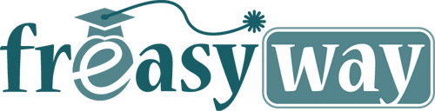
FOR IMMEDIATE REELEASE
PRESS RELEASE
31th august 2013

Virtual school of knowledge for everyone: the Freasyway teaching platform
(Your free and easy path towards knowledge)

Free Easy Way: the name of the platform was specifically chosen to describe an “easy and free path towards knowledge”. Starting today, this name is synonym with the most advanced virtual teaching platform. We are talking about a complete and unique access tool to distance learning contents. Such contents are offered by schools, colleges, universities, superior technical schools or independent professors. The courses are fee or paid and are made available to all members registered on the integrated network of Freasyway.
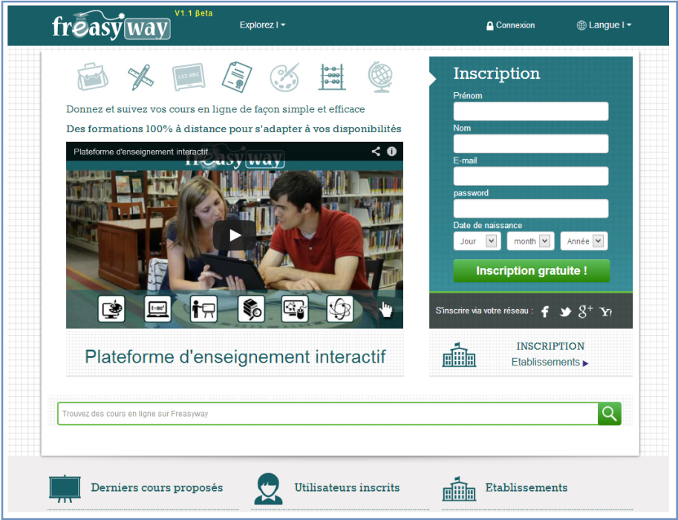
According to the name itself, the purpose of Free Easy Way is to become an international teaching platform, once it becomes available on all five continents. Currently, the platform is available in five languages and will expand until the end of this year.
Free easy Way: access online courses, connect with other users and browse the large number of educational institutions that offer high quality courses.
View the presentation video

A worldwide ambition with an altruist approach versus the emerging countries, especially at times when education rhymes with humanism
We have planned that <<Freasyway>> enlarges its development in emerging countries. Here, there will be implemented “Learning Centers” in areas where internet access is merely a possibility, such as certain countries from Africa Asia and South America.

One step forward with the student subscriptions and educational institutions already registered on <<Freasyway>>
Currently, Freasyway counts over 10,000 registered users, students and individuals eager to learn through our teaching platform. In addition, there are over 71 educational institutions, organizations and independent professors that actively contribute to enriching the varied course offer which available for all members.
Besides the extensive number of courses from all knowledge domains, our virtual school also provides the means to access interactive exercises that enable users to evaluate their level. Moreover, the platform features an educative virtual library and also varied and useful resources: manuals, homework database, exams documents, encyclopedias, dictionaries, etc. The virtual teacher ensures the tutoring process and the students’ management. He makes sure students will follow the course(s) and will be able to prove what they have learned though final examinations.
Students can start with a specific link (their social network on Freasyway), fulfill their needs and share information though an advanced learning platform: www.freasyway.com. They can share text files, photos, images, videos just like they already do on other social networks, but at the same time they learn.
On the other hand, educational institutions will access the platform using their own dedicated link: http://edu.freasyway.com.

Basic concepts and revolutionary approaches featured by our Freasyway platform
Freasyway was created based on a social network template, enhanced by the latest communication technologies and also a teaching platform template where interactive teaching and learning are main concepts (virtual school with multiple functions, featuring specialized interfaces).

The platform was specifically developed for matching different types of teaching: face to face, virtual school and traditional school, all being properly managed by each institution through an administrative interface that includes settings such as: opening/closing of registrations, admission tests before the formation process, followed by courses, curriculum… Moreover, students can take final online exams in order to validate their new knowledge acquisitions. Every member can use freely the video messaging feature or the live meeting feature of our interface (audio/video features of the instant messaging service, with the basic features of a Desktop Messenger application, a perfect tool for multi-user work, online conferences…).

Validation and follow-up of the efficiency of the teaching process?
Freasyway includes a compelling validation system used efficiently in order to make sure each course provider is authentic before they start posting courses online. We make sure the providers exist, they are accredited in the educational field and they offer useful courses. At the same time, it is our duty to make sure each educational institution adheres to our chart of values, is trustworthy when it comes to becoming part of our platform. Each institution that passes the validation process will be able to display a trust logo visible on their profile.

The teaching platform will propose educational institutions to offer diplomas or certificates at the end of each formation course
Each educational institution will be able to offer diplomas or certificates for each formation course though our platform, according to their own conditions, and they will offer such diplomas/certificates when the students successfully graduate the course. The responsibility of offering diplomas or certificates belongs to each educational institution.

The global approach and its benefits
Freasyway enables easy access to formation through courses readily available for the public of any formation level or any social conditions, in an international medium that facilitates the access to a high quality online teaching formula. Actually, Freasyway supports the principle that promotes equality of opportunity, since all users benefit without discrimination of free access to high quality courses posted voluntarily by educational institutions and independent professors chosen according to very rigorous criterion.

About us…
H-Technologies SA was founded in 2011 and counts 19 collaborators, with headquarters in Lausanne – Switzerland.

H-Technologies SA makes use of its extensive range of competencies and knowledge in the technological field (telephony, hardware, social and educational networks, web…), contributing with revolutionary approaches generously integrated in the new services. Our priority is security, concerning software where data traffic or the users are central elements. Our aim is that each user enjoys a secure and complete experience while using our products (confidence, security, mastery…). An important part of our development process is always featuring innovation, efficiency in using the means and the available resources while strengthening the functionalities of our IT platforms.

The website is available at: www.freasyway,com
You can find out more by <<Viewing the presentation video>>

Become a partner
Individuals, public or private companies, organizations, associations…anyone can contribute to the development of Freasyway by becoming a partner. According to their level of staffing or donation they can undertake an important role in our project and responsibilities regarding intervention or management. You can find out more at:
https://freasyway.com/public/pages/become-partner
Contact presse français :  H-Technologies SA  Département Freasyway  Ch. De Beau-Val 22  CH-1012 Lausanne / Switzerland  Skype: freasyway  Suisse: 0041 21 652 00 90  France: 0033 970 40 3002  Direct M: +41 79 41 41 509  E-mail: E-mail: edu.presse(at)freasyway(.)net | Press contact – English  H-Technologies SA  Department Freasyway  Ch. De Beau-Val 22  CH-1012 Lausanne / Switzerland  General Manager : Staicu Mihaela  Skype : freasyway  Cell : +1 650 318 5239  E-mail: edu.press(at)freasyway(.)net
Contact presse espagnol :
H-Technologies SA

Francisco Campos
+ 34 452 154 250
E-mail: f.campos(at)freasyway.net

