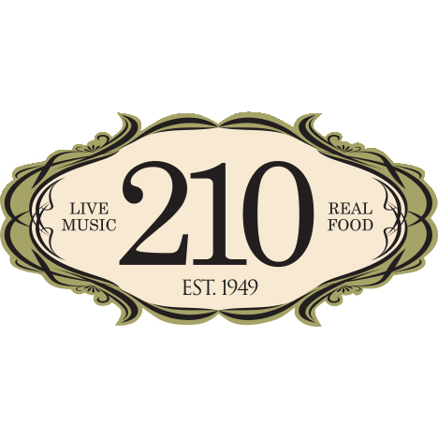
Media Contact:
Kurman Communications, Inc.
Cindy Kurman or Lee Barrie
(312) 651-9000
kurmanstaff@kurman.com

FOR IMMEDIATE RELEASE

210 Restaurant & Live Music Lounge Valentine’s Day Specials

What’s more perfect than a Valentine’s celebration with live music, the companionship of your partner and a gourmet dinner by Chef Jeff Tomchek? On Saturday, February 11 and Tuesday, February 14, 210 Restaurant (210 Green Bay Rd, Highwood; 847-433-0304) will be serving a special four-course Prix Fixe dinner with an optional champagne or wine flight.

210 Restaurant & Live Music Lounge will continue to spread the love on Valentine’s Day. Swoon to Bill Pantle, performing standards, 7-10:30 p.m., Tuesday, February 14, providing the setting for a romantic and memorable evening. Listen to love songs from the 40’s & 50’s, selections from the “Great American Songbook” and dance the night away.

An amuse-bouche of Champagne Mango Soup with Lobster Ceviche will start the meal and excite the taste buds.

Three choices are offered for the appetizer course: Shrimp and Chicken Gumbo, Mixed Greens with Green Apple, Goat Cheese and Cinnamon Pecans in an herb vinaigrette, or Hawaiian Tuna Poke with Guava & Toasted Macadamia Nuts.

For a main course, choose between a rich Roast New York Strip Loin with shallot white wine sauce, French fries and asparagus; or miso glazed Black Cod with mushroom fried rice and bok choy. A mouthwatering vegetarian option of spinach lasagna in an all-day marinara sauce with local winter carrots also is available.

Save room for a special, decadent Valrhona Chocolate Tart with Strawberry Gelato, the perfect finale before hitting the dance floor.

The dining Prix Fixe is $75 per person. For The Love, reserved seating tickets are online here and the $75 price includes tax and gratuity. For Valentine's Day, reservations are made here. An optional champagne or wine flight is available for an additional $30. For only the show, seating not guaranteed, purchase Bill Pantle tickets, for February 14, here and The Love tickets, for February 11, here.

About 210 Restaurant and Live Music Lounge
210 Restaurant & Live Music Lounge, located at 210 Green Bay Road in Highwood, Illinois, is a true supper club where guests enjoy live music five nights a week and delicious chef-driven dining. 210 is a community of musicians, food enthusiasts, and neighbors–an inviting, comfortable and romantic environment where singles, couples and families escape from their everyday life to relax, enjoy and indulge. 210 Restaurant & Live Music Lounge is open 5 p.m. to 1 a.m. Wednesday through Thursday and Sunday and 5 p.m. to 3 a.m. Friday and Saturday.

For more information, please visit www.210restaurant.com or call (847) 433-0304. Follow the newsroom at www.newsline360.com/210restaurantandlivemusiclounge.

Follow us on Facebook at https://www.facebook.com/210highwood/.

