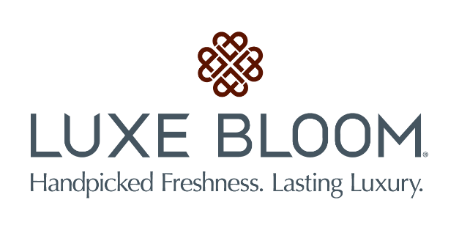

Media contact:
Kurman Communications, Inc.
Cindy Kurman or Lee Barrie
(312) 651-9000 office
(312) 543-3928 mobile
team@kurman.com

FOR IMMEDIATE RELEASE

Luxe Bloom® Brings the Enchantment to the Hollywood Premiere of Disney’s
live-action adaptation of “Beauty and the Beast”

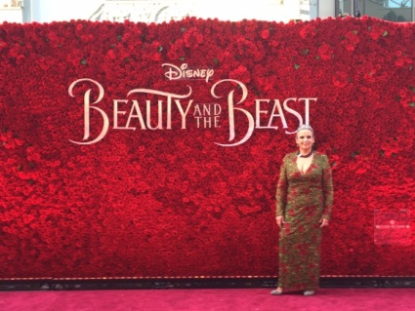
The tale as old as time received a fresh breath of magic thanks to Chicago-based luxury preserved rose company, Luxe Bloom®. As the official flower for Disney’s live-action adaptation of “Beauty and the Beast” and the official rose sponsor of the premiere, Luxe Bloom® decorated the Hollywood premiere with nearly 10,000 real roses.

Luxe Bloom® supplied 2,000 long stem fresh roses for the event and handed them out to celebrities walking down the red carpet. The real attraction, however, was the 19 foot long and 12 foot high rose wall designed by Luxe Bloom® Founder and CEO, Shelley Rosen. Using over 7,000 Luxe Bloom® preserved roses, the spectacular arrangement served as a perfect and elegant backdrop for the stars walking the red carpet.
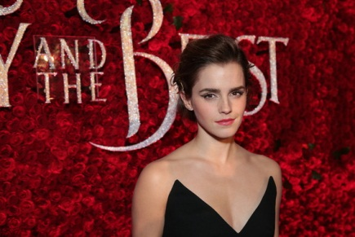
Emma Watson (Belle), Dan Stevens (Beast), Luke Evans (Gaston), Josh Gad (Lefou), Kevin Kline (Maurice), Ewan McGregor (Lumiere), Stanley Tucci (Cadenza), Ian McKellen (Cogsworth), Emma Thompson (Mrs. Potts), Audra McDonald (Madame Garderobe), Gugu Mbatha-Raw (Plumette), Bill Condon (director), Stephen Chbosky (screenwriter), Evan Spiliotopoulos (screenwriter), David Hoberman (producer) Todd Lieberman (producer) and Alan Menken (composer)—were all photographed in front of Luxe Bloom’s breathtaking flowing rose wall.
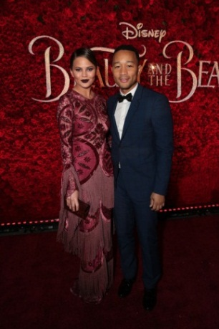
The film’s cast members weren’t the only ones enjoying the rose wall. Special guests Celine Dion, John Legend, Chrissy Teigen, Matt Damon, Javier Bardem, Jean Smart, Brenton Thwaites, Aubrey Plaza, Paige O’Hara, Cameron Boyce, Sofia Carson and many others were lucky enough to get their pictures taken in front of the stunning backdrop.

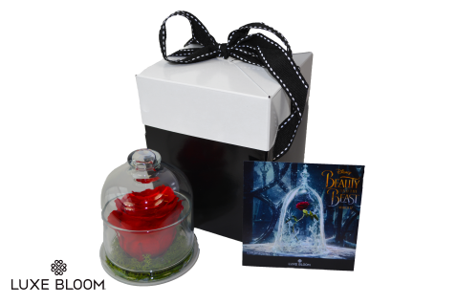
Didn’t make it to the premiere? Catch Luxe Bloom on Good Morning America Friday, March 10! Emma Watson and Luxe Bloom’s beautiful arrangements will be on set. See the stunningly preserved roses and bring home the magic. Luxe Bloom is selling their unique and beautifully preserved rose arrangements online in celebration of “Beauty and the Beast” at www.luxebloom.com and at amazon.com. The roses—which are real, not artificial—last for at least 60 days without water or other maintenance. Luxe Bloom® offers three special “Beauty and the Beast” products; a 4.5” Glass Cloche containing one crimson rose is priced at $55; a 6”x 6” crimson Rose Box of 9 roses is priced at $149 and an 8”x8” crimson Rose Box of 16 roses is priced at $399.

While Luxe Bloom®’s limited edition “Beauty and the Beast” arrangements are perfect for Disney lovers of all ages, the company’s standard collection of various creations also make wonderful gifts for any occasion, including Mother’s Day and graduations. Customizable in color, the luxurious, long lasting real rose arrangements will deliver enchanting magic to their recipient.

About Luxe Bloom®
Based in Chicago, Illinois, Luxe Bloom, LLC was founded in early 2013 by former Fortune 50 executive Shelley Rosen. Luxe Bloom offers real, long-lasting rose arrangements to luxury business operators and consumers on a monthly recurring basis. Luxe Bloom® roses are 100% ethically sourced.

View the whole collection at http://www.luxebloom.com. Follow Luxe Bloom® news at http://www.newsline360.com/luxebloom, Like Luxe Bloom on Facebook, Follow us on Twitter at @Luxebloomroses and on Instagram at luxebloomroses.
