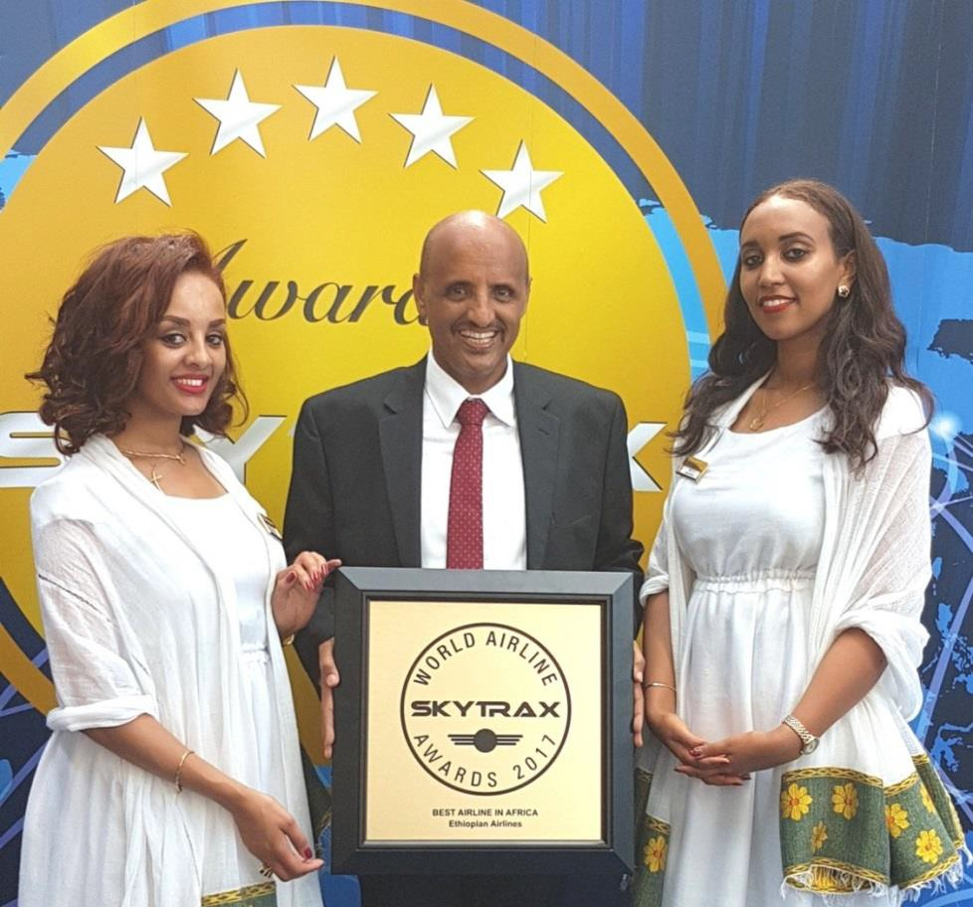

Ethiopian Wins SKYTRAX World Airline Award for Best Airline in Africa

June 21, 2017, New York, NY

Africa’s largest airline group, Ethiopian Airlines, is pleased to announce that it has won SKYTRAX World Airline Award for The Best Airline in Africa on June 20, 2017 at the Paris Air Show.
Skytrax is the most respected global air transport rating organization that conducts the world’s largest annual airline passenger satisfaction survey where customers make their own personal choices as to which airline they consider to be the best.

Mr. Tewolde GebreMariam, Ethiopian Airlines CEO, receiving award

While receiving the award, Group CEO Ethiopian Airlines, Mr. Tewolde GebreMariam, remarked; “We are thrilled that Skytrax, the most reputed global airline rating organization, has honored Ethiopian Airlines with The Best Airline in Africa award. I am very happy that Ethiopian has won the award as the Best Airline in Africa based on customer survey. This is a very strong testimony that in line with our vision 2025, our heavy investment in customer service, Human Resource Development, modern fleet, infrastructure and ICT has resulted in the desired customer delight which is expressed by the strong vote of confidence in the global survey. It will motivate us to continue to invest time, energy and money on the four pillars of our vision 2025 with sharp focus in customer service across the value chain.
I would like to thank Skytrax for this recognition and our valued customers for their strong vote of confidence. As always, we shall continue to work hard to exceed your expectations and provide you the best possible travel experience every time you fly with us. I wish to take this opportunity to congratulate my colleagues at Ethiopian for their exceptional commitment and hard work to keep our airline flying high in the skies. “
Ethiopian Airlines is a multi-award winning airline and has previously received SKYTRAX World Airline Award for Best Airline Staff in Africa, two times.
About Ethiopian
Ethiopian Airlines (Ethiopian) is the fastest growing Airline in Africa. In its seven decades of operation, Ethiopian has become one of the continent’s leading carriers, unrivalled in efficiency and operational success.
Ethiopian commands the lion’s share of the pan-African passenger and cargo network operating the youngest and most modern fleet to more than 95 international destinations across five continents. Ethiopian fleet includes ultra-modern and environmentally friendly aircraft such as Airbus A350, Boeing 787, Boeing 777-300ER, Boeing 777-200LR, Boeing 777-200 Freighter, Bombardier Q- 400 double cabin with an average fleet age of five years. In fact, Ethiopian is the first airline in Africa to own and operate these aircraft.

Ethiopian is currently implementing a 15-year strategic plan called Vision 2025 that will see it become the leading aviation group in Africa with seven business centers: Ethiopian Domestic and Regional Airline; Ethiopian International Passenger Airline; Ethiopian Cargo; Ethiopian MRO; Ethiopian Aviation Academy; Ethiopian In-flight Catering Services; and Ethiopian Ground Service. Ethiopian is a multi-award winning airline registering an average growth of 25% in the past seven years.

For more information about this press release, please contact etuspr@gmail.com or:
Mrs. Hanna Atnafu
Manager Corporate Communications, Ethiopian Airlines Tel :( 251-1)517-89-07/656/165/913/529
CorporateCommunication@ethiopianairlines.com www.ethiopianairlines.com www.facebook.com/ethiopianairlines www.twitter.com/flyethiopian

