Ethiopian Airlines Group Awarded 4-Star Ranking by SKYTRAX;
Announces 6th Gateway to the Americas

November 9, 2017 – FOR IMMEDIATE RELEASE

Africa’s largest airline group, Ethiopian Airlines, is pleased to announce that it has been awarded SKYTRAX 4-Star certification at a special ceremony held in London on November 8, 2017.

SKYTRAX is respected as the most prestigious international air transport standards and quality rating organization. Ratings are determined through direct and professional auditing and analysis of quality of service standards.

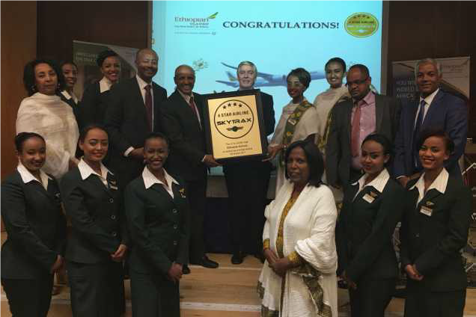
Mr. Tewolde GebreMariam while Receiving SkyTrax 4-Star Airline Award

While receiving the certificate, Group CEO Ethiopian Airlines, Mr. Tewolde GebreMariam, remarked, “The 4-Star recognition by SKYTRAX is a significant milestone in the long history of Ethiopian Airlines. As a customer focused airline, it is extremely gratifying that our hard work to ensure high level of customer satisfaction at all times through a consistent delivery of global standard product and superior level of service has borne fruit.”

Ethiopian Airlines is a multi-award winning airline and has previously received SKYTRAX World Airline Award for Best Airline Staff in Africa, two times and earlier in 2017 Ethiopian received SKYTRAX World Airline Award for Best Airline in Africa.

Ethiopian Airlines is also pleased to announce that it has finalized preparations to start five weekly flights to Buenos Aires, Argentina starting March 2018.

Group CEO GebreMariam stated, “We are glad to add Buenos Aires, our 6th gateway to the Americas, to our extensive global network. Our new flight to Buenos Aires will provide efficient connections to our network in Asia, the Middle East, and Africa, including Beijing, Shanghai, Seoul, Tokyo, Mumbai, Delhi, Dubai, Beirut, Nairobi, and Cairo.”

The new service will launch on March 8, International Women’s Day. To mark this important occasion the inaugural flight will be an All Women Operated Flight.

Buenos Aires will become Ethiopian’s 6th destination in the Americas. Ethiopian has service to Washington, New York, Los Angeles, Toronto, and São Paulo.

About Ethiopian
Ethiopian Airlines (Ethiopian) is the fastest growing Airline in Africa. In its seventy plus years of operation, Ethiopian has become one of the continent’s leading carriers, unrivalled in efficiency and operational success.
Ethiopian commands the lion’s share of the pan-African passenger and cargo network operating the youngest and most modern fleet to more than 100 international passenger and cargo destinations across five continents. Ethiopian fleet includes ultra-modern and environmentally friendly aircraft such as Airbus A350, Boeing 787, Boeing 777-300ER, Boeing 777-200LR, Boeing 777-200 Freighter, Bombardier Q-400 double cabin with an average fleet age of five years. In fact, Ethiopian is the first airline in Africa to own and operate these aircraft.
Ethiopian is currently implementing a 15-year strategic plan called Vision 2025 that will see it become the leading aviation group in Africa with seven business centers: Ethiopian Express & Ancillary Services; Ethiopian International Services; Ethiopian Cargo & Logistics Services; Ethiopian MRO Services; Ethiopian Aviation Academy; ET In-flight Catering; and Ethiopian Ground Services. Ethiopian is a multi-award winning airline registering an average growth of 25% in the past seven years.
For U.S. inquiries, please contact etuspr@gmail.com or:
Mrs. Hanna Atnafu
Manager Corporate Communications, Ethiopian Airlines
Tel :( 251-1)517-89-07/656/165/913/529
CorporateCommunication@ethiopianairlines.com
www.ethiopianairlines.com
www.facebook.com/ethiopianairlines
www.twitter.com/flyethiopian

