FOR IMMEDIATE RELEASE
Tuesday, March 5, 2024
Contact:
Holly Jo Anderson
Veritas Marketing
holly@veritasmarketing.com
952-738-8177, ext. 700

Intek Plastics acquires a large Wisconsin plastics extruder
The acquired facility and equipment greatly expand production capacity

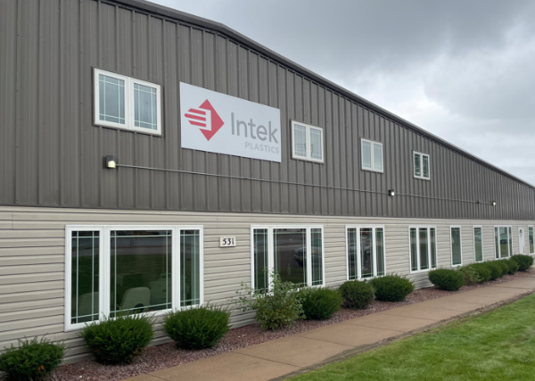
HASTINGS, Minn.—Intek Plastics is proud to announce the acquisition of a 72,000-square-foot extrusion facility in Medford, Wisconsin. With complementary equipment, the facility is structured to manufacture high-quality extrusion solutions for the fenestration market.
“This acquisition is part of our long-term growth and diversification initiatives,” says Kevin Hogan, CEO. “In addition to continuous investment in our Hastings facility, adding the Medford plant greatly increases our twin-screw extruder capacity. This allows us to immediately support the growth of our customers and further expand into the agriculture, power, infrastructure, lighting and other markets.”
The Wisconsin facility provides an important risk reduction with analogous production capabilities from two locations. The equipment acquired is equivalent to Intek’s best-in-class, high-volume twin-screw extruders in the Hastings facility. Intek will also utilize its advanced processes and systems in the new facility to deliver the same responsive, expert services and quality that customers expect.
A family-owned business for over 60 years, Intek has a culture and values that are dedicated to learning and team development for the success of employees, customers and partners. The company is focused on growth, both organically and through acquisition. Intek Plastics is assembling a strategic portfolio of plastics capabilities to achieve its vision of becoming one of the largest and most respected plastics companies in the world.
To learn more about Intek’s services and employment opportunities, visit www.intekplastics.com or call 651.437.7700.

Intek Plastics
Intek Plastics is a leading North American manufacturer that delivers engineered thermoplastic extrusions, fabricated sub-assemblies and value-added services to original equipment manufacturers. Headquartered in Hastings, Minnesota, with a second facility in Wisconsin, the company is a best-in-class partner with the largest customers in the fenestration industry. Additionally, Intek provides plastic extruded solutions to the construction, lighting, refrigeration, agriculture, recreation, appliances and transportation markets.

When collaborating with Intek Plastics’ team of experts, customers get more than high-quality extruded components. They gain a competitive edge. The Intek team is committed to collaborating with customers to revolutionize products with cutting-edge extrusion innovations. With an eye to the future, Intek has invested heavily in innovative materials, processes and technologies to meet the needs of its customers.

