Cleveland
Immigration Lawyers Since 1995

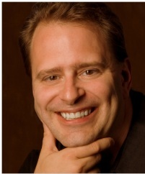

RICHARD HERMAN

Richard Herman is a nationally-known immigration lawyer and founder of the Herman Legal Group, a full-service immigration law firm serving corporate and individual clients nationwide. Along with attorneys Vania Stefanova and Charmaine Rozario, Richard and his team speak over 12 languages and have over 50 years experience in immigration law, handling all matters relating to employment and family-based immigration.

In the field of immigration law, Richard is “AV-Rated,” the highest rating by Martindale-Hubbell’s peer review conducted by lawyers and judges. Richard is admitted to the Ohio Bar; the U.S. Federal District Court, N. District of Ohio; and the U.S. 6th Circuit Federal Court of Appeals. Richard is a graduate of Case Western Reserve University School of Law and a former trustee of the Cuyahoga County Bar Association, the Legal Aid Society of Cleveland, the Cleveland Council on World Affairs, Global Cleveland, and Global Detroit.

For 10 years in a row, Richard has been acknowledged as a “Super Lawyer” and “Leading Lawyer” in the immigration field by various business publications.

In 2012, Richard received the “Client’s Choice Award” and top rating of “10” as an immigration lawyer by the law website AVVO.

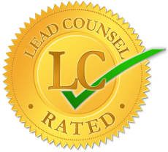
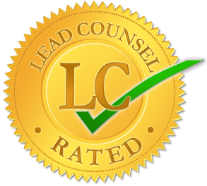
In 2013, Richard received the Lead Counsel Rating in Immigration Law
by the Lead Counsel Review Board.

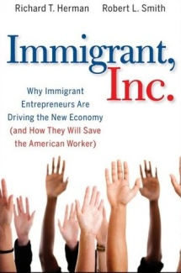
Richard is the co-author of the internationally-acclaimed book, Immigrant, Inc. ---Why Immigrant Entrepreneurs Are Driving the New Economy (John Wiley & Sons, 2009), a powerful interweaving of success stories and research which will forever change the way you look at immigrants ---- and America.

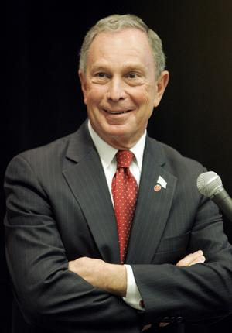
Richard speaks around the country on behalf of New York City Mayor Michael Bloomberg’s initiative, Partnership for a New American Economy, a national coalition of over 400 CEOs and mayors who make the case that smart immigration makes America stronger. A fierce advocate for his clients and for immigration law reform, Richard is a nationally-renowned commentator on immigration and global diversity.

Richard’s poignant commentary has been sought out by many national media outlets, including USA Today, BusinessWeek, Forbes, FOX News (The O’Reilly Factor), National Public Radio, Inc., National Lawyers Weekly, PC World, Computerworld, CIO, TechCrunch, Washington Times, San Francisco Chronicle and InformationWeek.
Richard is the co-founder of TiE-Ohio, a chapter of The Immigrant Entrepreneurs Association based in Silicon Valley.

Richard is a board member of The Swedish Chamber of Commerce of Ohio. Headquartered in Cleveland, the Ohio Chapter of SACC-USA serves the Ohio region., which includes Western Pennsylvania, Eastern Indiana, Western New York and West Virginia.

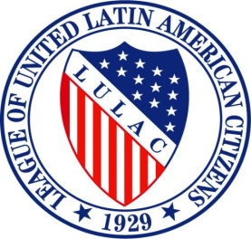
Richard is a founding member of the Cleveland Chapter of The League of United Latin America Citizens, the largest and oldest Hispanic organization in the U.S. Richard is also proud to serve as the Civil Rights Director of LULAC Ohio.

On a personal note, Richard is a Cleveland native and former resident of Moscow, Russia. He is married to Dr. Kimberly Chen, a physician born in Taiwan. They are raising their children, Nathan (11) and Isabella (9), to be citizens of the world.

