FOr Immediate Release
Contact: Lyn Cadence, 403.465.2345,
lyn@cadencepr.ca
Mental Health Week is May 5 – 11, 2014
Like most people with schizophrenia, Elizabeth Anderson is coping well.
Ask her about Being Mentally Healthy.
Winner of the True Grit Award and author of Being Mentally Healthy (despite having a mental illness) Elizabeth Ann Anderson is available for interviews in Edmonton May 1 -4 and Calgary May 5 - 11.
“Elizabeth shares her often agonizing story with honesty and a grace that is very moving. Her deep love for the people in her life, and for life itself, is inspirational to all who have fought the insistent darkness of mental illness.” – Fiona Haynes, Provincial Partnership Education Program Director & Calgary Branch Manager Schizophrenia Society of Alberta, Calgary Chapter.
Anderson had difficulties with depression in her youth and developed schizophrenia as she became an adult. She has found medication that works for her, a husband and friends who support her. She is making a life for herself as a writer and public speaker who helps people understand mental illness. Here is her Recipe for Success.
- Timely intervention
- The right medication
- Supportive people
- A reason to hope
- A reason to be well
- Something important to do
- Recovery
Elizabeth will tell you that medications have improved and that many people with schizophrenia are able to recover after one episode, or after a few episodes. You don’t need specialized training to deal with schizophrenia in these instances. You can provide friendship and a reality check.
Elizabeth Ann Anderson lives with schizophrenia in Calgary with her husband Wade. She is an accomplished public speaker and author of Being Mentally Healthy (in spite of a mental illness).

Elizabeth will be at South Point Chapters, 3227 Calgary Trail NW in Edmonton on Sunday, May 4, 2-4 pm and at Shelf Life Books in Calgary on Tuesday, May 6, 7-9 pm.

BACKGROUNDER This is her story.
When Elizabeth Ann Anderson watched her mother’s dreams dissolve and her subsequent decent into alcoholism, she had her first bout with depression. A few years later Elizabeth attempted suicide. She attempted university a few times, but unable to cope, she withdrew each time.
When she met Wade and he proposed marriage, a few new problems cropped up, but given all of the changes that were happening, stress was blamed. It wasn’t until after the wedding that Anderson’s problems gathered the ‘force of a tsunami.’ She stopped going out, stopped eating, she started throwing out the groceries, and stopped showering. Danger seemed to lurk everywhere and strangers in the shadows seemed to pose a threat. Her husband Wade did everything he could to prevent potential break-ins and assuage Elizabeth’s fears. Of that time, Elizabeth says, “I didn’t know I was sick. It is a scary thought that I was so sick but I was completely unaware. It is lucky that I had a friend who intervened.”
At that point, Elizabeth’s friend Deanna came to visit and she told Wade that Elizabeth was in psychosis. It isn’t too long before Wade took Elizabeth to hospital and then she was finally diagnosed with schizophrenia. It took a little experimentation to find the medication that worked for Elizabeth, but she began to stabilize and she began to rebuild by setting 3 goals per day. She and her husband underwent marriage counselling for a while, and then replaced therapy with a nightly cup of tea while they told each other about their day. A period of calm ensued.
In an effort to deal with the weight gain that was a side effect of her medication, Elizabeth began cutting her pills in half. It wasn’t long before the voices and the fears returned. She ended up back in hospital. The situation seemed hopeless. Her Mom even told her husband that he shouldn’t feel obligated to stay. Wade said, “I said til death do us part” not ‘til it becomes inconvenient’.
Elizabeth decided to plan a surprise birthday party for her husband and while cleaning up in preparation for the party, she had a psychotic episode and ended up in hospital. Elizabeth’s Mom called Wade to tell him about the surprise party happening the next day so he could carry off the event without Elizabeth. He did.
At that point Elizabeth found a psychologist named Arlo who provided her with some terrific help. Elizabeth followed his advice – to return to university, to hire an organizer and to learn to cook.
When Elizabeth joined the Schizophrenia Society of Alberta she got some really good support and she got a job at Progressive Alternatives Society of Calgary (PASC) providing one-on-one support to people with disabilities and coaching one person to do speeches about their disability. For five years she worked for the City of Calgary speaking to grade 6 students about schizophrenia.
While at university, Elizabeth did an independent study course in which her instructor Dr. Husby advised her to research fear of success. It was a turning point. She graduated from University of Calgary in 2010 with a Bachelor Degree in Communication and Culture.
Next she self-published Being Mentally Healthy (in spite of a mental illness) and established a business of speaking and writing.

On September 27th 2013, Elizabeth Ann Anderson was awarded The True Grit Award by the Lt. Governor’s Circle on Mental Health and Addictions at Government House in Edmonton Alberta.

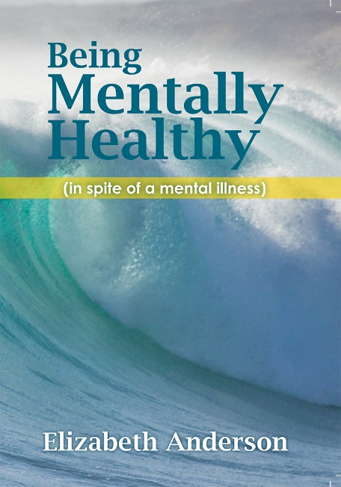
Being Mentally Healthy (in spite of a mental illness) is Elizabeth Anderson’s personal journey of mental illness. Easily read, the book offers an honest look at the reality of schizophrenia – for those who live with it and those who care for someone living with it – while providing both insight and inspiration. Anderson includes her “Recipe for Success” which helped her recover and live a good life. Completing this moving schizophrenia memoir are her husband’s perspective and comments from her best friend.
Early praise for Being Mentally Healthy (in spite of a mental illness)
“Though this book is about one woman’s battle with schizophrenia, this is a story about mental resilience, not mental illness. It should be required reading for anyone entering a helping profession.” – Dr. Heather Stuart, Professor and Bell Canada Mental Health and Anti-Stigma Research Chair, Queen’s University, Kingston, Ontario, Canada
“Elizabeth shares her often agonizing story with honesty and a grace that is very moving. Her deep love for the people in her life, and for life itself, is inspirational to all who have fought the insistent darkness of mental illness.” – Fiona Haynes, Provincial Partnership Education Program Director & Calgary Branch Manager Schizophrenia Society of Alberta, Calgary Chapter.
Elizabeth Ann Anderson
Elizabeth Ann Anderson lives with schizophrenia in Calgary with her husband Wade. She is an accomplished public speaker and author of Being Mentally Healthy (in spite of a mental illness).
Delivering the message of hope that people can recover from mental illness is Elizabeth Anderson’s life work. Since 1995 she has impacted more than 1000 audiences with the story of her journey from illness to recovery to victory.
Early successes in her recovery include being part of the World Psychiatric Association’s 1998 Anti-Stigma campaign and being one of the collaborators and original cast members in the play, Starry Starry Night, through the Schizophrenia Society of Alberta’s, Calgary Branch, Partnership Program.
After earning a Bachelor’s degree in Communication and Culture from the University of Calgary in 2010 (post-diagnosis) she decided to follow her dream of being an author. She self-published her book, Being Mentally Healthy (in spite of a mental illness). In 2012, she launched The Being Mentally Healthy Company and beingmentallyhealthy.com. Currently, Elizabeth is writing a second book, Being Mentally Healthy with Great Courage: 12 courageous choices to empower you to flourish (in spite of a mental illness).
Elizabeth’s objective is to share her experiences with others who are searching for a new paradigm for mental illness, mental health.

