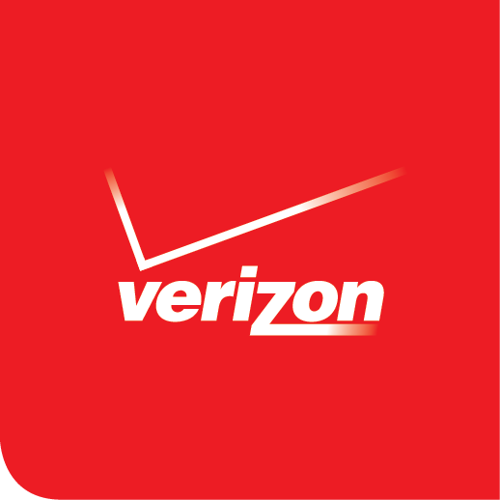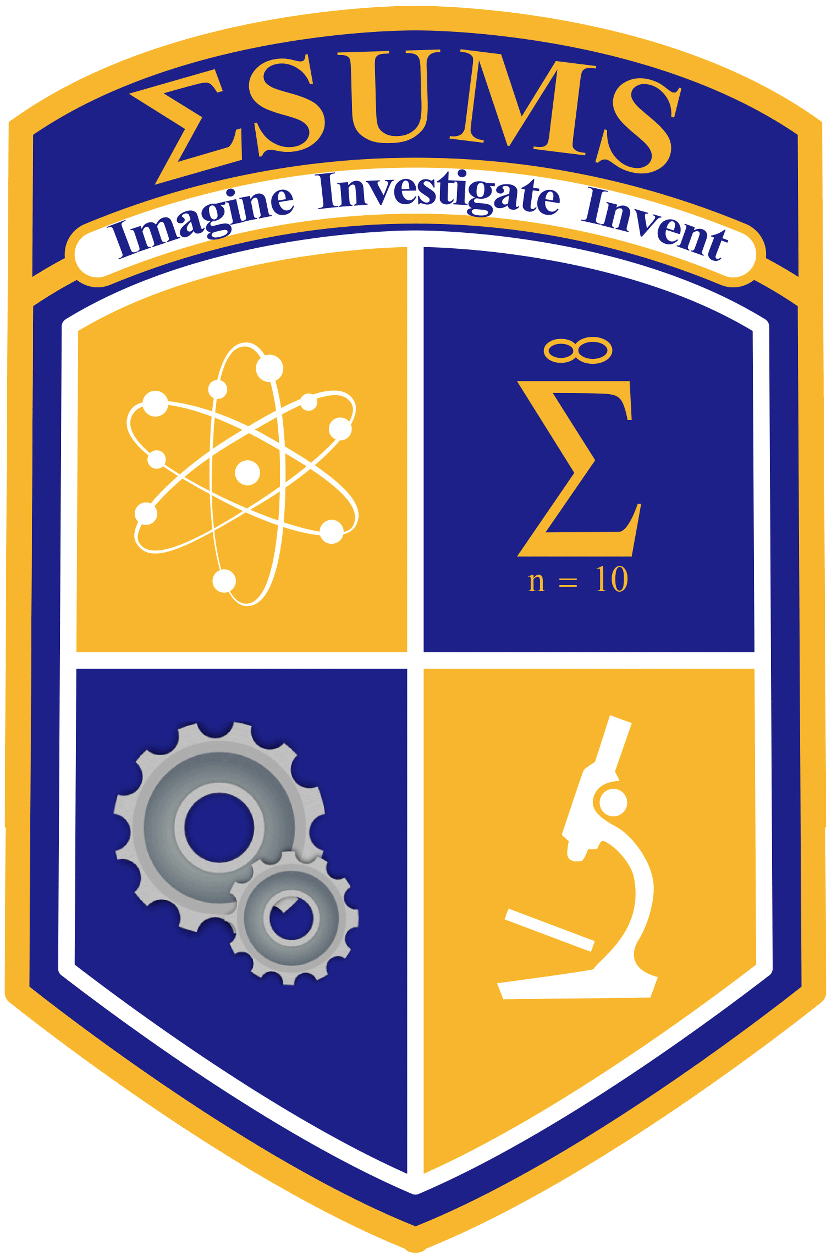

NEWS RELEASE

FOR IMMEDIATE RELEASE Media contacts:

January 8th, 2015 Ellen Yu 908-559-2818
ellen.yu@verizon.com
Twitter: @ellen_yu

Students from
Engineering and Science University Magnet School (ESUMS)
In Running To Win Verizon Third National App Challenge

High School Team Wins Best-in-State;
Will Advance in Innovative Contest, Aimed at Boosting Students’ Interest in
STEM Fields

NEW HAVEN, CT – High school students from Engineering & Science University Magnet School (ESUMS) have earned the title of Best in State in the third Verizon Innovative App Challenge, a national competition in which students design a mobile application concept that addresses a need or problem in their local schools or communities. The student team came up with an app concept called C-Step that grants young children the opportunity to connect with an interactive program, which provides an entertaining game while teaching the basics of carbon footprints.
In total, 90 teams of creative middle and high school students from across the country have advanced to the next phase of the judging process. A list of the Best in State winners is available at http://verizon.com/appchallenge2014.
“I am extremely proud of our students and technology teaching team for bridging the ESUMS students’ challenge to imagine, investigate and invent and with Verizon's challenge to innovate in the area of App Development,” said Principal Medria Blue-Ellis. “On behalf of our team of girls who are moving forward in the Verizon Challenge and the ESUMS community, we thank Verizon and TSA for providing this unique opportunity to showcase their creativity, content knowledge and collaboration skills. These youth will be society’s next STEM professionals and leaders.”
“Winning the app challenge truly inspires me as a female STEM student to continue to strive to achieve. As a student at the Engineering and Science University Magnet School, I have established a high standard of goals for myself,” said sophomore Arianna McDaniels. “This app challenge was presented by our instructor, and it is an honor to be at a school where we can enter challenges to gain real world experiences. We are living in the 21st century, where more women are entering into STEM careers, and we would like to show younger female students interested in STEM that they can achieve their goals and succeed in technology.” With the help of their instructor, Melissa Manzione, and department head, Leon Tynes, the ESUMS students look forward to the upcoming rounds of the competition.

The Verizon Innovative App Challenge was created by in partnership with the Technology Student Association in response to a critical need to inspire student interest in science, technology, engineering and math. Student interest and proficiency in STEM has been stagnant in the United States, especially among women and minorities, although 80 percent of all jobs over the next decade will require STEM skills. Currently, 3 million STEM jobs are unfilled in the U.S., and occupations related to STEM are projected to increase to more than 9 million by 2022.
More than 90 percent of the winners from last year’s Innovative App Challenge expressed interest in pursuing STEM careers after learning coding and launching their winning app in the Google Play store. Roughly 70 percent reported increased creativity, teamwork and communication skills, and content knowledge.
“This contest has exposed students to new skill sets such as learning to collaborate, negotiate and best of all problem solving,” said Justina Nixon-Saintil, director of education programs for the Verizon Foundation. “We can’t wait to see which of these creative concepts will become actual working mobile apps that can help make a difference in local communities.”
One of the 2013-14 App Challenge winners, an all-girls team from Resaca Middle School in Los Fresnos, Texas, was invited to the annual White House Science Fair to demonstrate its “Hello Navi” app, which was built to help a blind classmate better navigate the halls at school.
The Path to Best in Nation
The 90 Best in State teams advance to the next round of the competition. On Jan. 16, Verizon and the TSA will name 24 Best in Region middle and high school team winners from the West, Midwest, South and Northeast. Each Best in Region team will earn a $5,000 cash grant for its school to further develop or support a program in science, technology, engineering and math, the so-called STEM subjects.
On Feb. 3, the Innovative App Challenge competition’s final phase will conclude with the selection of eight Best in Nation winners – four middle school and four high school teams – chosen from the Best in Region teams. Best in Nation teams will earn their schools an additional $15,000 cash grant to further develop or support a STEM-related program. Each team member will receive a Samsung tablet, courtesy of Samsung Electronics America. In addition, MIT App Inventor Master Trainers from the Center for Mobile Learning at the MIT Media Lab will give the Best in Nation teams onsite and virtual training on coding and app development, using MIT App Inventor to develop the teams’ apps.
Verizon, in collaboration with the MIT Media Lab, will help the students develop their app concepts, making them ready for sharing and distribution. Apps developed during the first two years of the Verizon Innovative App Challenge have been downloaded more than 26,000 times from the Google Play store.
In June, the members of the eight winning teams will be invited to present their apps in person at the National TSA Conference in Dallas, Texas, courtesy of Verizon.
To see the list of the Best in State winners, visit http://verizon.com/appchallenge2014.

About the School
The Engineering and Science University Magnet High School is a public college preparatory high school. Students are challenged to imagine, investigate and invent while being prepared for demanding science, technology, engineering, and math programs at a collegiate level. For more info about ESUMS, please visit http://www.esumsnh.net.

About the Verizon Foundation
The Verizon Foundation is focused on accelerating social change by using the company’s innovative technology to help solve pressing problems in education, healthcare and energy management. Since 2000, the Verizon Foundation has invested more than half a billion dollars to improve the communities where Verizon employees work and live. Verizon’s employees are generous with their donations and their time, having logged more than 6.8 million hours of service to make a positive difference in their communities. For more information about Verizon’s philanthropic work, visit www.verizon.com/about/responsibility; or for regular updates, visit the Foundation on Facebook (www.facebook.com/verizonfoundation) and Twitter (www.twitter.com/verizongiving).

####

VERIZON’S ONLINE NEWS CENTER: Verizon news releases, executive speeches and biographies, media contacts and other information are available at Verizon’s online News Center at newscenter.verizon.com. The news releases are available through an RSS feed. To subscribe, visit newscenter.verizon.com/corporate/feeds.

