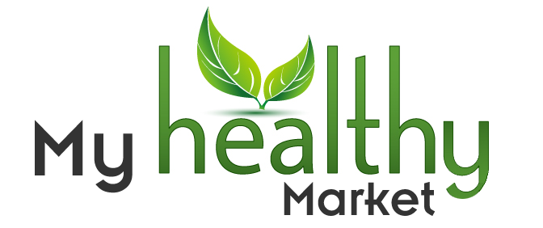 Dear Reader!

My Healthy Market is a new Internet global selling and shopping platform focused on healthy, organic, and environmentally friendly products. Our selling platform allows anybody to join and sell products on line to the worldwide market.
We offer a wide range of categories and thousands of diverse organic products for sale directly from our website.
Additionally, we are inviting businesses to offer their products to other businesses globally. Joining our platform is very easy. There is a video library with FAQ’s that will guide you through every step. We have a generous affiliate program focused on rewarding our B to B members. You are invited to join us to sell or shop globally and to promote a healthier and better life style to others.

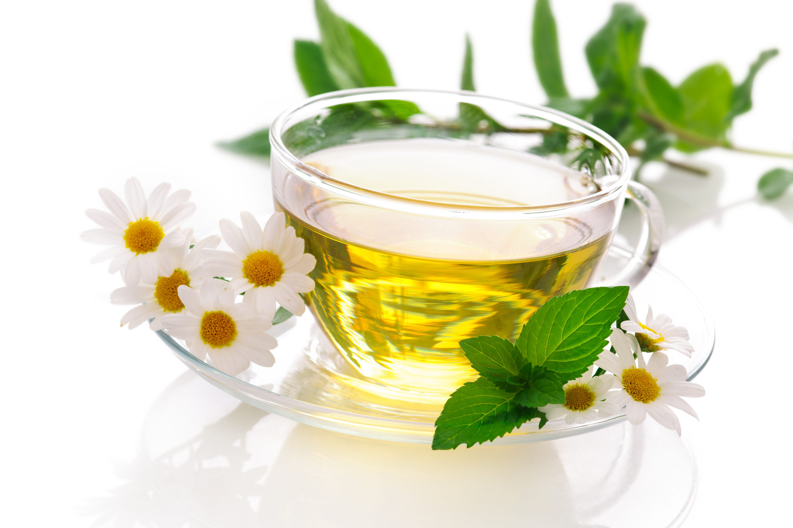
Please visit us at www.myhealthymarket.com.
Our organic marketplace and global supermarket welcomes you!

“Whenever you are creating beauty around you, you are restoring your own soul”
~ Alice Walker

