Media Contact
Kurman Communications, Inc.
Cindy Kurman or Lee Barrie
(312) 651-9000
team@kurman.com

FOR IMMEDIATE RELEASE
Cozy up for a Romantic Night and Delicious Specials this Valentine’s Day at Prairie Grass Cafe

Treat your loved one to a romantic Valentine’s Day dinner at Prairie Grass Cafe (601 Skokie Blvd.; Northbrook, IL) on Tuesday, February 14. Chefs Sarah Stegner and George Bumbaris have created delicious specials in which to indulge.

For savory and sweet flavors, the Roasted Butternut Squash Salad with Pea Shoots, Arugula, Pumpkin Seeds, Sliced Sweet Peppers and Goat Cheese ($10) will excite all taste buds. Other delicious specials include the Sautéed Wild Striped Bass with Cauliflower Puree and Roasted Tri-Color Carrots ($34) and the succulent eight ounce "Creekstone" All-Natural Filet Mignon with a Gruyere-Mushroom-Chive Twice Baked Potato ($45).
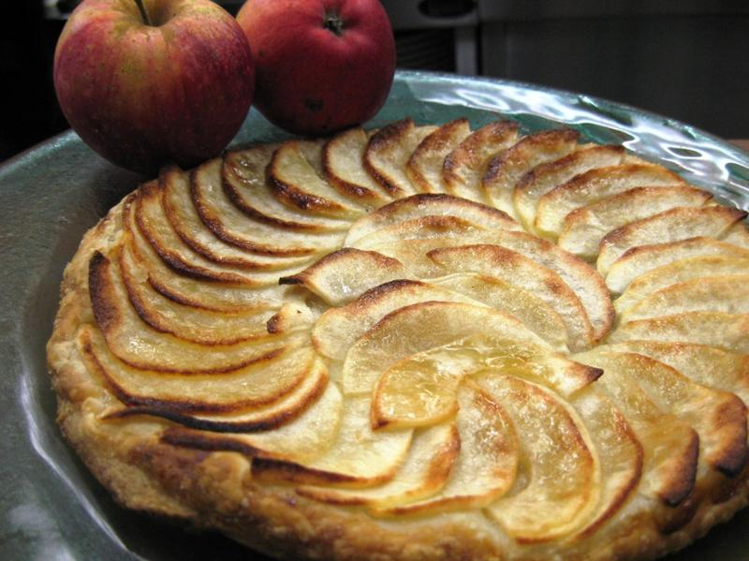
Save room for a scrumptious dessert—Thin Apple Tarts with Crème Anglaise ($12).

Remember to toast to the holiday and your special relationship with a Half Bottle of Bollinger Brut Champagne ($48).

There is no better way to celebrate Valentine’s Day than over delicious food in a welcoming, gracious restaurant such as Prairie Grass Cafe. For reservations please call (847) 205-4433.

About Prairie Grass Cafe
Prairie Grass Cafe (601 Skokie Blvd.; Northbrook, IL; 847-205-4433) supports Chicago’s Green City Market and local sustainable farms, selecting the freshest ingredients to reflect the season. Prairie Grass Cafe currently serves lunch Monday - Friday 11 a.m. to 2 p.m. and dinner Monday through Sunday. Dinner is served Tuesday - Thursday from 5 p.m. to 9:30 p.m., Friday and Saturday from 5 p.m. to 10:30 p.m., and Monday and Sunday 5 p.m. to 9 p.m. Prairie Grass Cafe also serves breakfast Saturdays 10 a.m. to 2 p.m. and Sundays 9:30 a.m. to 2 p.m. Light fare is available in the bar Monday through Friday 2 p.m. to 5 p.m. For more information or to make a reservation, please call (847) 205-4433 or visit prairiegrasscafe.com. Follow Prairie Grass Cafe news at newsline360.com/prairiegrasscafe and on Facebook at Facebook.com/PrairieGrassCafe.

# # #

