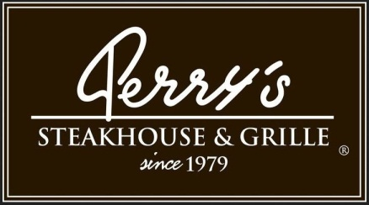

Media Contact:
Kurman Communications, Inc.
Cindy Kurman or Lee Barrie
(312) 651-9000
kurmanstaff@kurman.com

FOR IMMEDIATE RELEASE

Hop to the Chop this Easter with a Delicious Meal at Perry’s Steakhouse & Grille
Opening at 11 a.m. Easter Sunday

Celebrate Easter Sunday with a Sunday Supper special at Perry’s Steakhouse & Grille (5 Oakbrook Court, Oak Brook, IL 60523; 630-571-1808). “Easter Sunday is a time for families to celebrate together with great food,” says Chris Perry, owner of Perry’s Steakhouse & Grille. “We’re pleased to give our guests the opportunity to dine with us after church or for dinner.” In honor of the holiday on April 16th, Perry’s Steakhouse & Grille will open early, at 11 a.m., serving its dinner menu throughout the day and evening. In addition, Perry’s will be offering a special three-course meal from 4 p.m. to 9 p.m. for $29.95 a person.
The special Easter menu consists of a three-course menu: a salad, Perry’s Famous Pork Chop and the dessert trio, making it the perfect meal for ending Lenten fasts.

To start, choose between the Wedge Salad, Spinach & Warm Bacon Vinaigrette Salad, Caesar Salad, Butcher’s Chop Salad with Perry’s famous homemade Italian dressing, Kale Salad with Jalapeño Mint Vinaigrette or the Field Green, Pear & Candied Pecan Salad.

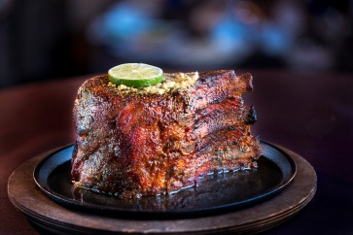
Move onto the main course, Perry’s Famous Pork Chop. A mouth-watering prime chop measuring seven fingers high as an ode to the measuring system used by butchers back in the day, the pork chop is sourced from choice Midwestern farms and butchered in house from the pork loin. Once cut, it’s rubbed with proprietary seasoning, cured and roasted on a rotisserie with pecan wood for up to six hours until it’s sweet, smoky and sizzling. Upon order, the chop is glazed, caramelized, topped with Perry’s signature herb-garlic butter and carved tableside. The pork chop is plated as three portions: the “eyelash” (the most marbled, tender, melt-in-your-mouth section above the eye of the chop), three baby-back ribs and the center-cut loin for the ultimate comforting indulgence.
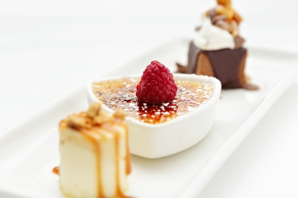
Finish on a sweet note with Perry’s Dessert Trio featuring three of Perry’s finest sweets: Vanilla Bean Crème Brûlée served with fresh berries, Praline Cheesecake and Perry’s Chocolate Crunch, crunchy milk chocolate covered with a dark chocolate ganache, served with homemade whipped cream, toffee and peanut brittle.

Make Easter Sunday reservations by calling (630) 571-1808.

About Perry’s Steakhouse & Grille
Perry’s Steakhouse & Grille has earned a faithful following by perfecting prime since 1979. Beginning as a modest meat market, Perry’s has grown into a renowned group of award-winning restaurants with a stunning array of culinary creations. Perry’s currently operates 13 steakhouse locations in Chicago, Denver, Birmingham and across Texas, with a new location planned for Grapevine, Texas in late 2017 as well as two Perry & Sons Market & Grille locations. For more information and updates on Perry’s Steakhouse, please visit www.PerrysSteakhouse.com.

# # #

