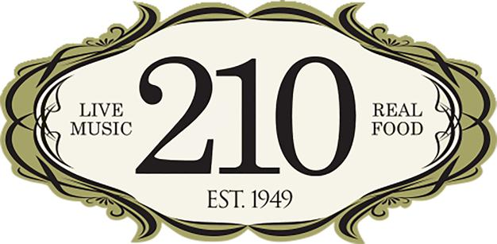

Media Contact:
Kurman Communications, Inc.
Cindy Kurman or Lee Barrie
(312) 651-9000
kurmanstaff@kurman.com

FOR IMMEDIATE RELEASE

210 Restaurant & Live Music Lounge: April News and Music Calendar

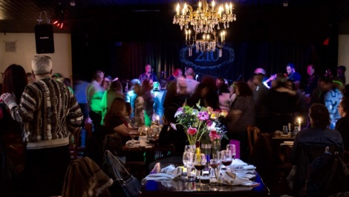
210 Restaurant & Live Music Lounge (210 Green Bay Road, Highwood, IL 60040; telephone: 847-433-0304) continues to grow its following as a sought-after restaurant and live music venue on Chicago’s North Shore. This spacious and sophisticated restaurant features excellent regional American comfort food from accomplished Executive Chef Jeff Tomchek, while offering music lovers a relaxing, beautifully designed setting to hear the region’s top artists. The entertainment represents a wide variety of musical styles, and the performers have been loving the roomy, fully equipped stage, complete with a state of the art sound system, recording system, plus an in-house Kawai concert grand piano and Hammond B-3 organ.

Chef Jeff presents a frequently changing menu of contemporary American cuisine, using fresh locally sourced ingredients whenever possible. From globally inspired delights to barbecue and hearty comfort food, 210 Restaurant & Live Music Lounge offers a full evening of food and entertainment with something for everyone. Be sure to save room for the luscious desserts!

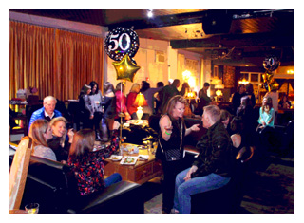
Get the Party Started and Book Upcoming Events Now
Party! Yes, it’s that time of year when spring and summer parties are in full swing. Event planners at 210 Restaurant & Live Music Lounge in Highwood, recommends getting a jump on party planning by booking events early.

“Popular venues like 210 Restaurant tend to book early,” says Yvette Reitmeyer, 210’s in-house planner. From small graduation parties and corporate function to large wedding receptions and reunions, 210 offers groups a lot of fun and flexibility. “Guests looking for something out of the ordinary, you’re come to the right spot,” says Yvette.

Located in the heart of Highwood’s restaurant and entertainment district, 210 is a luxurious, eclectic restaurant that gives off a sophisticated city vibe and has the capacity to comfortably seat 250 guests or provide cocktails and passed appetizers for up to 400. Seating includes high top tables, vintage dining sets and couches so guests can seamlessly transition between eating, dancing and mingling.

All entertainment, from live performers to DJs to picture slide shows and best man speeches, is enhanced thanks to the restaurant’s 24 x 16-foot stage. Programmable LED lighting, a 6’1” Grand Piano, Hammond B-3 organ, full professional audio system and a professional mixer with an operator brings entertainment to a whole new level. 210 Restaurant & Live Music Lounge even offers post-production packages for purchase so guests can cherish the memories for years.

“Ping pong lovers will enjoy our kitchy recreation room with games and a bar.”

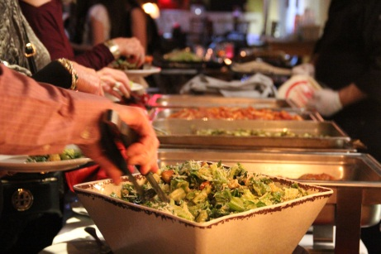
Great food makes any party better and 210’s catering menu shows off the culinary talent of head chef, Jeff Tomchek. For starters, choose 5 hors d’oeuvres from a selection of bite sized portions and tabled portions. The buffet style dinner includes a salad, two entrees and two sides. Additionally, desserts and stations—such as Carved Pit Smoked Beef Brisket, Pad Thai and Chinese Noodles—are also available. Additionally, the menu can be customized to fit specific needs and desires.

The restaurant is beautiful in its standard setup but can be reconfigured to work for all types of events.
View the 210 Party Brochure including the full catering menu to learn more about 210’s party planning services. Schedule a tour with Yvette by calling 847-433-0304.

On Wednesdays Happy Hour is Even Sweeter at 210 Restaurant & Live Music Lounge.
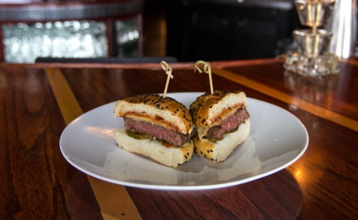
Celebrate Hump Day with a 21+ Happy Hour and an 11 & under free dinner. On Wednesdays, kids 11 and under eat free off of 210’s Kid Menu. Main dishes include Buttermilk-Fried Chicken Fingers, Hamburger, Cheeseburger, Penne with Butter or Marinara or Chicken tacos. In addition, kiddos have their choice of sides—Macaroni & Cheese, French Fries or Peas—and get a scoop of ice cream as dessert. Limit one kid per adult for the free meal. The three course kids menu is always offered for $10.

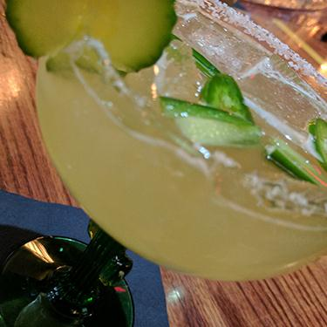
While the kids enjoy their treat, the grown up kids can enjoy their own. Unwind from a long work day with $4 drafts, $5 mixed drinks and $6 house wine as well as two appetizers for the price of one. Appetizers include delicious soups, the Classic Shrimp Cocktail, Korean or Buffalo Chicken Wings, Bacon-Wrapped Dates, Hand-Cut Fries, Israeli Platter and more. View the full dinner, cocktail and dessert menus.

Happy Hour is enjoyed from 5-7 pm every Wednesday and Thursday 210 Restaurant & Live Music Lounge.

210 RESTAURANT & LIVE MUSIC LOUNGE’S APRIL LIVE MUSIC CALENDAR
210 Restaurant & Live Music Lounge is bringing first class performers to the restaurant to satisfy the music cravings of its varied North Shore and Chicagoland audience. Wednesdays showcase the Highland Park Pops Big Band monthly and a selection of acoustic acts for dining and listening. Thursdays and Sundays boast top shelf jazz trios and quartets. On Fridays and Saturdays, the music kicks up a notch with funk, rock or dance music that begins around 9 p.m., so guests can enjoy a delicious conversation-friendly dinner before getting their groove on.

The music calendar for April includes:

Day | Date | Times | Performer | Genre
Friday | April 7 | 9 PM-12 AM | Shout Out- Ticketed Event | Dance
Saturday | April 8 | 8:30-11:30 PM | Max Weinberg and The Rory David Deutsch Foundation Fundraiser- Ticketed Event | Rock
Sunday | April 9 | 7-10 PM | Jack Wilson Guitar Wizard | Jazz
Wednesday | April 12 | 7:30-9:30 PM | Highland Park Pops Big Band | Jazz, Big Band
Thursday | April 13 | 7-10 PM | Makaya McCraven – Cover at Door | Jazz
Friday | April 14 | 9 PM-12 AM | Sam Cockrell- Ticketed Event | Soul, Funk, R&B
Saturday | April 15 | 9 PM-12 AM | 8 Miles South - Ticketed Event | Southern/Classic Rock, Country
Monday | April 17 | 7:30-10 PM | Louis Zagoras hosts The 210 Blues Jam! | Blues
Wednesday | April 19 | 7:30-10:30 PM | John Erickson Piano Bar | Jazz
Thursday | April 20 | 7-10:30 PM | Joe Policastro Trio | Jazz
Friday | April 21 | 9 PM-12 AM | Tributosaurus Does Crosby Stills Nash & Young- Ticketed Event | Rock
Saturday | April 22 | CLOSED | PRIVATE EVENT | --
Sunday | April 23 | 7:30-10 PM | Brad Cole Band | Jazz, Standards, Rock, Blues
Wednesday | April 26 | 7-10 PM | Fred Simon Solo Piano Presentation- “Songs of my Youth” | Jazz
Thursday | April 27 | 7:30-10:30 PM | Big Time Wookie–Cover at Door | Rock
Friday | April 28 | 9 PM-12 AM | Not For Profit Band (Fundraiser) - Ticketed Event | Rock
Saturday | April 29 | 9 PM-12 AM | Mr. Blotto – Ticketed Event | Jam Band
Sunday | April 30 | 7 PM-10 PM | Lara Driscoll Trio | Jazz, Standards

ARTIST INFORMATION:

Shout Out, Friday, April 7, 9pm-12am
Since 1997 Maggie Speaks has been honing the craft of live music performance and Shout Out continues this pursuit with some of the finest performers in Chicago. Delivering high energy, non-stop performances Shout Out is playing the music that brings you to the dance floor! Learn more about the band here.

Buy tickets now before the concert sells out. Tickets are $10. Dinner guest please RSVP online by phone at 847-433-0304, in advance, as reservations are expected to sell out.

The Rory David Deutsch Foundation, Saturday, April 8, 8:30 pm – 11:30 pm
The Rory David Deutsch Foundation’s April 8 fundraiser will feature the legendary drummer of Bruce Springsteen's E Street Band and recent Rock & Roll Hall of Fame inductee Max Weinberg. The benefit is open to the public. Tickets are $200 per person and $350 per couple. Tickets may be purchased here.

Jack Wilson Guitar Wizard, Sunday, April 9, 7pm-10pm
Jack Wilson is an accomplished guitarist from the Chicagoland area. Playing everything from hard rock and heavy metal, to bluegrass and country standards, to jazz and classical guitar, Jack captivates all types of music lovers.

He has released one cd appropriately titled "Fidgety Digits" that demonstrates his fingerstyle arranging and writing abilities. He immediately gets your attention on the opening track by producing a cowbell sound from the guitar from his version of "Low Rider" by the band War. He is currently working on some of his original material, as well as another fingerstyle cd to be released in the near future. There is no cover charge.

Highland Park Pops Big Band, Wednesday, April 12, 7:30pm-9:30pm
Highland Park Pops Big Band is Swingin’ in Spring! The Highland Park Pops Big Band is a 17-piece jazz band that plays swing tunes, jazz favorites, dance music and big band standards and has kept jazz from the big band era alive on the North Shore for the past three decades, playing the classic and popular arrangements of Count Basie, Duke Ellington, Woody Herman, Stan Kenton and many other renowned artists and styles. The music is timeless, and the full, brassy sound is enjoyed by music lovers of all ages at outdoor programs, civic functions and dances. There is no cover charge. Learn more here.

Makaya McCraven, Thursday, April 13, 7 pm-10pm
Makaya McCraven, recently returned from his first European tour, has innumerable accolades including Billboard Magazine, the Los Angeles Times, and Wall Street Journal. Says Billboard, “McCraven expands his entry into the eternally popular realm of jazz-inflected beat-making (and groove-oriented jazz-making) with this re-release, a polished effort that begs for (but doesn’t require) rappers to add their take on top.”
According to the LA Times, Best of 2015: 2015’s must-hear jazz albums carve new paths and communicate eloquently. “Capturing a sound informed by hip-hop’s cut-and-paste beat constructions as much as Teo Macero, McCraven distilled the results into an album that forms an infectious, innovative celebration of creation and the almighty groove.”
Advance reservations are encouraged. RSVP online or by phone at 847-433-0304. There will be a $10 cover at the door.

Sam Cockrell, Friday, April 14, 9pm-12am
Growing up in the Blues territory of Chicago’s South Side, Sam knew the area’s biggest blues names but was not drawn to the genre. Instead, his early influencers were rock bands such as Grand Funk Railroad, Yes, the Doobie Brothers and Steely Dan as well as soul and R&B music starts like Sly and The Family Stone, The Commodores and Michael Jackson. As he matured, Sam developed his own eclectic style characterized by his open-minded attitude towards music and unwillingness to play what was expected of a black musician. His music takes on contemporary and age-old issues with sincerity but mixes in humor and spirit, culminated in high-spirited music that makes people happy.

Advance reservations are encouraged. Buy your ticket now. Tickets are $10. Dinner guest please RSVP online or by phone at 847-433-0304.

8 Miles South, Saturday, April 15, 9pm-12am
8 Miles South is group of lucky bandolero musicians whose paths crisscrossed over 20 years until they formed a musical intersection of southern/classic rock, country and zydeco. Playing a tasty gumbo of southern flavored feel good music from the Allman Brothers, Lynyrd Skynyrd, Little Feat, Jackson Brown, Eagles, Johnny Cash, Meryl Haggard, Doobie Brothers and anything else on the radio during the late '60's and early '70's, these guys are serving up a party you don’t want to miss.

Advance reservations are recommended. Buy your tickets now. Tickets are $10. Dinner guest are encourage to RSVP online or by phone at 847-433-0304 as performance seating is expected to sellout.

Blues Jam with Louis Zagoras, Monday, April 17, 7:30pm-10pm
Calling all musicians. Join the 210 Restaurant & Live Music Lounge open jam session Monday, April 17. Louie Zagoras, founder, lead singer/lead Guitarist and primary songwriter of Rollover, will be tonight’s guest host. Louie and Rollover toured the States back and forth in the 90's when Rollover’s first record broke big on Chicago's 93.1 WXRT FM radio. Louie's song "Shipwreck" was the break-out single. His sound is described as "Roots Rock meets the Blues". Louie was the first Chicago Rock Artist ever to be signed by the Legendary Bill Graham Management (Santana, Lynyrd Skynyrd, The Neville Brothers, Joe Satriani etc.). Learn more about Louis and his band here.

John Erickson Piano Bar, Wednesday, April 19, 7pm-10pm
John Erickson, of The John Erickson Trio, will be playing a special solo piano performance you won’t want to miss. Swing by 210 for some delicious food and wonderful live music.

Joe Policastro Trio, Thursday, April 20, 7:30pm-10:30pm
Chicago bassist, composer and arranger Joe Policastro grew up in the fertile jazz, classical, and popular music scene of Cincinnati, OH. He studied Classical Double Bass Performance on full scholarship at Miami University. Joe earned his Bachelor of Music in Jazz/Studio Music from the College Conservatory of Music at the University of Cincinnati and his Master of Music in Jazz Studies from DePaul University in Chicago. After performing and recording in Germany, he settled in Chicago where he quickly established himself an in-demand musical voice as both performer and composer/arranger. He has performed and recorded with jazz luminaries such as Diane Schuur, Jeff Hamilton, Howard Levy, Phil Woods, Tim Ries, Ira Sullivan, Howard Alden, Rick Margitza, Jim Snidero, David "Fathead" Newman, and Billy Hart.
He leads the Joe Policastro Trio, and the group has two albums featuring his writing, arranging, and performing: 2013's West Side Story Suite For Jazz Trio and 2016's Pops! He also leads and co-leads the Gerry Mulligan-esque ensembles, Jeru, and the Mulligan Mosaics Big Band and the Mulligan Mulligan Mosaics Nonet for which he has extensively written and arranged. As composer/arranger, his work can be heard on recordings by numerous artists including Ira Sullivan and the Rob Parton Big Band.

As an educator, he has been a Ravinia Jazz Mentor, a Lecturer of Jazz Studies at DePaul University, and he is currently on faculty at Morton College, the Chicago Academy for the Arts, and the Midwest Young Artists Conservatory. Learn more about Joe here.

Tributosaurus Does Crosby Stills Nash & Young, Friday, April 21, 9pm-12am
Tributosaurus, Chicago’s top-tier tribute band, is playing Crosby, Stills, Nash & Young for a rockin night of fun. The band usually only performs this show at festivals but is making an exception and bringing cool grooves, psychedelic overtones and amazing harmonies of classic American music to 210 Restaurant. Chef Jeff is offering a limited (but awesome as always) dinner menu for the event.

Buy your tickets now as the performance is expected to sell out. There are three tiers of tickets being offered:

STANDING ROOM ONLY (SRO): Tickets are priced per person and are $25 in advance through Eventbrite and $35 "day of" at the door.

DINING TABLE SEATING: Tickets will be purchased through OpenTable and are $35 per person.

VIP SEATING: Reservations are for a whole section of couches or the chill vestibule area beside the front door and include a number of tickets commensurate with the size of each section. Ticket counts include 4 people per physical couch and 1 person per lounge chair and are priced between $400 and $550 for 8-11 people. Purchase VIP seating here.

Brad Cole Band, Sunday, April 23, 7:30pm-10pm
The songs of Brad Cole address the ups and downs of the human condition with both wit and raw insight. His passionate and distinctive delivery of roots-based folk music, woven with the grit and groove of old school bossa and rhythm & blues moves the listener’s soul in a direction that is unexpected, yet perfectly familiar. Cole has been a fixture on the Chicago music scene for years, performing alongside artists that make up the fabric of the city’s musical legacy such as Uncle Tupelo and the Smashing Pumpkins. Brad led several Chicago based bands including Treatment, The Second Story and toured with NYC-based The Subscribers. Along with singer-songwriter Jeff Libman, he is co-founder of the acoustic/soul collective known as Check With Lucy. He was also a longtime member of Chicago’s Old Town School of Folk Music’s monthly “Songwriters Forum”. Brad continues this collaborative acoustic tradition with his acclaimed songwriters’ performance series, “Acoustic Circus”. Learn more about the band here.

Advance reservations are recommended. Tickets are $10 each. Purchase tickets here. Dinner guest please RSVP online or by phone at 847-433-0304, in advance, as we anticipate that our dining and lounge areas will commit early.

Fred Simon’s “Songs of my Youth”, Wednesday, April 26, 7-10pm
Chicago keyboardist Fred Simon will play a special solo piano featuring favorite songs from his youth. Selections may include music by The Beatles, Joni Mitchell, James Taylor, Stevie Wonder, Carole King, Leonard Cohen, The Beatles, Neil Young, Grateful Dead, Jimmy Webb, Paul Simon, The Police, and, of course, The Beatles.

Big Time Wookie, Thursday, April 27, 7:30-10:30pm
Big Time Wookie brings the best jams this side of the Dagobah System to 210 Restaurant & Live Music Lounge 7:30-10:30 pm Thursday, April 27. Featuring Grateful Dead grooves with a healthy side of Phish, Allman Bros., Traffic and more, Big Time Wookie focuses on ripping solos, soaring harmonies, and tight jams that will keep you on your toes. Always expect the unexpected with BTW, and be ready to groove.

RSVP online or by phone at 847-433-0304 as we anticipate that our dining and lounge areas will commit early. There will be a $5 cover at the door.

Not For Profit Band (Fundraiser), Friday, April 28, 9pm-12am
Not for Profit and Holy Cross join forces to benefit St. Malachy School in Chicago 9pm-12am, Friday, April 28 at 210 Restaurant & Live Music Lounge. Not for Profit is a Chicago area band that hosts fundraisers for charities. Since 2007, they have raised over $1.6 million for a myriad of charitable causes.
Honoring the memory of Mary Jo Homan, Not for Profit will be playing a fundraiser/concert for St. Malachiy's School in Chicago. Mary Jo was a dedicated supporter of St. Malachy's, the sharing parish of Holy Cross Parish in Deerfield and Friends of St. Malachy's at Holy Cross. Not for Profit will rock the house at 210 in Mary Jo's memory and raise money for St. Malachy's. If you can't make the show but would like to donate, visit: https://www.givecentral.org/location/384/event/8846

Advance reservations are recommended. Tickets are $10 and all proceeds go to charity. Purchase tickets here. Dinner guest please RSVP online by phone at 847-433-0304 as seating in the dining and lounge areas will commit early.

Mr. Blotto, Saturday, April 29, 9pm-12am
Mr. Blotto was born in Chicago as an off-night vehicle for musicians who loved each other’s playing but were in different bands at the time. The only rule was that they would only play what they absolutely loved to play. That philosophy continues to this day and has led Mr. Blotto into unique musical situations.

Mr. Blotto takes the Jam band aesthetic into areas unfamiliar to the standard Jam Scene. They have been known to cover entire albums by Led Zeppelin and The Who as well as perform entire shows of Country and Reggae. Artists as diverse as the Grateful Dead, the Flaming Lips, Willie Nelson and The Velvet Underground have seen their material interpreted by Mr. Blotto in the 2400+ shows the band has performed in the last 20 years.

Mr. Blotto draws from a 300+ song list. It starts from the band's Original Material, which is drawn from 5 released and 2 as-yet unreleased CD's as well as a wealth of unrecorded songs. Mr. Blotto builds its sets on these 100 or so Original songs and peppers the rest of the sets with material from sources as varied as Dancehall, Reggae and Outlaw Country with some Chicago Blues thrown in for good measure. Set lists vary depending on the setting, but rely primarily on the Original Material, with no two shows being the same.

"Barlow Shanghai", the 5th and latest CD was released in 2006 and saw the band in collaboration with John Perry Barlow (lyricist to the Grateful Dead).

Reservations are recommended. Tickets are $15 and may be purchased here. Early reservations for dinner are encouraged. Please RSVP online or by phone at 847-433-0304 as dinner and lounge seating areas are expected to commit early.

Lara Driscoll Trio, Sunday, April 30, 7pm-10pm
Lara Driscoll is a French-American pianist and composer from Chicago. While recently completing her masters in Jazz Performance at McGill University in Montreal, Canada, she performed at the Montreal Jazz Festival, recorded an album of her original trio compositions and taught jazz piano, theory and history at McGill.

A versatile artist with a passion for expressive communication through music, Lara has performed in venues such as The Jazz Showcase, Andy's Jazz Club, Chicago Symphony Center, Krannert Center, Pickstaiger Hall, Peoria Bach Festival, Bowery Poetry Club, Montreal Jazz Festival, Upstairs Jazz Bar, The LilyPad and has shared the stage with artists such as Terrell Stafford, Jim Pugh, Dick Oates, Fred Wesley, Larry Gray, Andre White, Joel Miller, Jean Michel Pilc and Kevin Turner. Learn more about Lara and her current projects here.

About 210 Restaurant and Live Music Lounge
210 Restaurant & Live Music Lounge, located at 210 Green Bay Road in Highwood, Illinois, is a true supper club where guests enjoy live music five nights a week and delicious chef-driven dining. 210 is a community of musicians, food enthusiasts, and neighbors–an inviting, comfortable and romantic environment where singles, couples and families escape from their everyday life to relax, enjoy and indulge. 210 Restaurant & Live Music Lounge is open 5 p.m. to midnight Wednesday, Thursday and Sunday and from 5 p.m. to 2 a.m. Friday and Saturday.

For more information, please visit www.210restaurant.com or call (847) 433-0304. Receive regular updates to their music schedule by following 210’s newsroom at www.newsline360.com/210restaurantandlivemusiclounge, like 210 on Facebook at https://www.facebook.com/210highwood/, follow on Twitter @210Restaurant and on Instagram.

