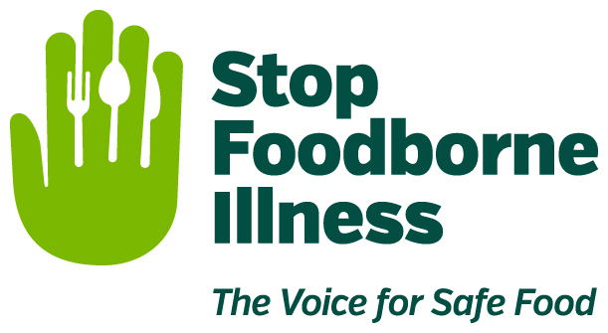

Media Contact:
Kurman Communications, Inc.
Cindy Kurman or Elisa Rascia
(312) 651-9000
team@kurman.com

FOR IMMEDIATE RELEASE

Produce Safety a hot topic at Global Food Safety Initiative’s 2017 Conference
Stop Foodborne Illness CEO, Deirdre Schlunegger, Weighs-In

Last month, Deirdre Schlunegger, Stop Foodborne Illness’ CEO, joined a panel of experts at the Global Food Safety Initiative (GFSI) 2017 conference to discuss produce safety, a hot topic for food industry professionals. The Food Safety Modernization Act’s (FSMA) Produce Safety Rule, (first proposed in January 2013) is now final and farms are implementing the rule’s mandates.

“The rule establishes mandatory science-based, minimum standards for the safe growing, harvesting, packing, and holding of fruits and vegetables grown for human consumption,” says Schlunegger. “These standards are designed to reduce the presence of potentially dangerous bacteria in the food supply, and set, as their definitive goal, a significant reduction in the number of illnesses caused by contaminated produce.”

Produce food safety is exceptionally important and yet, difficult, because there are many different stages where a pathogen carrying foodborne illness can be introduced to food. From growing, to shipping, to storage, to handling, to display and sale, produce needs to be safely managed at every step.

While those who handle food are on the front lines of making food safer for consumers, the work of Stop Foodborne Illness is an important second line of defense.

An advocate for achieving and maintaining a safe food supply, Stop helps food companies develop a strong food safety culture and sound practices. By sharing the stories of those hardest hit by foodborne illness through video projects, speaking engagements, webinars and increased consumer education and outreach, Stop Foodborne Illness gets to the heart of the matter – the WHY of food safety.

At the GFSI conference, Stop represented the consumer perspective. Schlunegger reiterated that food safety must be practiced from the beginning of the food supply and all the way through to the consumers’ tables.

As Bob Whitaker, Chief Science & Technology Officer at the Produce Marketing Association and a key presenter at the session, pointed out, safe practices means different things to different segments of the supply web. Whittaker emphasized that safe produce is not just up to domestic producers. Those in retail, foodservice and the FDA are crucial to securing safe produce for everyone.

Fully addressing FSMA’s Produce Safety rule requires four steps: awareness, understanding, implementation and verification. Integrating the rule into the produce industry is an ongoing challenge but, fortunately, it is being met with a lot of support. A large percentage of the industry is engaged in food safety talks and, aided by accelerated research, education and outreach by associations and commodities, adoption of strong food safety practices continue to push forward.

The Global Food Safety Initiative is a collaboration between many of the world's leading food safety experts in the retail, manufacturing and food service sectors and service providers associated with the food supply chain. GFSI strives to ensure confidence in the delivery of safe food to consumers. Drawing from collective concerns across the industries, GFSI works on food safety issues that affect the entire supply chain and benchmarks food safety management schemes against a set of requirements established by its stakeholders.

About Stop Foodborne Illness
Stop Foodborne Illness is a national nonprofit, public health organization dedicated to preventing illness and death from foodborne pathogens by advocating for sound public policy, building public awareness, and assisting those impacted by foodborne illness. For more food safety tips please visit http://www.stopfoodborneillness.org/awareness/. If you think you have been sickened from food, contact your local health professional. You may subscribe to receive Stop Foodborne Illness e-Alerts and eNews here: http://www.stopfoodborneillness.org/take-action/sign-up-for-e-alerts/.

For questions and personal assistance, please contact Stanley Rutledge, Community Coordinator, at srutledge@stopfoodborneillness.org or 773-269-6555 x7.
# # #

