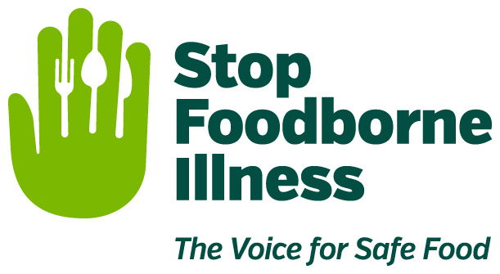

Media Contact:
Kurman Communications, Inc.
Cindy Kurman or Elisa Rascia
(312) 651-9000
team@kurman.com

FOR IMMEDIATE RELEASE

Michael Taylor, Gillian Kelleher and Adrian Esparza
Join the Board of Stop Foodborne Illness

Stop Foodborne Illness, a national nonprofit public health organization dedicated to the prevention of illness and death from foodborne pathogens, announces three new members of its board: Michael Taylor, Gillian Kelleher and Adrian Esparza. Their diverse backgrounds and dedication to making the world a safer place will strengthen Stop’s collaborative approach to advocating for sound public policy, building public awareness and assisting those impacted by foodborne illness. Stop has touched many lives since its founding in 1993.

Michael Taylor served until June 2016 as Deputy Commissioner for Foods and Veterinary Medicine at the Food and Drug Administration (FDA), where he led implementation of the Food Safety Modernization Act of 2011. Following the tragic and historic Jack in the Box outbreak of foodborne illness in 1993, he served as administrator of the USDA Food Safety and Inspection Service (FSIS), where he led modernization of the meat and poultry safety program, including establishing the principle of industry responsibility for preventing contamination with such pathogens as E. Coli O157H7.

“Stop Foodborne Illness changed the trajectory of my professional life,” he recalls. As Administrator of FSIS, Taylor met with Nancy Donley and Mary Heersink who told him stories of their personal losses from E. Coli O157H7. The meeting was profound for Taylor because it “made food safety personal for me and provided the inspiration and energy to make things better, not only for me, but for thousands of people in government and industry who are working hard to make things better.”

The deeply personal dimension of food safety also inspired Gillian Kelleher, VP of Food Safety & Quality Assurance at Wegmans Food Markets Inc., to pursue a collaborative relationship with Stop. “Stop is centered on consumers and what’s best for them. It strikes me that Stop is all about meaningful change and making steady improvements that make our food supply safer for all consumers,” she says, emphasizing that food safety has “never been about meeting legal requirements when it comes to preparing and selling food—that’s a given for us. It’s about doing what’s right—for our customers, our employees, and our families. Partnering with Stop helps us put a big exclamation point on this.”

Although those working in the food industry are responsible for ensuring food safely moves from farm to grocery store to table, “food safety is everyone’s business,” Kelleher says, quoting her CEO.

Everyone has a bond with food—it sustains life and connects people to others—thereby holding all consumers accountable for eating and sharing safe food. New Stop board member Adrian Esparza says, “I think how we experience food needs to be protected as our nation continues to grow…with the right governance, tools, education, and transparency, foodborne illness is preventable.” Unlike Taylor and Kelleher, Esparza does not work in the government or food industry, but as a data scientist at a cloud-based technology company, Vail Systems. Still, food safety is a subject he holds close to his heart after contracting a foodborne illness while studying abroad in the Dominican Republic.

Experiencing the devastating illness in a developing country inspired Esparza to use his quantitative background and love for food and restaurants to help ensure people around the world have access to safe food. “As we continue to learn more about foodborne illness and how to curb its effects,” he says, “My hope is that we can provide a set of measures or protocols for people here and in developing nations in a cost-effective way so that we can improve quality of life, increase awareness, and make people safer.”

Taylor reiterates Esparza’s point, agreeing that much has been accomplished by the food industry but much more needs to be done to strengthen food safety culture and practices across the food system. “Stop’s strong stand for more than 20 years helped trigger a shift in mindset that has been key to the elevation of both government policy and food industry practices,” says Taylor.

The organization and its members are in a great position and ready to work with farmers, processors, and retailers to instill a strong culture of individual responsibility for food safety and deep institutional commitment to continuous, science-based improvement in standards and practices across the entire food system.

About Stop Foodborne Illness
Stop Foodborne Illness is a national nonprofit, public health organization dedicated to preventing illness and death from foodborne pathogens by advocating for sound public policies, building public awareness and assisting those impacted by foodborne illness. For more food safety tips please visit http://www.STOPfoodborneillness.org/awareness/. If you think you have been sickened from food, contact your local health professional. You may subscribe to receive Stop Foodborne Illness e-Alerts and eNews here: http://www.STOPfoodborneillness.org/take-action/sign-up-for-e-alerts/.

For questions and personal assistance, please contact Stanley Rutledge, Community Coordinator, at srutledge@STOPfoodborneillness.org or 773-269-6555 x7.

Professional Biographies:

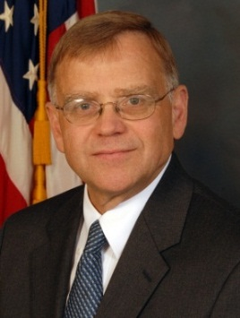
Michael Taylor
Taylor got his start in food safety at the Food and Drug Administration (FDA) as a staff attorney (1976-80) and served as the FDA’s Deputy Commissioner for Policy (1991-94) before moving to the USDA where he served as Administrator of the Food Safety and Inspection Service and Acting Under Secretary for Food Safety (1994-96). Before rejoining the FDA in 2009, Taylor spent close to a decade conducting food safety, food security and public health policy research and serving as a Senior Fellow at the Partnership to Cut Hunger and Poverty in Africa, where he conducted research on U.S. policies affecting agricultural development and food security in Africa. In his third stint at the FDA as the Deputy Commissioner for Foods and Veterinary Medicine, Taylor led the comprehensive overhaul of FDA’s food safety program Congress mandated in the Food Safety Modernization Act of 2011 and oversaw all of FDA’s food-related activities, including its nutrition, labeling, food additive, dietary supplement, and animal drug programs. Taylor is currently a senior fellow at the Meridian Institute, focusing on food safety globally and food security in Africa and other developing regions.

In the private sector, Taylor founded the food and drug practice and was a partner in the law firm of King & Spalding, was Vice President for Public Policy at Monsanto Company, and served on the boards of the Alliance to End Hunger and RESOLVE, Inc. He is currently a member of the board of Clear Labs, Inc.

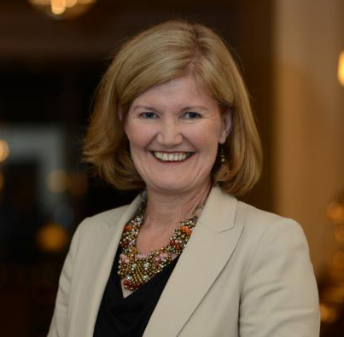
Gillian Kelleher
Kelleher started her career with Express Foods Group in England where she worked at various locations in manufacturing Quality Assurance. From there, she moved to Burger King Europe in London to work as a Supplier Quality Assurance Auditor and in 1992, relocated to France to work as a plant Quality Assurance Manager at Häagen Dazs’ green field European manufacturing site. Kelleher’s next Stop was with Grand Metropolitan Foods Europe where she served as Senior Quality Assurance Manager and was responsible for all aspects of Quality Assurance for eight manufacturing locations in four countries. Currently, Kelleher works for Wegmans Food Markets, Inc., a mid-Atlantic grocery chain, where she has been the VP of Food Safety & Quality Assurance since 1997.

For over three years, Kelleher has been central to cultivating Wegmans’ relationship with Stop Foodborne Illness.

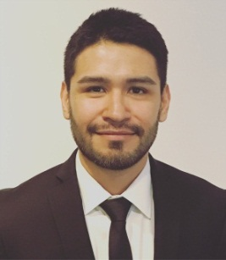
Adrian Esparza
Esparza earned his B.A. in Economics at the University of Illinois at Chicago and his M.S. in Statistics at the University of Massachusetts, Amherst. From there, Esparza worked in education for the University of Chicago. As a statistician, he worked on research projects that empirically tested the effects public policies or interventions programs have on the development, education, and general well-being of vulnerable populations. After leaving the University of Chicago, Esparza took a post at University of Wisconsin, Madison with their Value-Added Research Center (VARC) where he oversaw the Atlanta Public Schools Value-Added program, including the district’s yearly estimation of teacher and school effectiveness, and provided statistical support to other school districts seeking to uncover meaningful patterns in academic data to improve educational outcomes. For the past 3 years, he has worked with various Chicago technology companies to build predictive models and recommendation engines that deliver measurable benefits to the end-user of products and services. Esparza currently works as a Data Scientist at Vail Systems interpreting historical telephony data in ways to distinguish cause from coincidence to evaluate consequences of alternative policy and decisions.

Esparza is primarily interested in education and using science to learn more about how the world works and using that knowledge to control it.

# # #

