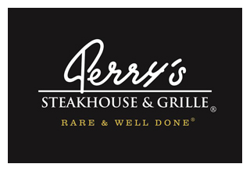

Media Contact:
Kurman Communications, Inc.
Cindy Kurman or Elisa Rascia
(312) 651-9000
kurmanstaff@kurman.com

FOR IMMEDIATE RELEASE

Meet the “Strait Paloma,” a New Cocktail inspired by George Strait at Perry’s Steakhouse & Grille in Oak Brook

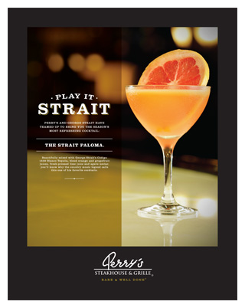
Forget salt and lime; Perry’s Steakhouse & Grille (5 Oakbrook Court, Oak Brook, IL 60523; 630-571-1808) is introducing a new way for people to enjoy tequila. Launching April 18, the Strait Paloma is a delicious ode to country music legend George Strait, King of Country and notable investor of Código 1530 Blanco Tequila.

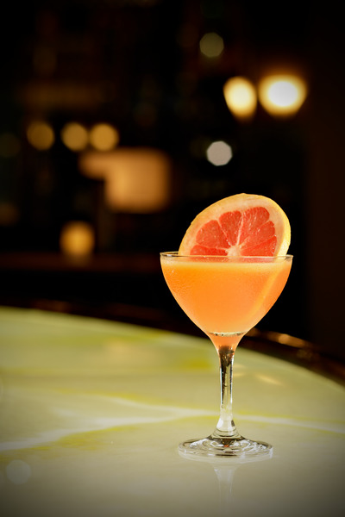
For most people, drinking tequila is a distant memory associated with burning shots in college bars. However, Código 1530 Blanco Tequila is a high quality blanco. When mixed with blood orange and grapefruit juices, fresh-pressed lime juice, agave nectar and beautifully garnished with a blood orange wheel, this cocktail is refreshingly delicious.

The Strait Paloma is the perfect drink for unwinding from a long work week at Social Hour in Perry’s Bar 79 or for enjoying during dinner in the dining room. Try one today and see why it’s one of George Strait’s favorite cocktails. View Perry’s dinner menu and wine list. To make reservations, call 630-571-1808.

About Perry’s Steakhouse & Grille
Perry’s Steakhouse & Grille has earned a faithful following by perfecting prime since 1979. Beginning as a small butcher shop, Perry’s has grown into a renowned group of award-winning restaurants featuring USDA Prime beef, tableside carvings, signature selections, flaming desserts and handcrafted cocktails at its Bar 79. Specializing in a Rare and Well Done experience, Perry’s currently operates 13 steakhouse locations in Chicago, Birmingham, Denver, and across Texas, as well as the two original butcher shops now known as Perry & Sons Market & Grille. A new Perry’s Steakhouse will be opening in Grapevine, Texas late 2017. For more information and updates on Perry’s Steakhouse, please visit www.PerrysSteakhouse.com.

# # #

