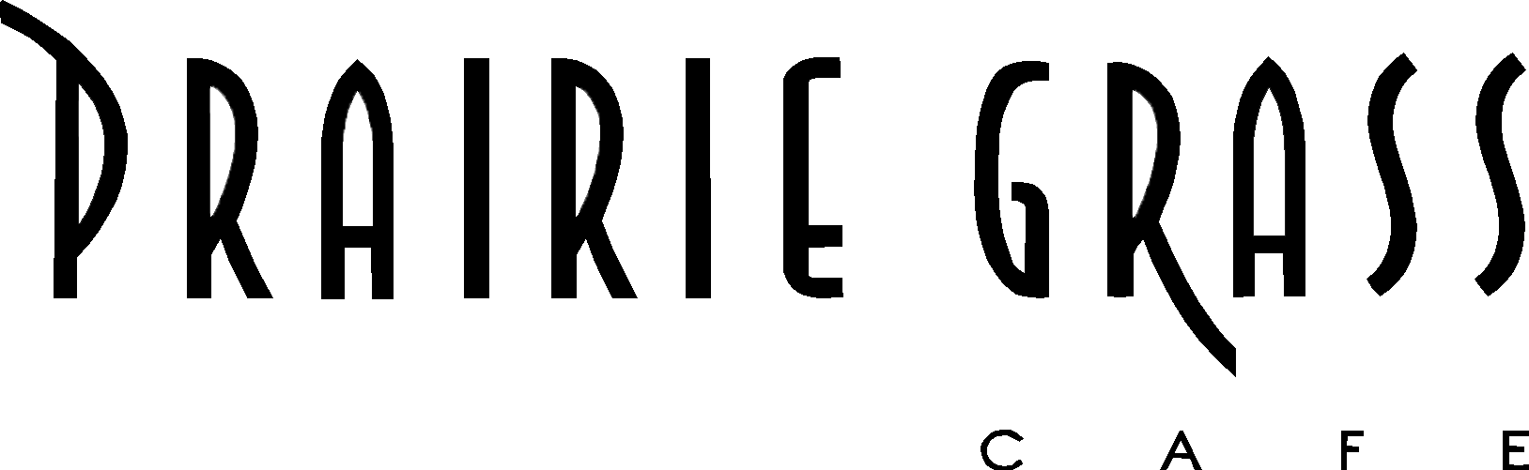
Media Contact:
Kurman Communications, Inc.
Cindy Kurman, Lee Barrie or Elisa Rascia
(312) 651-9000
kurmanstaff@kurman.com

FOR IMMEDIATE RELEASE

Treat Mom to an Extravagant Mother’s Day Brunch
at Prairie Grass Cafe in Northbrook

Celebrate Mom with an extravagant brunch buffet at Prairie Grass Cafe (601 Skokie Blvd, Northbrook, IL 60062; 847-205-4433). Mother’s Day Brunch will be served buffet style from 10 a.m. to 1:30 p.m., Sunday, May 14. The price is $49.50 for adults and $18 for children 10 and under. View the full Mother’s Day Brunch menu online. Reservations are strongly recommended.
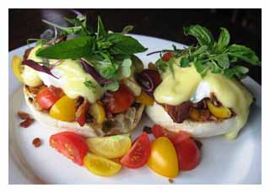
Each guest starts with the popular signature “PGC Benedict” featuring a perfectly poached egg on top of spinach and served with a roasted tomato Hollandaise sauce. Mm m

After the Benedict, dive into the buffet. Starters and vegetables feature spring’s delightful produce: Grilled Asparagus with a Lemon-Feta Vinaigrette and Sliced Radishes; Mighty Vine Tomato Salad with Cucumber, Jicama, Micro-Greens and Red Wine Vinaigrette; Tuna Tartare served with Wonton Chips and a Mixed Green Salad with Fresh Peas, Endive, Radicchio, Pea Shoots, Arugula and a Cider Vinaigrette.

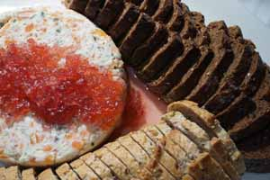
Load your plate with mouthwatering sides like a Baked Goat Cheese Cake with Berry Sauce; Warm Brie with Raspberry Jam in Puff Pastry; Applewood Smoked “Maple Creek Farm” Bacon; Homemade Maple Breakfast Sausage; Mashed Potatoes. Enjoy a luscious assortment of baked goods: Crusty Multi Grain Artisan Breads, Mini Chocolate Croissants, Cheese Danish, Raspberry Jam Danish and Sticky Pecan Rolls.

The stars of the brunch—besides Mom—include skin-on and bone-in Roasted Chicken Breast with Wild Rice, Roasted Grapes and Toasted Pine Nuts; Braised Lamb with Spicy Chipotle Sauce, Carrots, Onions, Tomatoes, Garlic and Potatoes; Parmesan Crusted Tilapia with Creamed Spinach; and Mini Bagels topped with Smoked Sliced Salmon, Creamed Cheese, Chives, Limes and Capers.

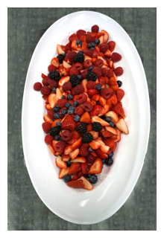
A Mother’s Day Buffet at Prairie Grass Cafe wouldn’t be complete without someone cooking and carving for Mom. Enjoy a carved to order Roasted All-Natural New York Loin with Mushroom Sauce; a Fresh Hot Waffle Station with Maple Syrup; and an Omelet Station with a variety of fixings including onions, peppers, tomato, ham, cheddar cheese, mushrooms and spinach.

For those with an insatiable sweet tooth, there will be more than enough mouth-watering sweets at the Dessert Buffet to satisfy all cravings. Enjoy fresh fruit and berries; Double Chocolate Cup Cakes with Butter Cream Icing; Mom’s Fruit Cream Pie; Strawberry Rhubarb Crumble; and Mini Cream Filled Éclairs. Or, order a crepe at the Crêpe Station where toppings include chocolate, whipped cream, raspberry jam and apple butter.

About Prairie Grass Cafe
Prairie Grass Cafe (601 Skokie Blvd.; Northbrook, IL; 847-205-4433) supports Chicago’s Green City Market and local sustainable farms, selecting the freshest ingredients to reflect the season. Prairie Grass Cafe currently serves lunch Monday - Friday 11 a.m. to 2 p.m. and dinner Monday through Sunday. Dinner is served Tuesday - Thursday from 5 p.m. to 9:30 p.m., Friday and Saturday from 5 p.m. to 10:30 p.m., and Monday and Sunday 5 p.m. to 9 p.m. Prairie Grass Cafe also serves breakfast Saturdays 10 a.m. to 2 p.m. and Sundays 9:30 a.m. to 2 p.m. Light fare is available in the bar Monday through Friday 2 p.m. to 5 p.m. For more information or to make a reservation, please call (847) 205-4433 or visit prairiegrasscafe.com. Follow Prairie Grass Cafe news at newsline360.com/prairiegrasscafe and on Facebook at Facebook.com/PrairieGrassCafe.

# # #

