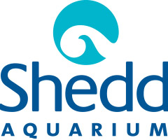

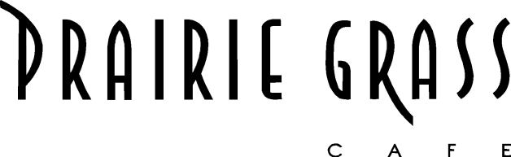

Media Contact:
Kurman Communications, Inc.
Cindy Kurman or Lee Barrie
(312) 651-9000
kurmanstaff@kurman.com

FOR IMMEDIATE RELEASE

Starting on Earth Day, Prairie Grass Cafe
is Partnering with the Shedd Aquarium to #SheddTheStraw

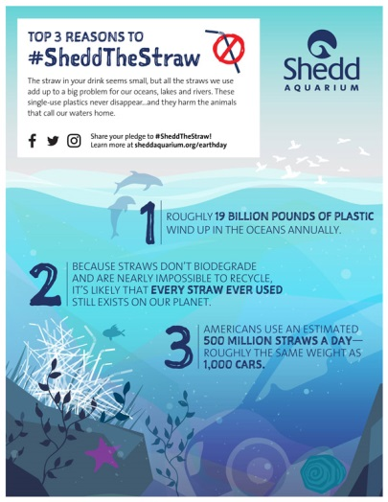
Prairie Grass Cafe (601 Skokie Blvd, Northbrook, IL 60062; 847-205-4433) is going straw-less for a good cause. Americans use approximately 500 million plastic straws every day and since these single-use plastics never disappear, they end up harming animals who call the seas and lakes home.

To help protect these animals, Prairie Grass Cafe is teaming up with the Shedd Aquarium and saying no to single-use plastic straws and switching to biodegradable alternatives. Beginning on Earth Day, Saturday, April 22, Prairie Grass Cafe will no longer offer straws to customers unless the customer requests a straw—straws will be paper and/or biodegradable.

#SheddTheStraw is a movement honoring Earth Day by celebrating and protecting the aquatic world. Learn more about #SheddTheStraw and why it’s important here. Take the Pledge to Pass on Single-Use Plastic here.

About Prairie Grass Cafe
Prairie Grass Cafe (601 Skokie Blvd.; Northbrook, IL; 847-205-4433) supports Chicago’s Green City Market and local sustainable farms, selecting the freshest ingredients to reflect the season. Prairie Grass Cafe currently serves lunch Monday - Friday 11 a.m. to 2 p.m. and dinner Monday through Sunday. Dinner is served Tuesday - Thursday from 5 p.m. to 9:30 p.m., Friday and Saturday from 5 p.m. to 10:30 p.m., and Monday and Sunday 5 p.m. to 9 p.m. Prairie Grass Cafe also serves breakfast Saturdays 10 a.m. to 2 p.m. and Sundays 9:30 a.m. to 2 p.m. Light fare is available in the bar Monday through Friday 2 p.m. to 5 p.m. For more information or to make a reservation, please call (847) 205-4433 or visit prairiegrasscafe.com. Follow Prairie Grass Cafe news at newsline360.com/prairiegrasscafe and on Facebook at Facebook.com/PrairieGrassCafe.
# # #

