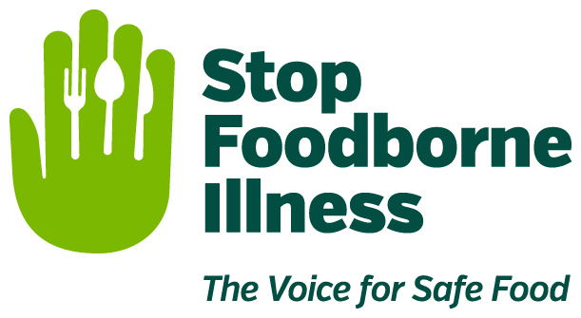

Media Contact:
Kurman Communications, Inc.
Cindy Kurman or Elisa Rascia
(312) 651-9000
team@kurman.com

FOR IMMEDIATE RELEASE

Give Kitchens a Healthy Makeover with
Spring Cleaning Tips from Stop Foodborne Illness

Tis the season for spring cleaning and Stop Foodborne Illness is helping purge the dirt with some tips on spotting and washing the dangerously germy areas often overlooked. Surprisingly, most of these places are found in the kitchen. "There are so many things that we don't think about in terms of food safety, for instance, touching raw chicken and then grabbing a spice bottle with unwashed hands and putting it back in the cabinet. It is a good time to review your food safety practices and incorporate a few new healthy habits," says Deirdre Schlunegger, CEO of Stop Foodborne Illness, a national, nonprofit, public health organization dedicated to preventing illness and death from foodborne pathogens.

From sponges to drawer handles to the refrigerator, the kitchen is the room most likely to be bacteria-tainted, including food that cross-contaminates everything in its path. As you clear out the clutter collecting dust in cabinets and on shelves, do not forget about the everyday bacteria breeding grounds hiding in plain sight around the kitchen.

Reusable Grocery Bags
Reusable grocery bags are great for the environment but they are also great for spreading bacteria like E. coli. A 2010 study found that more than half of eco-friendly reusable totes are contaminated with bacteria because almost 97 percent of shoppers interviewed said they never wash their bags. Keep food safe by throwing your bags in the wash.

Sponges & Dishrags
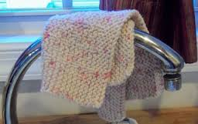
Public health and safety firm NSF International found that 72 percent of sponges and dishrags were contaminated with bacteria which can cause food poisoning, making them the germiest thing in your house. Prevent the growth of bacteria, like salmonella, by allowing sponges and rags to dry between uses or zap them in the microwave for a minute or two. A recent Fitness Magazine article recommended replacing your sponges once every three weeks.

Oven Mitts
Oven mitts protect hands from hot pans but not from bacteria. Slower growing microorganisms thrive on mitts because they are not frequently washed even though they occasionally brush up against food, have been left on dirty counters and get hung up or shoved in a dark drawer. Washing mitts after every few uses to keeps them clean and bacteria safe.

Sink
Sinks can be prime real estate for nasty bacteria like E. coli. Many people dump raw meat juices or drain packets containing raw meat straight into the sink thinking it help contains the spread of bacteria. However, within 20 minutes of E.coli coming into contact with a sink, it can multiply like wildfire. Combat those germs by scrubbing down counters, utensils and sinks as part of your regular cleaning routine.

Refrigerator
The fridge is one of the most forgotten spots while cleaning. When The Today Show’s national investigative correspondent, Jeff Rossen, went germ-hunting in his home he found that his fridge’s shelves had a reading of 904 on the bacteria meter, slightly over nine times higher than what experts consider acceptable.

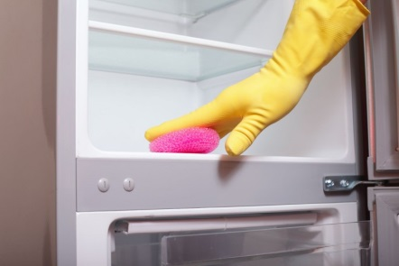
According to experts, foods like spilled milk and raw meat, combined with cold temperatures, create a perfect environment for bacteria—including E. coli and Salmonella—to thrive. These bacteria can lead to foodborne illness. To reduce risk, wipe up any spills immediately and wrap raw meat in a disposable bag and place it on a plate before storing it in the refrigerator. Read more tips on how to clean your fridge and keep food safe.

Keeping your kitchen sanitized is a good start to practicing food safety. Avoid cross contamination by touching raw meat as little as possible, and by not touching cabinets, drawers, or other items on the counter when working with raw meat. Do not cut vegetables on the same board, or with the same knife, used on raw meat. And, always wash your hands.

About Stop Foodborne Illness
Stop Foodborne Illness is a national nonprofit, public health organization dedicated to preventing illness and death from foodborne pathogens by advocating for sound public policies, building public awareness and assisting those impacted by foodborne illness. For more food safety tips please visit www.STOPfoodborneillness.org/awareness/. If you think you have been sickened from food, contact your local health professional. You may subscribe to receive Stop Foodborne Illness e-Alerts and eNews here: www.STOPfoodborneillness.org/take-action/sign-up-for-e-alerts/.

For questions and personal assistance, please contact Stanley Rutledge, Community Coordinator, at srutledge@STOPfoodborneillness.org or 773-269-6555 x7.

