Ethiopian Airlines in cooperation with the Airbus Foundation and partners fly relief goods to Ethiopia

New York, 3 May 2017 – Ethiopian Airlines, the German NGO humedica e.V, Aviation without Borders and the Airbus Foundation have joined forces to facilitate the transport of nine tonnes of humanitarian goods from Toulouse, France, to Addis Ababa, Ethiopia, utilizing the delivery flight of Ethiopian Airlines’ newest A350 XWB. The goods are destined to provide relief to drought prone areas in the East African region.

The humanitarian cargo consisted of diarrhoeal disease kits, emergency food rations, interagency emergency health kits and clothing. The goods will be handed over to the Ethiopian Airlines Foundation, the Ethiopian Administration for Refugee and Returnee Affairs and the National Disaster Risk Management Commission for further distribution to refugee camps as well as health stations.

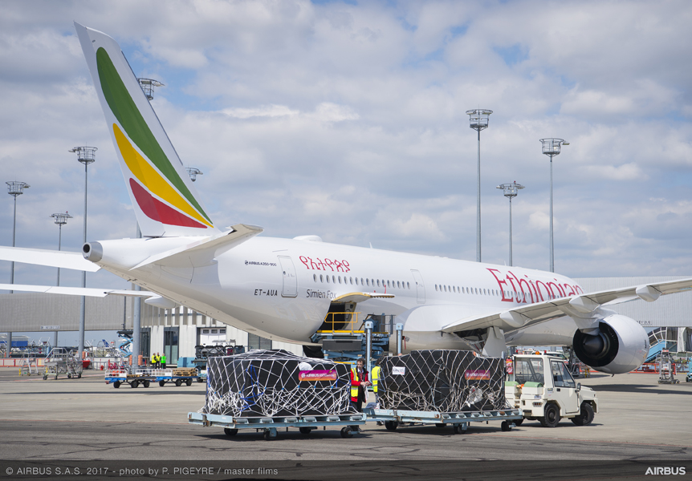

Humedica employees loading relief goods on Ethiopian Airlines latest A350 XWB at Toulouse Blagnac Airport

“We are honored to be working with humedica, Aviation without Borders and the Airbus Foundation to perform this humanitarian flight. The acceptance of our latest A350 XWB is made more meaningful as we transport much needed relief goods to the drought affected areas in the region. Ethiopian Airlines will continue with its leadership role in fulfilling its corporate social responsibilities, focusing as much on sustainability and social responsibility as on pure business performance,” said Tewolde GebreMariam, Group Chief Executive Officer Ethiopian Airlines.

“Whenever possible, we try to use delivery flights of new aircraft to our customers to ship medical or humanitarian donations to countries or regions in need,” said Fabrice Brégier, President Airbus Commercial Aircraft and member of the Airbus Foundation’s Board of Directors. “I would like to thank Ethiopian Airlines, humedica, Aviation without Borders and all partners involved in the organization for their tireless efforts and logistics support to successfully execute this mission.”

About Ethiopian
Ethiopian Airlines (Ethiopian) is the fastest growing Airline in Africa. In its seven decades of operation, Ethiopian has become one of the continent’s leading carriers, unrivalled in efficiency and operational success. Ethiopian commands the lion’s share of the pan-African passenger and cargo network operating the youngest and most modern fleet to 95 international destinations across five continents. Ethiopian fleet includes ultra-modern and environmentally friendly aircraft such as Airbus A350, Boeing 787, Boeing 777-300ER, Boeing 777-200LR, Boeing 777-200 Freighter, Bombardier Q-400 double cabin with an average fleet age of five years. In fact, Ethiopian is the first airline in Africa to own and operate these aircraft. Ethiopian is currently implementing a 15-year strategic plan called Vision 2025 that will see it become the leading aviation group in Africa with seven business centers: Ethiopian Domestic and Regional Airline; Ethiopian International Passenger Airline; Ethiopian Cargo; Ethiopian MRO; Ethiopian Aviation Academy; Ethiopian In-flight Catering Services; and Ethiopian Ground Service. Ethiopian is a multi-award winning airline registering an average growth of 25% in the past seven years.

For more information about this press release, please contact: / www.ethiopianairlines.com / www.facebook.com/ethiopianairlines www.twitter.com/flyethiopian

About the Airbus Foundation
The Airbus Foundation, chaired by Tom Enders, CEO of Airbus, includes Airbus, Airbus Helicopters and Airbus Defence and Space as founding and contributing members. It is the company’s vehicle for corporate philanthropy, using the group’s resources, aeronautic and space products, competencies, diverse workforce and culture for driving innovation to address societal issues. In particular, the Foundation supports the global humanitarian community and inspires and prepares young people for the challenges of tomorrow. Since its launch in December 2008, the Airbus Foundation has facilitated more than 50 relief or goodwill flights to numerous destinations around the globe. More information can be found at www.airbusgroup.com/foundation. Follow us on Twitter: @AirbusFdn

*****
Contacts:
Samsana Ismail (Airbus) +971 56 1717025
samsana.ismail@airbus.com

Daniel Werdung (Airbus Foundation) +49 89 607 34275
daniel.werdung@airbus.com

Hanna Atnafu (Ethiopian Airlines) (251-1) 517-89-07/656/165/913/529
CorporateCommunication@ethiopianairlines.com

Steffen Richter (humedica e.V.) +49 8341 966 14845
s.richter@humedica.org

