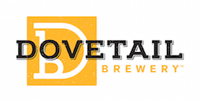

Media Contact:
Kurman Communications, Inc.
Cindy Kurman or Lee Barrie
(312) 651-9000
kurmanstaff@kurman.com

FOR IMMEDIATE RELEASE

Dovetail Brewery Raises its Glass at Chicago Craft Beer Week for the First Time

Chicagoans are known for their fervent love of outdoor dining, Ketchup-less hotdogs and fabulous craft beer. To celebrate the state’s booming craft beer scene, the Illinois Craft Brewers Guild hosting its annual Chicago Craft Beer Week from May 18 through May 25. Dovetail Brewery (1800 W. Belle Plaine, Chicago, IL; 773-683-1414) will be participating for the first time and is diving right in with an exciting line up of events.

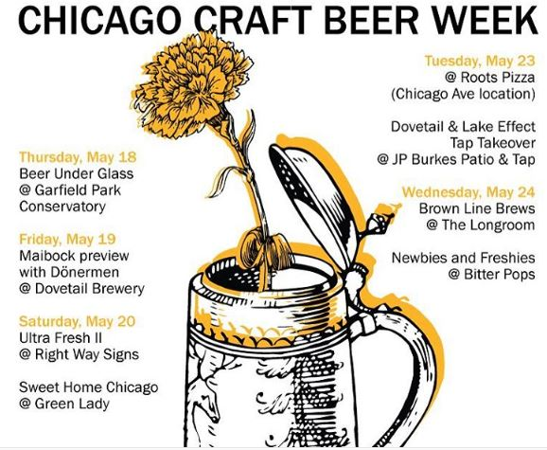
Catch Dovetail all week long starting with Beer Under Glass, the official kick off to Chicago Craft Beer Week, from 5:30 p.m. to 9:30 p.m. Thursday, May 18 at Garfield Park Conservatory. This event is filling up so purchase tickets now. The brewery will then host a Maibock preview with Donermen in Dovetail’s taproom on Friday, May 19. The next day, Dovetail will be at two events: Ultra Fresh II at Right Way Signs and Sweet Home Chicago at Green Lady Saturday, May 20. Tuesday is a big day for the brewery. Find them at Roots Pizza (Chicago Ave location) and doing a tap takeover with Lake Effect at JP Burkes Patio & Tap Tuesday, May 23. Dovetail wraps up the week with a Brown Line Brews event at The Longroom and the Newbies and Freshies event at Bitter Pops on Wednesday, May 24.

Check out chibeerweek.com for a full list of events, including release parties, beer dinners and tap takeovers.

Since Dovetail opened in June 2016, owners and master brewers Hagen Dost and Bill Wesselink have delivered delicious craft beers to Chicago’s beer fanatics. The brewery has already established itself as one of the nation’s best new breweries, recently ranking number five in the USA TODAY 10Best Contest for ‘Best New Brewery’ to open in the United States of America within the past three years.

About Dovetail Brewery
Dovetail Brewery, located at 1800 W. Belle Plaine in Chicago, Illinois, is a craft brewery owned by brewers Hagen Dost and Bill Wesselink, specializing in delicious, balanced beers brewed using traditional German and Belgian brewing methods. Signature beers include unfiltered German-style lagers, traditional Hefeweizen, Rauchbier and Lambic-style sour beers. Dovetail Brewery also produces a variety of special seasonal beers.

Taproom hours are: Tuesday- 2 pm - 10 pm; Wednesday- 2 pm - 10 pm; Thursday- 2 pm - 10 pm; Friday- 12 pm - 11 pm; Saturday- 11 am - 11 pm; Sunday- 12 pm - 8 pm.

The 22,000-square foot brewing facility includes an attractive tap room that is open to the public for drinking and retail sales. The tap room is also available as a rental space for private events.

Dovetail Brewery delivers beer by the keg to venues near the brewery and also to some select venues closer to the Loop. All bars, taverns and restaurants in the greater Chicagoland area that wish to serve Dovetail beer on tap are welcome to pick up kegs, in two sizes, at the brewery during normal business hours.

See what passionate beer lovers and industry professionals are saying about Dovetail: https://www.newsline360.com/dovetailbrewery/itn/.

For more information about Dovetail Brewery, please visit the brewery’s website at http://dovetailbrewery.com, their newsroom at http://www.newsline360.com/dovetailbrewery or contact Bill Wesselink or Hagen Dost by email. For information about special events, promotions and private events, contact Adrianne Dost. For additional information, call 773-683-1414.

Follow Dovetail Brewery on Twitter (https://twitter.com/dovetailbrewchi; @DovetailBrewChi)
Follow Dovetail Brewery on Facebook (https://www.facebook.com/DovetailBrewery/)
Follow Dovetail Brewery on Instagram (https://www.instagram.com/dovetailbrewery/)

# # #

