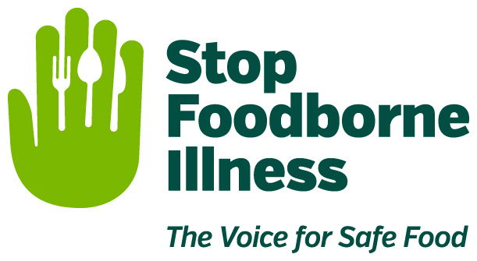

Media Contact:
Kurman Communications, Inc.
Cindy Kurman or Elisa Rascia
(312) 651-9000
team@kurman.com

FOR IMMEDIATE RELEASE

Start the School Year on the Right Foot: Brush up on Food Safety for Students of all ages during National Food Safety Education Month

September is National Food Safety Education Month and Back-to-School month, making it the perfect time to review good food safety practices. Stop Foodborne Illness, a national nonprofit, public health organization dedicated to preventing illness and death from foodborne pathogens, is reminding students from pre-K to college on the importance of food safety and how to keep school lunches free from foodborne illness.

Since parents generally pack lunches for young kiddos, learning how to keep harmful pathogens out of the lunch box is important for the whole family. Parents can use Stop’s kid-friendly factsheet Rylee & Rusty Discuss Food Safety to start a conversation with children about washing produce and hands. Teachers can bring food safety to their classrooms using Stop’s Curriculum Materials and Education Resources for Teachers to help their students make a difference.
- Wash your hands. Washing your hands thoroughly when preparing lunches reminds kids of the importance of hand-washing in preventing foodborne illness. Encourage your child to wash their hands before and after eating. Hand-washing with soap and water is best, but wet wipes or hand sanitizer that is 60% alcohol will work in a pinch.
- Use an insulated lunchbox. Whether hard-sided or soft, an insulated lunchbox helps keep food at the appropriate temperature and out of the bacteria “danger zone.” To ensure hot foods stay hot and cold foods stay cold, go the extra mile; use an insulated thermos to keep soups, chili or mac and cheese hot. Freezing milk, juice boxes and water bottles keeps cold foods cold. Bonus: the frozen drinks will melt during morning classes and be ready for drinking at lunch. Don’t forget to clean and sanitize lunch boxes each evening before packing the next day’s lunch. Learn more with these box cleaning tips.
- Pack lunches correctly. Wash fresh fruits and veggies thoroughly before drying and packing in separate plastic containers. When drying, use a clean cloth towel or paper towel to further reduce bacteria that may be present on the surface.
- The 5-second myth. The “5-second rule” is a myth. Any food that touches the floor needs to be thrown away. Additionally, remind kids to avoid putting food directly on tables. Pack a paper towel or some wax paper to be used as a makeshift plate instead.
- Toss perishable food. To avoid foodborne illness, let your child know it is okay to throw away perishables like meat, poultry or egg sandwiches, if not eaten at lunchtime. Unopened, room-temperature-safe foods and uneaten fruit can be kept.
For those not lucky enough to have cafeteria service in grade school or junior high, high school introduces a new type of dining. However, just because someone else is handling the food does not mean you are exempt from practicing food safety.
- Wash your hands. Wash your hands thoroughly before and after eating. Hand-washing with soap and water is best, but wet wipes or hand sanitizer that is 60% alcohol will work in a pinch.
- Check for undercooked food. If meat looks raw/pink, do not eat it. Additionally, “hot” foods that are cold in the middle should not be eaten.
- Checking for food that looks spoiled. Do not eat vegetables or fruits that are wilting, have mold, or look discolored. Learn more with these tips.
- Reporting unsanitary conditions. Examples include: Cafeteria workers not wearing gloves or hairnets, surfaces or equipment that are dirty, yellowish water flowing from a drinking fountain, and bugs or rodents roaming around. If your child sees these kinds of unacceptable conditions, they should report it to a school authority ASAP.
Finally, for those almost grown up kids headed off to college campuses—mom is not there so it is a good time to exercise food safety and practice proper food handling techniques. In addition to continuing the usual practices, like always washing your hands thoroughly when handling food, here is some more “food for thought” to consider for those leaving the nest.
- Late night/early morning snacking. It might be tempting but don’t eat last night’s pizza that was left out! Two hours is the limit for cooked foods left at room temperature. Foodborne bacteria grow fastest in the "Danger Zone" (temperatures between 40 and 140 °F) and can double in number every 20 minutes.
- Cooking firsts. For those living on their own for the first time, a newfound sense of independence means cooking without mom’s help for the first time. Whether you’re making microwavable mac and cheese or using the oven to roast chicken, don’t burn down the dorm and don’t forget to practice basic safe food procedures.
- Bringing leftovers back to school. Bringing Thanksgiving leftovers back to campus? Transport that last slice of pumpkin pie safely. The general rule of thumb is to keep cold food cold and hot food hot. When in doubt, throw it out. Read more about how to handle leftovers.

About Stop Foodborne Illness
Stop Foodborne Illness is a national nonprofit, public health organization dedicated to preventing illness and death from foodborne pathogens by advocating for sound public policies, building public awareness and assisting those impacted by foodborne illness. For more food safety tips please visit www.Stopfoodborneillness.org/awareness/. If you think you have been sickened from food, contact your local health professional. You may subscribe to receive Stop Foodborne Illness e-Alerts and eNews here: www.Stopfoodborneillness.org/take-action/sign-up-for-e-alerts/.

For questions and personal assistance, please contact Stanley Rutledge, Community Coordinator, at srutledge@Stopfoodborneillness.org or 773-269-6555 x7.

###

