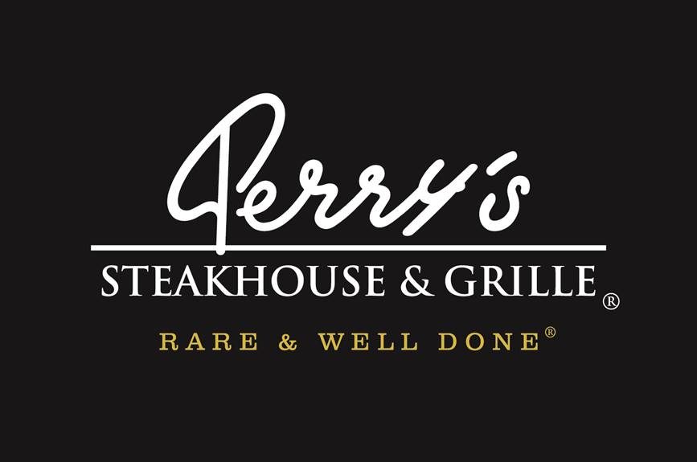
Media Contact:
Kurman Communications, Inc.
Cindy Kurman or Lee Barrie
(312) 651-9000
kurmanstaff@kurman.com

FOR IMMEDIATE RELEASE
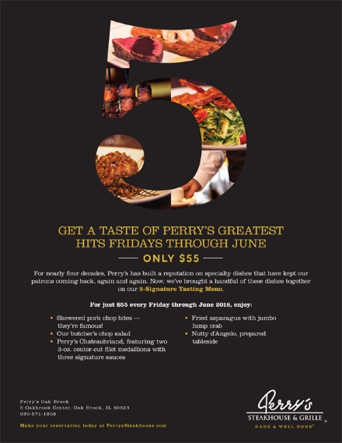

Get A Taste of Perry’s Greatest Hits Fridays Now through June 29th
for only $55
For nearly four decades, Perry's Steakhouse & Grille (5 Oakbrook Center, Oak Brook, IL 60523 630-571-1808) has built a reputation on specialty dishes that have kept their patrons coming back again and again. Now, they are introducing a special that brings a handful of these dishes together on their new 5-Signature Tasting Menu.
For just $55 every Friday through June 29, 2018, you can enjoy a tasting menu including Perry’s famous skewered pork chop bites; the delicious butcher's chop salad; Perry's Chateaubriand, featuring two 3-oz. center-cut filet medallions with Truffle Merlot Demiglace, Bearnaise, and Peppercorn reduction sauces; fried asparagus with jumbo lump crab, and the Nutty d'Angelo, prepared tableside.
About Perry’s Steakhouse & Grille
Perry’s Steakhouse & Grille has earned a faithful following by perfecting prime since 1979. Beginning as a small butcher shop, Perry’s has grown into a renowned group of award-winning restaurants featuring USDA Prime beef, tableside carvings, signature selections, flaming desserts and handcrafted cocktails at its Bar 79. Specializing in a Rare and Well Done experience, Perry’s currently operates 14 steakhouse locations in Chicago, Birmingham, Denver, and across Texas, as well as the two original butcher shops now known as Perry & Sons Market & Grille. For more information and updates on Perry’s Steakhouse, please visit www.PerrysSteakhouse.com.

Facebook (Facebook.com/PerrysDining), Twitter (@PerrysDining) and Instagram (@PerrysSteakhouse)

