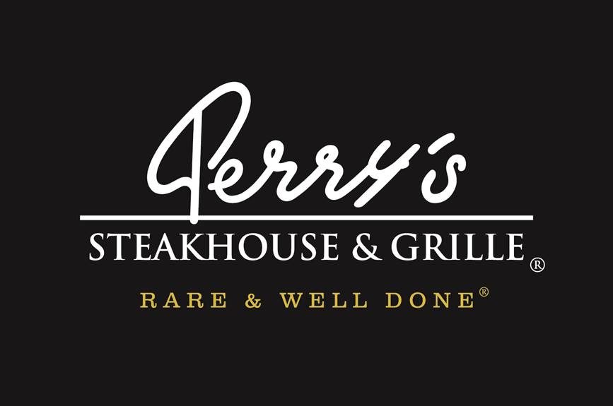

Media Contact:
Kurman Communications, Inc.
Cindy Kurman or Elisa Rascia
(312) 651-9000
kurmanstaff@kurman.com

FOR IMMEDIATE RELEASE

Celebrate Cinco de Mayo
at Perry’s Steakhouse & Grille in Oak Brook
Special cocktail – Rita Rosé Olé –Now through May 10
Just in time for Cinco de Mayo, Perry’s Steakhouse & Grille (5 Oakbrook Court, Oak Brook, IL 60523; 630-571-1808) is introducing a new limited time only cocktail that incorporates both a Mexican wine and a Mexican tequila. The Rita Rosé Olé, available through May 10 for $15, is a unique wine-based cocktail made with Casa Madero Rosé wine and Codigo 1530 Rosa Tequila.

Although the oldest winery in the New World hails from Mexico, these wines are somewhat hard to find, says Susi Zivanovic, Perry’s Steakhouse & Grille ’s Corporate Sommelier and Beverage Director. Recently, however, Mexican wines have been gaining international importance and growing in popularity.

Established in 1597, Casa Madero is the oldest winery in the Americas and the 6th oldest in the world. Coming from Parras, Coahuila, Mexico, the Casa Madero Rosé starts slightly sweet and smooth with a crisp, fruity, garden-fresh intensity. This 100% Cabernet Sauvignon has notes of candied orange, fresh red berries and apricot, giving it a refreshing taste.

The Código 1530 Rosa Tequila begins with the purity of Blanco, then is rested for 1 month in uncharred Napa Cabernet French White Oak barrels. The result is a refined spirit with a natural color as beautiful as its taste. The Código 1530 Rosa has rested just long enough in Cabernet barrels to enrich the natural agave juice, without overpowering its delicate floral notes.

The combination of Casa Madero Rosé and Código 1530 Rosa Tequila to create the Perry’s Rita Rosé Olé provides a twist on the traditional Margarita, while still giving a nod to the history of Mexican wines and spirits.
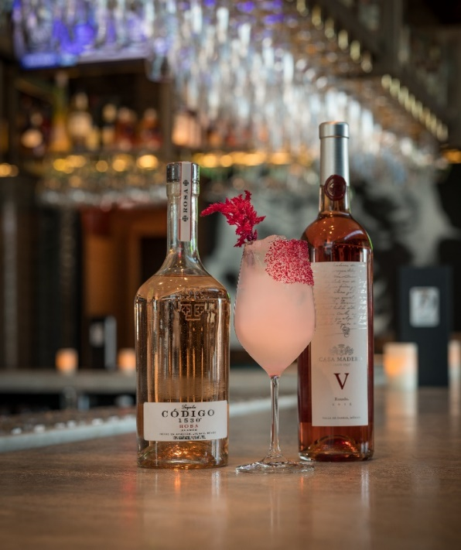
Perry’s Rita Rosé Olé

About Perry’s Steakhouse & Grille
Perry’s Steakhouse & Grille has earned a faithful following by perfecting prime since it began as a butcher shop in 1979. Named as one of Open Table’s “Top 100 Steakhouses in America 2016,” Perry’s has grown into a renowned group of award-winning restaurants. Featuring USDA Prime beef, tableside carvings, signature selections, flaming desserts and handcrafted cocktails at its Bar 79, Perry’s specializes in a Rare and Well Done experience, currently operating 14 steakhouse locations in Chicago, Denver, Birmingham and across Texas, as well as the two original butcher shops now known as Perry & Sons Market & Grille. For more information and updates on Perry’s Steakhouse, please visit www.PerrysSteakhouse.com.

