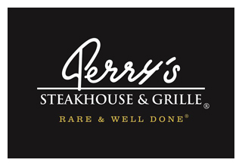

Media Contact:
Kurman Communications, Inc.
Cindy Kurman or Lee Barrie
(312) 651-9000
kurmanstaff@kurman.com

FOR IMMEDIATE RELEASE

Raise A Glass and Support Mental Health
at Perry’s Steakhouse & Grille in Oak Brook
May 11 through June 30, 2018

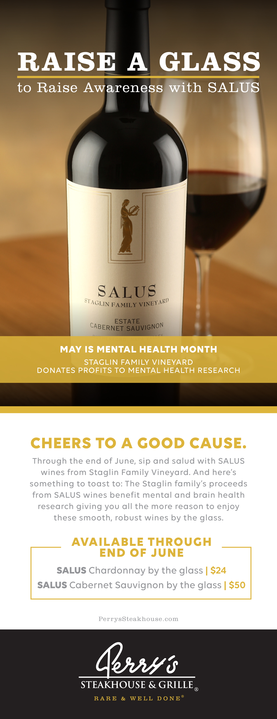
May is Mental Health Month and Perry’s Steakhouse & Grille in Oak Brook (5 Oakbrook Center, Oak Brook, IL 60523; 630-571-1808) along with Staglin Family Vineyard are helping to raise awareness by donating proceeds from the sale of Staglin’s SALUS wines beginning May 11 through June 30, 2018. Staglin will donate their proceeds to benefit mental and brain health research, giving you even more reason to enjoy these exquisite wines by the glass.

Featured wines include SALUS Chardonnay by the glass ($24) and SALUS Cabernet Sauvignon by the glass ($50). The smooth and robust SALUS wines are named after the Roman goddess of health and well-being. This name is quite appropriate because 100% of the proceeds from the sales of these wines will go toward fundraising for mental health research, a cause that is very near and dear to the Staglin family’s hearts.

About Perry’s Steakhouse & Grille
Perry’s Steakhouse & Grille has earned a faithful following by perfecting prime since 1979. Beginning as a small butcher shop, Perry’s has grown into a renowned group of award-winning restaurants featuring USDA Prime beef, tableside carvings, signature selections, flaming desserts and handcrafted cocktails at its Bar 79. Specializing in a Rare and Well Done experience, Perry’s currently operates 14 steakhouse locations in Chicago, Birmingham, Denver, and across Texas, as well as the two original butcher shops now known as Perry & Sons Market & Grille. For more information and updates on Perry’s Steakhouse, please visit www.PerrysSteakhouse.com.

Facebook (Facebook.com/PerrysDining), Twitter (@PerrysDining) and Instagram (@PerrysSteakhouse)

# # #

