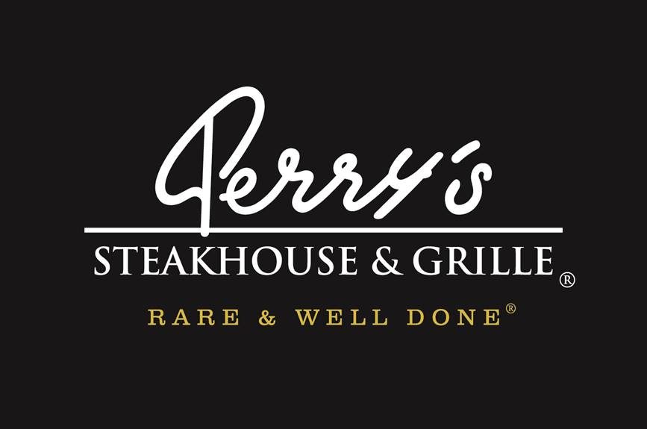

Media Contact:
Kurman Communications, Inc.
Cindy Kurman or Lee Barrie
(312) 651-9000
kurmanstaff@kurman.com

FOR IMMEDIATE RELEASE

Raise a Glass to National Chardonnay Day Friday, May 25
at Perry’s Steakhouse & Grille in Oak Brook
Toast to specially priced bottles of Perry's Reserve Chardonnay

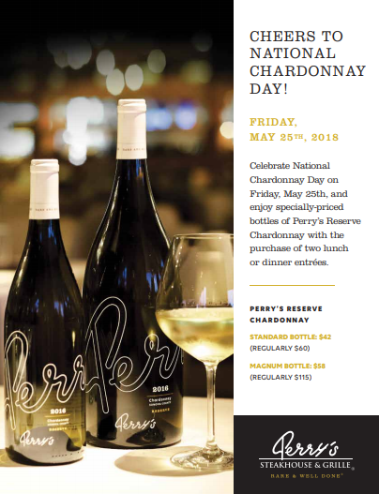
Friday, May 25 is National Chardonnay Day and Perry’s Steakhouse & Grille (5 Oakbrook Center, Oak Brook, IL 60523; 630-571-1808) is celebrating by offering specially priced bottles of Perry’s Reserve Chardonnay with the purchase of two lunch or dinner entrées.
On this day only, Perry's is offering their Reserve Chardonnay for $42 (regularly $60) and their Magnum Bottle, which is double the size of the standard bottle, for $58 (regularly $115) with the purchase of two lunch or dinner entrées.

Aged in French oak barrels, Perry's Reserve Chardonnay features luscious notes of pear, green apple and vanilla with a long elegant finish, making it a patron favorite and versatile accompaniment to the restaurant's dining menu.

Kick off the weekend on a high note. Bring a friend or the whole squad, and honor National Chardonnay Day the right way. Make Chardonnay Day reservations for Friday, May 25 by calling (630) 571-1808 or by visiting http://www.perryssteakhouse.com.
About Perry’s Steakhouse & Grille
Perry’s Steakhouse & Grille has earned a faithful following by perfecting prime since 1979. Beginning as a small butcher shop, Perry’s has grown into a renowned group of award-winning restaurants featuring USDA Prime beef, tableside carvings, signature selections, flaming desserts and handcrafted cocktails at its Bar 79. Specializing in a Rare and Well Done experience, Perry’s currently operates 14 steakhouse locations in Chicago, Birmingham, Denver, and across Texas, as well as the two original butcher shops now known as Perry & Sons Market & Grille. For more information and updates on Perry’s Steakhouse, please visit www.PerrysSteakhouse.com.

Facebook (Facebook.com/PerrysDining), Twitter (@PerrysDining) and Instagram (@PerrysSteakhouse)

