Philadelphia PA
January 27, 2020
NEWS RELEASE:
Eli Razon, Founder of Easy-Walking Inc. a manufacturer of therapeutic devices for rehabilitation and restoration of walking for children and adults.
After hundreds of hours of patient mobility and bio mechanical studies of walking Eli recognized the strain on muscles, tendons and ligaments placed on knee flex activities.
Eli founded Ambena Inc, a manufacturer of unique adjustable devices to reduce knee strain for individuals doing knee flex activities such as Yoga, Flooring Installations, any activity requiring individuals to fold legs (knees) back and sit or dwell while performing the work.
Meditation-T for conditioning activities 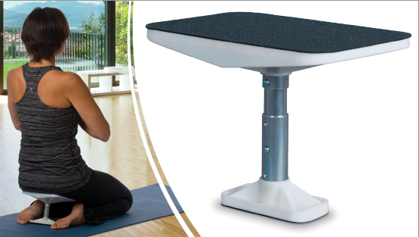
Flooring Knee-T for work activities 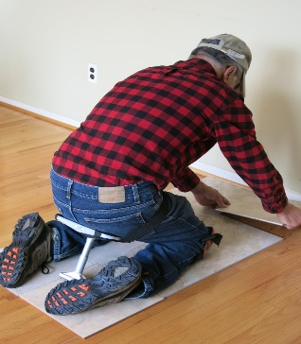
For further information call, email or request by mail to:
Ambena, Inc. 1123 Ivy Hill Road
Philadelphia PA 19150
Phone: 267-405-3441
Email: info@ambena.com or eli.razon@ambena.com
All AMBENA, INC PRODUCTS FABRICATED AND ASSEMBLED IN PHILADELPHIA PA USA

