.
Press release

Executives Secret Weapon for Leading Through COVID-19
- A new study reporting leadership coaching improves executive performance during the coronavirus pandemic
September 21, 2020, Novi, Michigan
Elite athletes train with coaches for thousands of hours in preparation for that one key moment. The stakes
are high. The world is watching. This single performance will mean the difference between victory and defeat.
In the world of business, 2020 is such a time for leaders of people and organizations. The stakes are high, and their performance matters. Leaders could have turned to many different experiences in their life to support them as they responded to COVID-19. The reason leaders relied on their coaching during this time is because, as they also reported, their coaching provided them with insights that helped them better navigate the uncertainty that was unfolding in front of them.
“93% of Dion Leadership Coachees reported that Leadership Coaching better equipped them to utilize new behavior required during COVID-19”
Simply put, leadership coaching works. It has been particularly useful in supporting recently coached leaders as they navigate what may be the most difficult year in their career. The percent of coachees in our study reporting specific benefits from coaching are listed below.

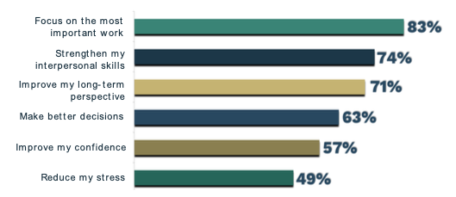
“Coaching helped me be a better communicator and leader. COVID has been the most difficult time in many people’s lives. Uncertainty about their own health, the safety of their families, the security of their jobs has contributed to unprecedented stress levels for everyone. Understanding how to have an empathetic discussion about fear and concerns with staff in an open and supportive manner was the most valuable lesson I learned in coaching!”
This pandemic is far from over. Leaders are running a marathon – not a sprint. If you would like support so you or your leaders can receive the benefits shown in this study, reach out to us. Our large team of experienced executive coaches can help. The full study on leadership coaching can be found at https://dionleadership.com/covid-response-programs/.

About Us: Dion Leadership is a training, coaching, assessment, and organizational development consultancy based in Detroit, Michigan. We help our clients build strong leaders that create even stronger organizational cultures. Our team of 50+ expert coaches and consultants serve as a long-term partner to assess talent, develop leadership competency, build teams, drive culture change, and improve performance for large, complex organizations in a variety of industries including healthcare, manufacturing, and professional services. Get to know us at www.dionleadership.com.
Name of Press Contact: Lauren Zbranchik | Phone: 248-515-2235 | Email:letstalk@dionleadership.com

