DOOGEE launches its new N30 and S40 Pro affordable Android 10 smartphones
DOOGEE N30 Full Netcom, 16MP AI Quad Rear Camera, MT6762V Octa Core processor, fluid aesthetics and 6.5” HD+ Perforated screen
DOOGEE S40 Pro 4G, 4650mAh battery, IP68/IP69K, 4GB RAM +64GB ROM storage, MT6762D Octa Core processor, 13MP AI Double Rear cameras+5MP front camer, 5.45” Corning Gorilla Glass coating
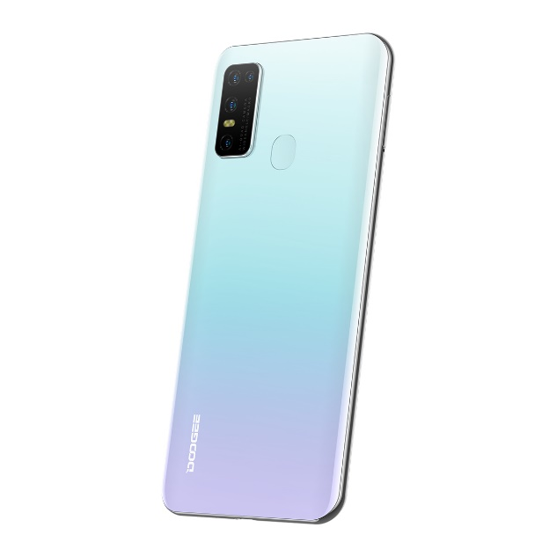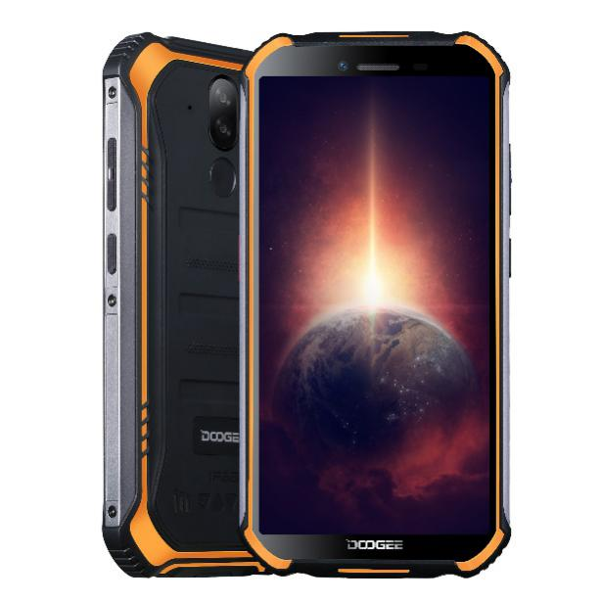
N30 S40 Pro
London, XX September 2020: Innovative technology company, DOOGEE Hengtong Technology Co. Ltd, is pleased to announce the launch of two new affordable Android 10.0 smartphones, the N30 and S40 Pro. With a rugged option and a sleek everyday option, both smartphones represent great value for money with Octa Core processors, large batteries, dual SIM capabilities and AI rear cameras. The N30 is available from AliExpress for $99.99 (October 5th – 11th) and Banggood for $99.99 between September 28th – October 4th and the S40 Pro is available from AliExpress and Banggood for $99.99 between September 28th – October 4th.
DOOGEE N30
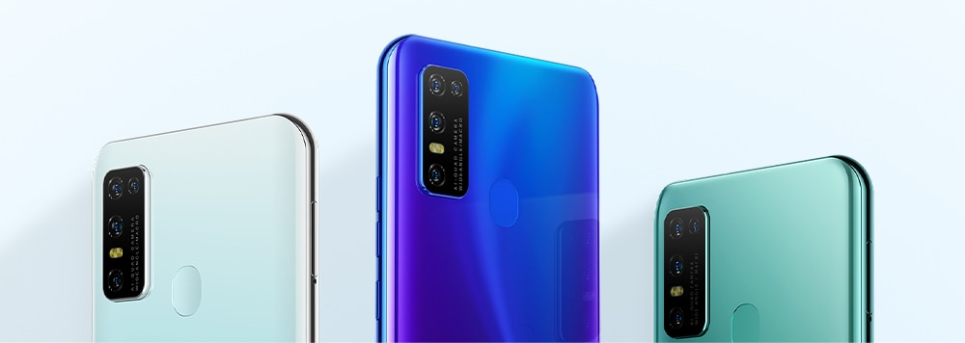
Available in Dreamy Blue, Elegant Green, Magic Black and Misty White, the N30 is a Full Netcom smartphone with a MT6762V/WD Helio A25 Octa-Core processor for a fast and smooth user experience. The 6.55” HD+ Perforated IPS screen has a 93% screen-to-body ratio and 19:9 Aspect Ratio, is great quality and perfect for viewing apps, videos and general phone use with real clarity. In addition, the N30 has a 4500mAh large battery giving 1-2 days with normal use and 11 days standby and supports 10W Type-C fast charging so that battery life won’t be a problem with this device. Featuring 4GB RAM and 128GB ROM (up to 256GB with an SD card), there is plenty of space to hold all apps, pictures and storage that are needed whilst not impacting on the phone’s performance and maintaining fluidity and speed. With Android 10.0 and Bluetooth 5.0, it is an effortless phone experience.
Featuring a 16MP+8MP+2MP+2MP AI quad rear camera and an 8MP Samsung front camera, it is also an ideal phone for taking pictures and videos when exploring, viewing scenes or just taking selfies. The 16MP main camera has F/2.2±5% Aperture, 86-degree FOV and supports flash LED, an 8MP wide angle camera offers a 130-degree FOV for impressive landscapes and shots of scenery and a 2MP macro camera to take extreme close-up shots from 2cm. The 8MP Samsung front camera also includes a selfie beauty feature that has automatic retouching to make every photo impress.
Also supporting four satellite navigation systems with GPS Galileo, Glonass and Beidou, it’s ideal for taking on trips and to prevent getting lost! The Dual SIM makes it easy to transition when away in another country and weighing just 190g, it is a slim and light phone to take on holidays. Using the Face Unlock and fingerprint ID also provides security and efficiency with a 0.19s response speed, 360-degree identification angle, capacitance touch sensor and 508DPI scanning resolution to give both peace of mind but also easy access.

DOOGEE S40 Pro
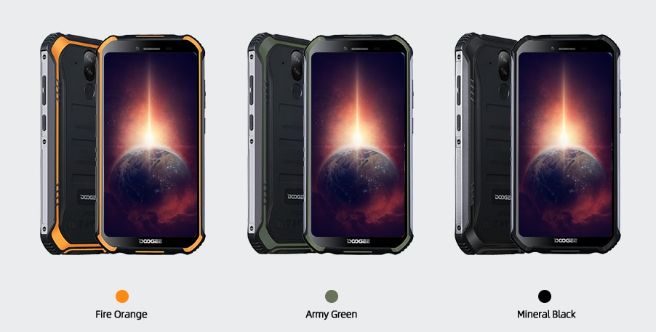
The DOOGEE S40 Pro 4G smartphone is a rugged phone that is designed to be both tough and powerful at a great value price. The durable quality combines with a smooth and reliable performance in a slimmer and lighter design for it to be more portable and easier to handle. With a vibrant in-cell display that provides sharper images for a pleasant visual experience, the 5.45” HD+ IPS screen has 720*1440 resolution, 18:9 Aspect Ratio and Corning Gorilla Glass.
Backed by military certification, the 810G device can withstand the most harsh and extreme environments. The S40 Pro has an IP68 dustproof and waterproof rating and it can be immersed in water for a short time (up to 1.5m for 30 minutes) but also fully immersed within 1.5m for up to 2 hours, drop proof from up to 1.5m heights and able to with stand temperatures from -55°C to 70°C, it can be taken anywhere without worries of it breaking or being damaged by the extremities.
Featuring a cutting-edge MT6762D A25 Octa core processor, the rugged phone gives a seamless performance with a maximum main frequency up to 1.86Hz, maximum rendering frequency 650MHz and increased speed in operations, gaming, AI and any other activities. The S40 Pro has a 4650mAh battery which has improved power efficiency and intelligent power management systems to make it last longer. Offering 288H standby, 6H gaming, 21H calling, 25H music and 8H video, it has plenty of capacity for long use. When running low, the phone can charge up to 70% power in just 30 minutes using the 10W fast charge so it won’t be out of battery for long. Offering large space for daily use, the 4GB high speed RAM gives a fast and smooth switch between apps and 64GB ROM (256GB with an SD card) provides lots of storage. Using Bluetooth 5.0 and Android 10.0 also offers an efficient, fast and enjoyable experience.
The S40 Pro has an AI rear dual camera giving flagship-level performance. The SONY 13MP sensor in the primary camera supports flash LED and has an F/2.8±5% Aperture and the 2MP portrait camera perfects portraits every time. The camera tracks low-light and night time photography effortlessly to present incredible images in every setting. Videos and images taken can also be edited and shared instantly and easily, making it a great rugged phone to take on adventures but also to take stunning photos. With whitening, buffing, thin and enlarge eye options for editing, the AI selfie camera also ensures clear and impressive selfie images.
The rear-mounted fingerprint sensor is easy to reach and quick to unlock the phone without the need for a password and the user-friendly NFC function supports the use of Google pay for an easier purchase experience on transport or in shops. Equipped with GPS, Glonass, Beidou and Galileo four navigation systems, the S40 Pro offers navigation accuracy so is particularly useful when on an adventure holiday. Also backed with multiple professional sensors and tools, the DOOGEE S40 Pro is a great practical outdoor toolkit using apps such as plumb bob, gradientier, magnifier and picture hanging.
The DOOGEE N30 is available in Misty White, Magic Black, Elegant Green and Dreamy Blue from AliExpress and Banggood for $99.99 between September 28th – October 4th.

The DOOGEE S40 Pro is available in Mineral Black, Army Green and Fire Orange from AliExpress and Banggood for $99.99 between September 28th – October 4th.
High resolution imagery is available here

Specifications:

N30 | S40 Pro
6.55” HD+ Perforated Screen | 5.45” Corning Gorilla Glass Anti-Fingerprint Coating HD+IPS Screen
4500mAh (Built-in) battery. Supports 10W quick charge | 4650mAh (Built-in) battery
16MP AI Quad Rear Camera+8MP Samsung front camera | IP68/IP69K
MT6762V Octa-core Processor | MT6762D A25 Octa-core Processor
Dual Nano SIM | 13MP+2MP SONY AI Double Rear Camera+5MP front camera
Android 10.0 | Android 10.0
4GN RAM+128GB ROM | 4GB RAM+64GB ROM

- ENDS-

About DOOGEE Hengtong Technology Co., Ltd:
DOOGEE is a technology company that was set up in Spain in March 2013. This contributes to the high performance of its products as well as their beautiful design and features, smart operation, and “micro-innovation”.
DOOGEE’s new slogan is “Live Your Life,” delivering fashionable products with new technology, with the aim of becoming the most popular smartphone supplier in the world.
For more information or to discuss a review sample, please contact Kristy px-xie@doogee.cc or info@doogee.cc

