.
Press release

October 5, 2021, Novi, Michigan
Dion Leadership Releases a New Study Comparing In-Person and Virtual Delivery of Leadership Programs
In addition to disrupting where we work, the pandemic has put a halt to in-person, classroom-based leadership development programs. These programs serve as an important catalyst for identifying, developing, and engaging the next generation of talent and can help to combat The Great Resignation for management level positions.
Organizations faced a difficult decision when it became clear that their leaders weren’t returning to the office anytime soon. Should they continue to put these programs on hold and, as a result, place a plug in their leadership pipeline? Or should they invest in retooling their programs for virtual delivery, priming the pump of talent development while risking a less-than-stellar learner experience?
In a study of leadership development programs in the manufacturing industry, Dion Leadership examined the learner experience of in-person and virtually facilitated high-potential program. While the participant groups varied between the virtual and in-person programs, the other key learner experience variables remained constant: the content, facilitators, and organizational cultures were all the same. This created an ideal opportunity to compare the learning experiences.
With feedback from nearly 100 participants, this study collected 200 post-session evaluations. Approximately half were collected from the in-person course participants and half were collected from virtual session participants.
Simply put, learners responded almost as favorably to virtually facilitated leadership development programs. The percent of learners agreeing or strongly agreeing with the statement “Overall, this program was a worthwhile investment of time and attention” remained extremely high at 92% (vs 98% in the in-person program).
The complete study, additional insights, and learner comments are available here.
”All involved—from our executive leadership team to the participants—were pleasantly surprised to find that the quality of content, facilitation, and group connection were very similar to our previous in-person approach," explained Chuck Jozwiak, Director of Global Talent, DexKo Global.

While some learners shared that they missed in-person training and the ability to network with peers, they also said using blended and hybrid approaches did result in learning new skills, shifting mindsets, and building camaraderie. This feedback indicates blended learning has a bright future in preparing future leaders. “Hybrid work is here to stay. To support this new way of working, virtual learning programs will be the new way of learning,” commented Steve Dion, Founder and CEO, Dion Leadership

About Us: Dion Leadership helps organizations build strong leaders and even stronger organization cultures. Our team of 60 extraordinary coaches and consultants craft practical approaches to unique problems, delivering proven solutions. Our offerings include leadership coaching, management training programs, leadership and team development, talent assessment, and organizational development consulting. We recently launched a new research-based training product that supports work-life alignment.

Infographic from the study publication:
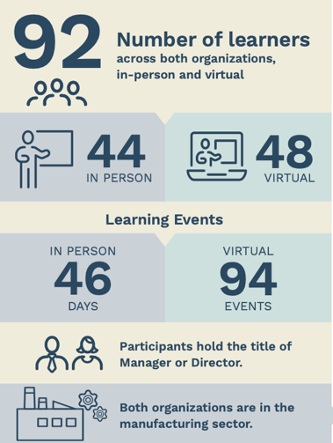

Name of Press Contact: Lauren Zbranchik | Phone: 248-515-2235 | Email:letstalk@dionleadership.com

